**Practical AI CA1**

**Gobest Cab Data Analysis**

**Project Report**

By

Class: DAAA/FT/2B/01

Team Members (Student ID):

Tan Wen Tao Bryan (2214449)

Ryan Yeo (2214452)

Zachary Leong Yao Jie (2201861)

Ethan Pang (2214241)

Submission Date: 1 December 2023

Word Count: 1992 words

(excluding headers & images)

**1 INTRODUCTION**

1.1 Project Objective

The primary objective of this project is to develop a comprehensive data science solution for GoBest Cab, a ride-hailing service company. The goal is to create an intuitive and portable machine learning software application that visualizes and analyses cab data. The application could provide some insights into the drivers’ behaviour, find out if they are dangerous or safe drivers.

**2 BACKGROUND RESEARCH**

2.1 Business Objective

GoBest Cab aims to enhance operational efficiency and decision making by visualizing and analysing the cab data. The team’s objective is to develop a machine learning application to address this issue. First, we had to understand the areas related to the issue.

2.1.1 Stakeholders

Stakeholders are people affected by the issue. Key stakeholders of the company include the managers, administrators, and cab drivers. The team formed user stories to address each stakeholder’s needs. To evaluate the success of the user stories, confirmations were drafted for the team to meet as success criteria.

2.1.2 Project Scope

The project scope centers around the development of a portable application tailored for use on the manager’s laptop. The term “portable” implies that the application should be capable of running seamlessly on the manager’s laptop without requiring extensive dependencies or resources.

Hence, the team will tailor the application to address specific queries outlined by the mangers, with a primary focus on trip safety and the behaviour of the cab drivers throughout the entire journey.

Boundaries may include the application should only be designed exclusively for managerial use. By clearly defining the project scope, the team is able to establish a focused direction, ensuring that the team’s solution meet the stakeholders’ needs and requirements.

2.1.3 Risk Assessment

The project’s objective operates within defined resource constraints, primarily governed by a limited timeline of 4 months and a team structure consisting of 4 students per group.

To address the timeline issue, the team’s product owner drafted a product backlog which allocated the number of hours needed to complete each task, prioritised by importance. The team will have to adhere to the schedule and all activities must align with specific deadlines.

To address the manpower issue, effective communication and collaboration strategies are essential to optimize the collective capabilities of the team. Hence, scrums are held twice a week to optimize collective capabilities and ensure the assigned tasks are completed.

2.1.4 Communication Plan

To ensure effective communication and collaboration strategies, scrum meetings were held twice a week.

The main topics discussed were: 1) What were the tasks completed last week? 2) What each team member is going to complete this week? 3) What obstacles is each team member facing?

The discussion was entirely recorded in the bi-weekly scrum reports for documentation. Obstacles were also promptly resolved during the scrum meetings to ensure the flow of business value was smooth without any hindrance.

Scrum meetings were held through the proper channels – Discord. The team will present their work progress quickly to ensure quality and timely completion of the tasks.

2.2 Data Understanding

The data consists of seven csv files.

Five of these files belong to the sensor dataset consisting of these columns: bookingID, accuracy of the GPS in metres, bearing in degrees, acceleration_x, acceleration_y, acceleration_z, gyro_x, gyro_y, gyro_z, second and speed in metres per second.

Some of these columns needed additional context: Bearing was the direction of GPS to travel from a location to the destination in metres. Acceleration determines the acceleration of the device in motion in metres per second square. Gyro determines the rate of orientation of the device relative to the earth’s gravity in radian per second. Second refers to the time of the sensor’s record.

One of the files belong to the driver dataset consisting of these columns: driver_id, name, date_of_birth, number of years driving experience, gender, car make, car model year and the drivers’ ratings which were ranked from two to five.

Last dataset was the safety labels which had these columns: bookingID, driver_id and labels which were tags to indicate dangerous driving trips (zero – normal trip/ one – dangerous trip).

**3 DATABASE OPERATIONS**

3.1 Entity Relationship Diagram

Schema is made up of 3 entities – Sensor Data, Safety Labels and Cab Driver. Each entity consists of these columns as seen in the picture.

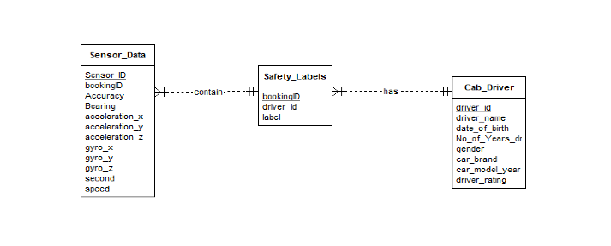

3.2 SQL Database Build

Creation of Tables:

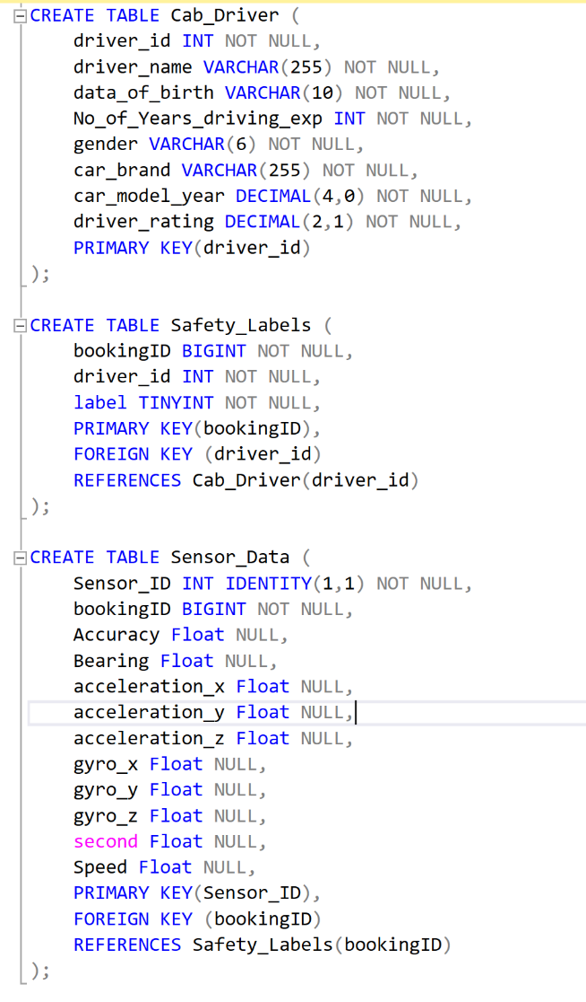

BULK INSERT was used for the insertion of values to each table.

3.3 SQL Queries

Query 1:

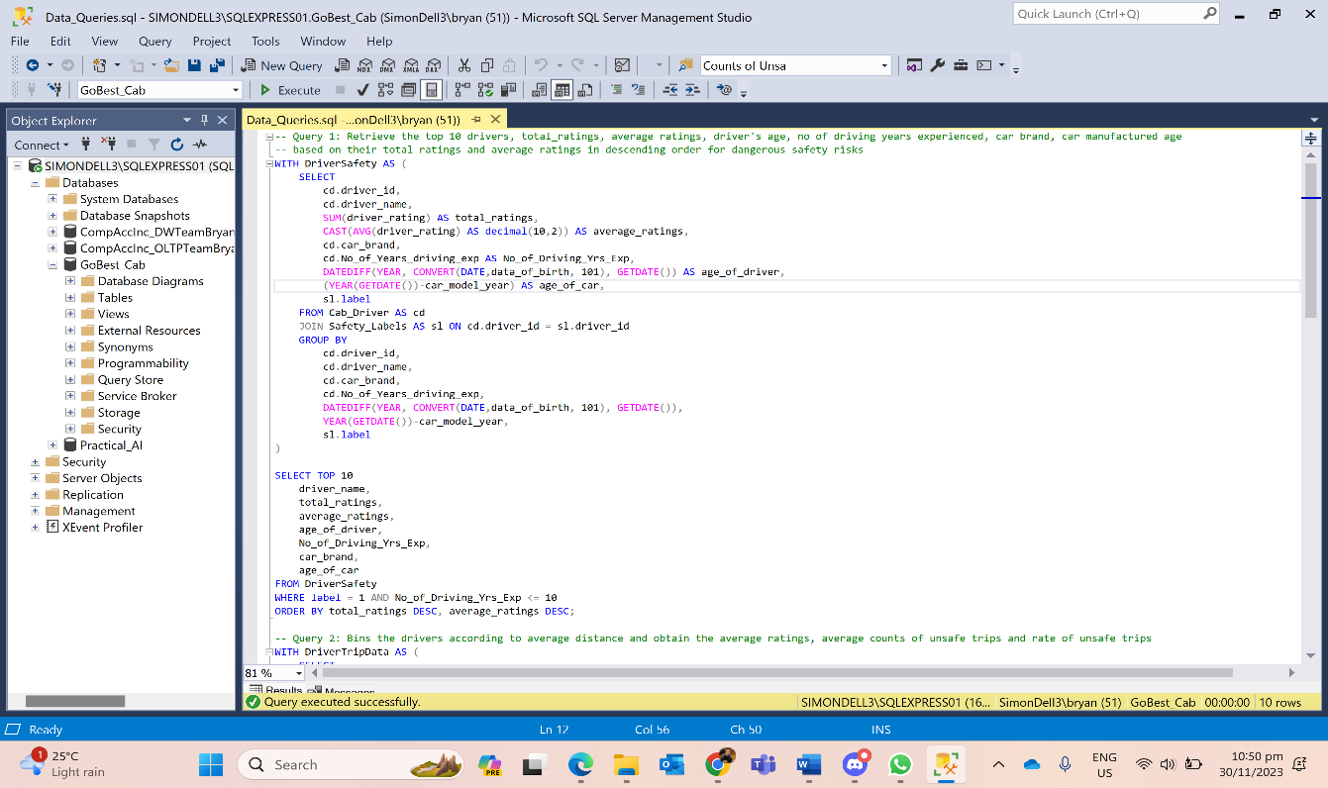

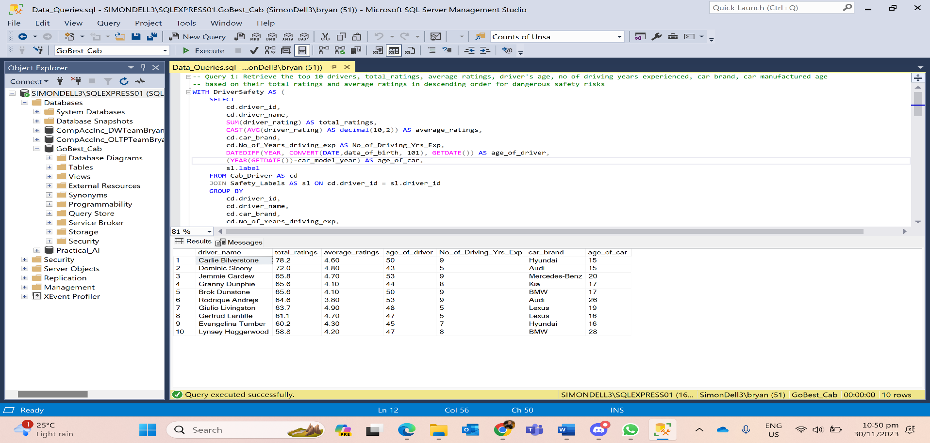

**Insight**: Carlie Bilverstone is the driver with the highest total ratings. Out of the top 10 drivers with less than 11 years of driving experience, Rodrique Andrejs has the lowest average ratings but a high total rating. This suggests that he has some trips that had higher ratings compared to the other drivers and some of lower ratings, increasing the total ratings.

Query 2:

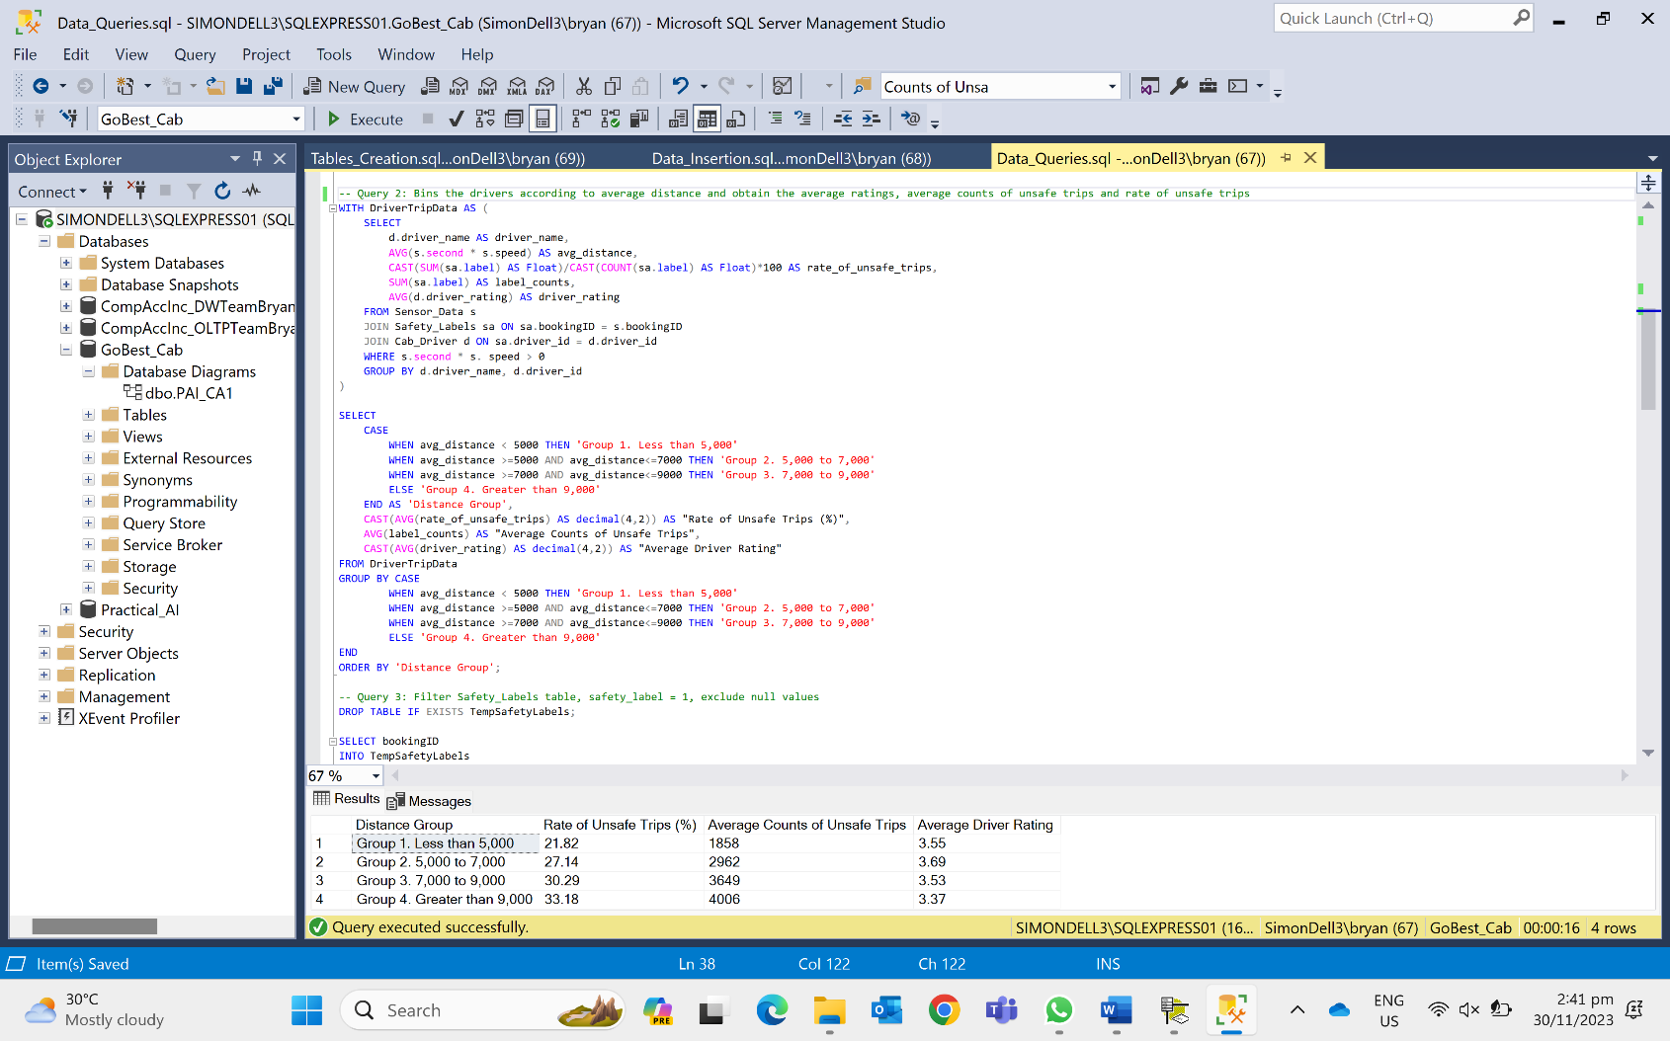

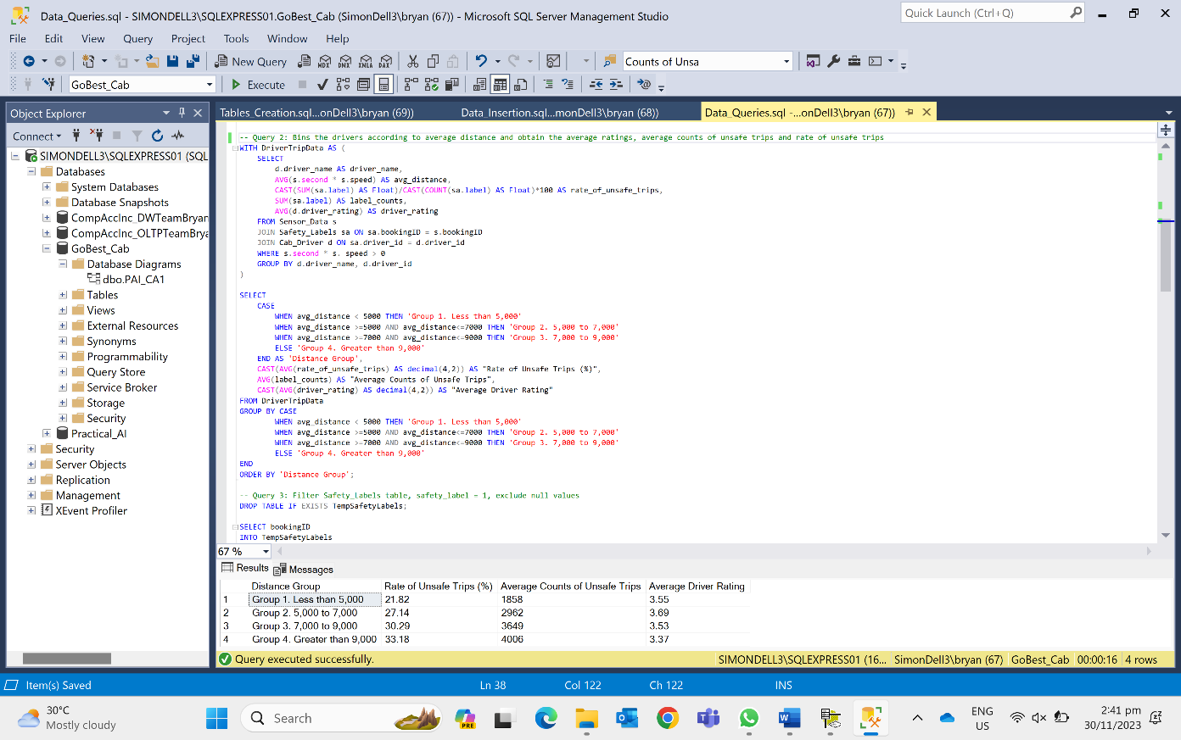

**Insight**: The table shows that drivers that drive longer trips tend to have a greater number of unsafe trips and a greater rate of unsafe trips. However, their average driver rating is not as affected by the distance on average.

Query 3:

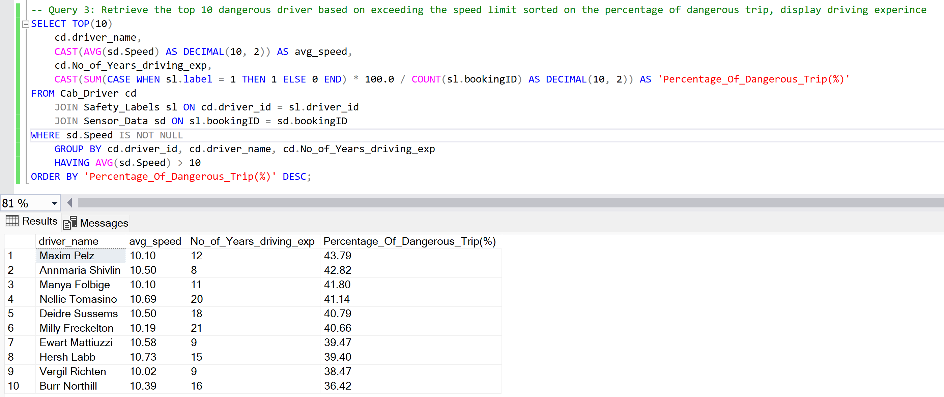

**Insight**: Drivers who exceed the speed limit of 10m/s pose a danger to their riders based on the percentage of dangerous trips. Number of years driving experience does not affect the percentage of dangerous trips.

3.4 ETL Pipeline

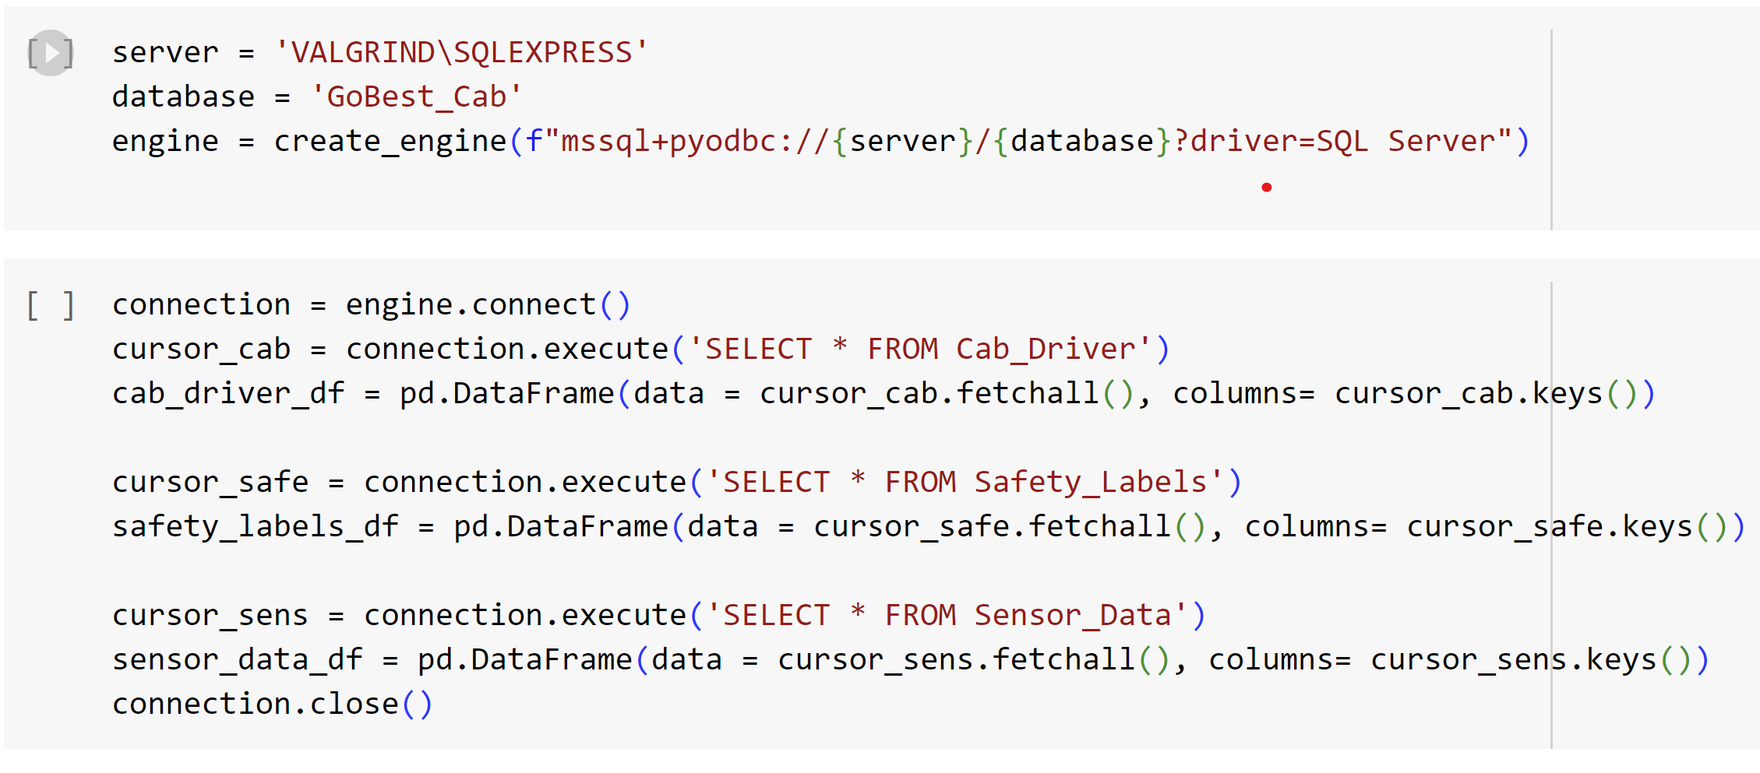

**4 DATA PREPARATION & FEATURE ENGINEERING**

4.1 Data Preprocessing & Data Cleaning

Conversion of Data Types

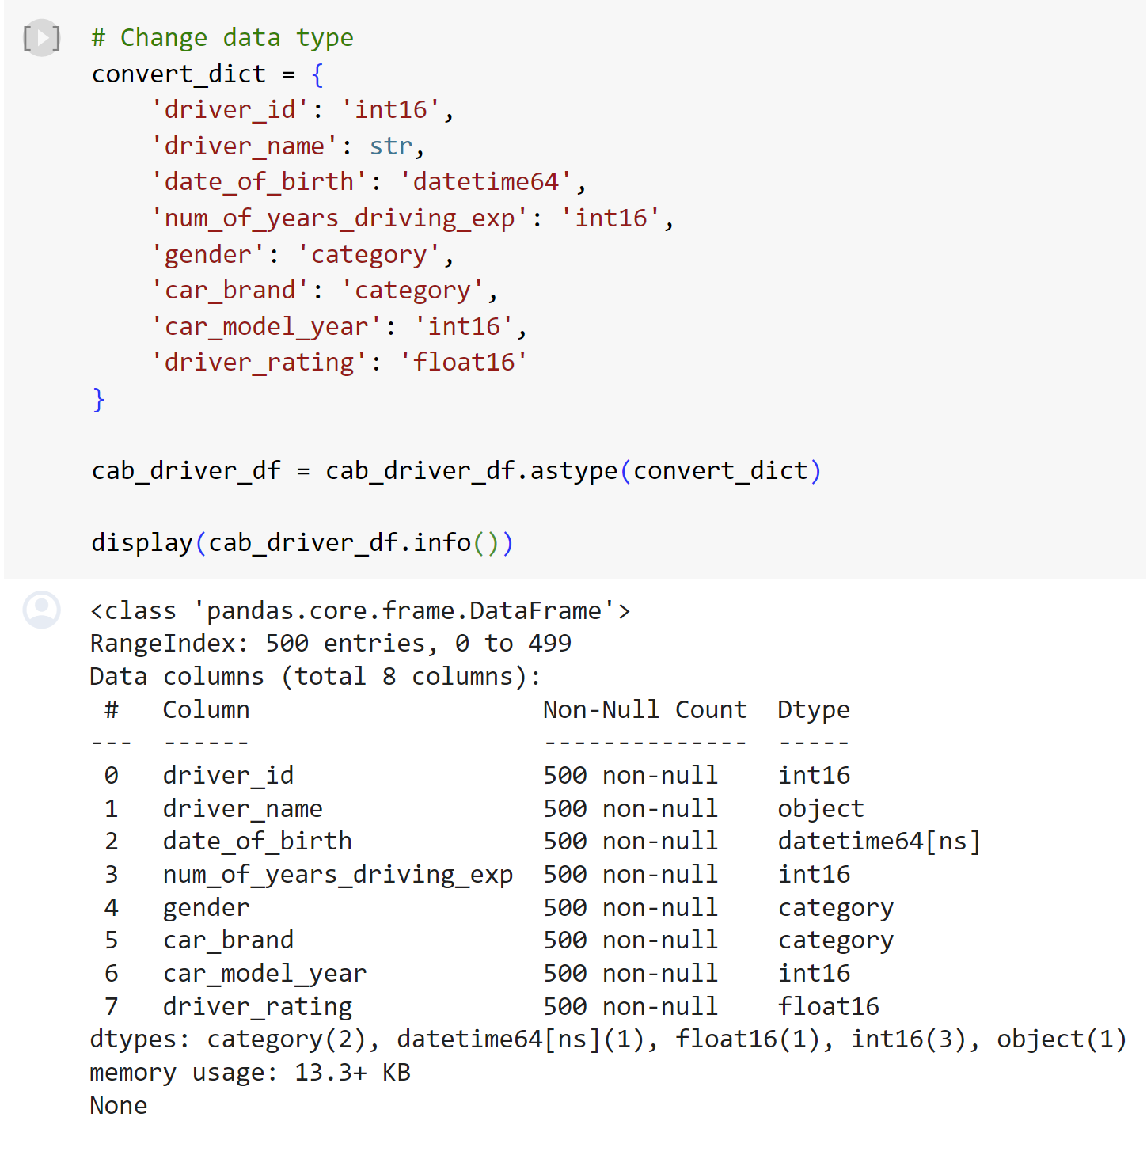 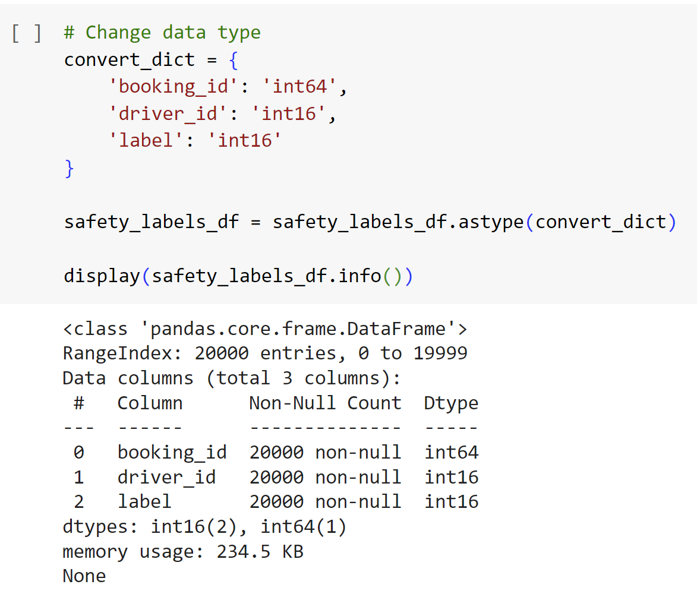

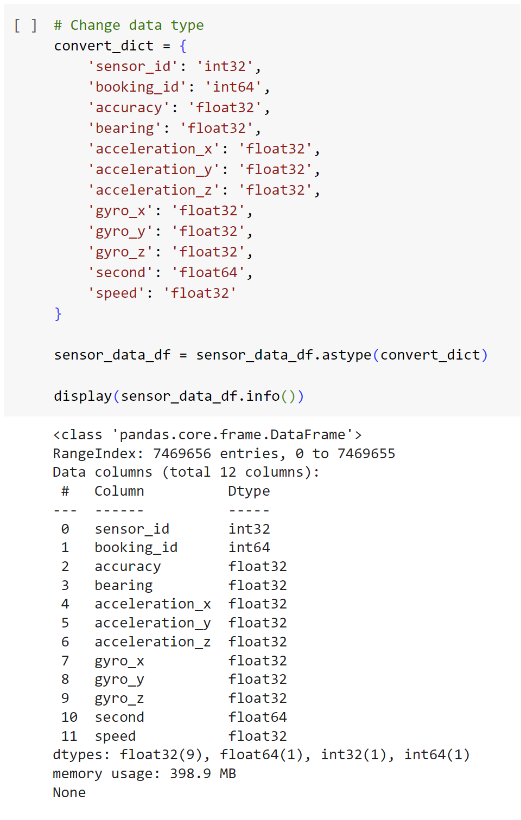

Merging Datasets (Sensors Data & Safety Labels)



Before removal of extreme data for seconds

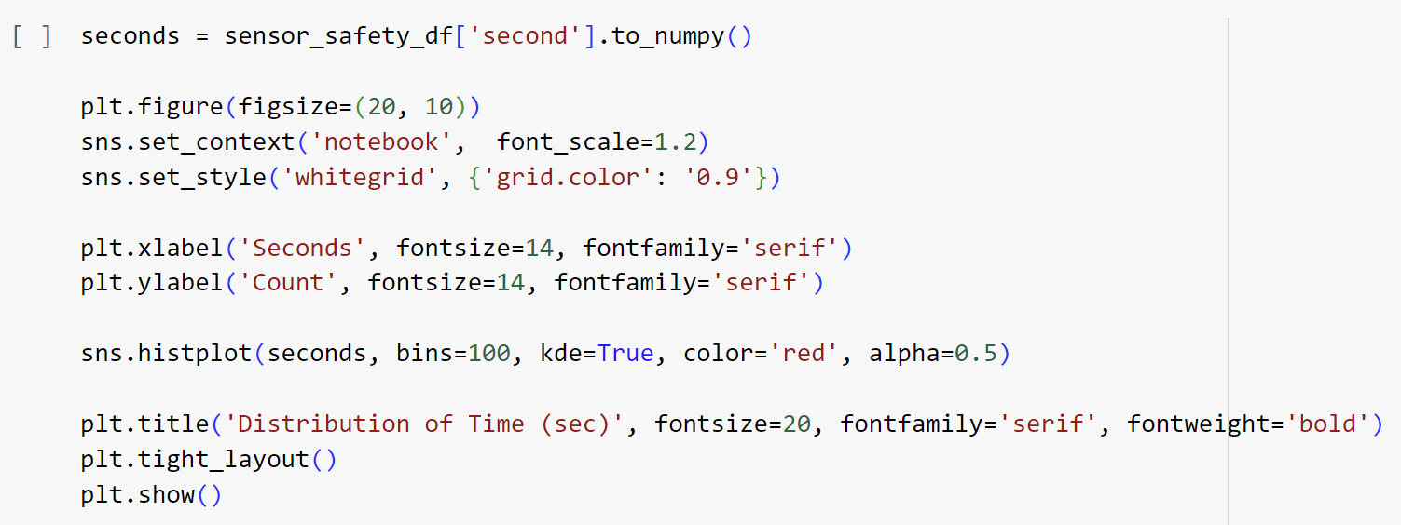

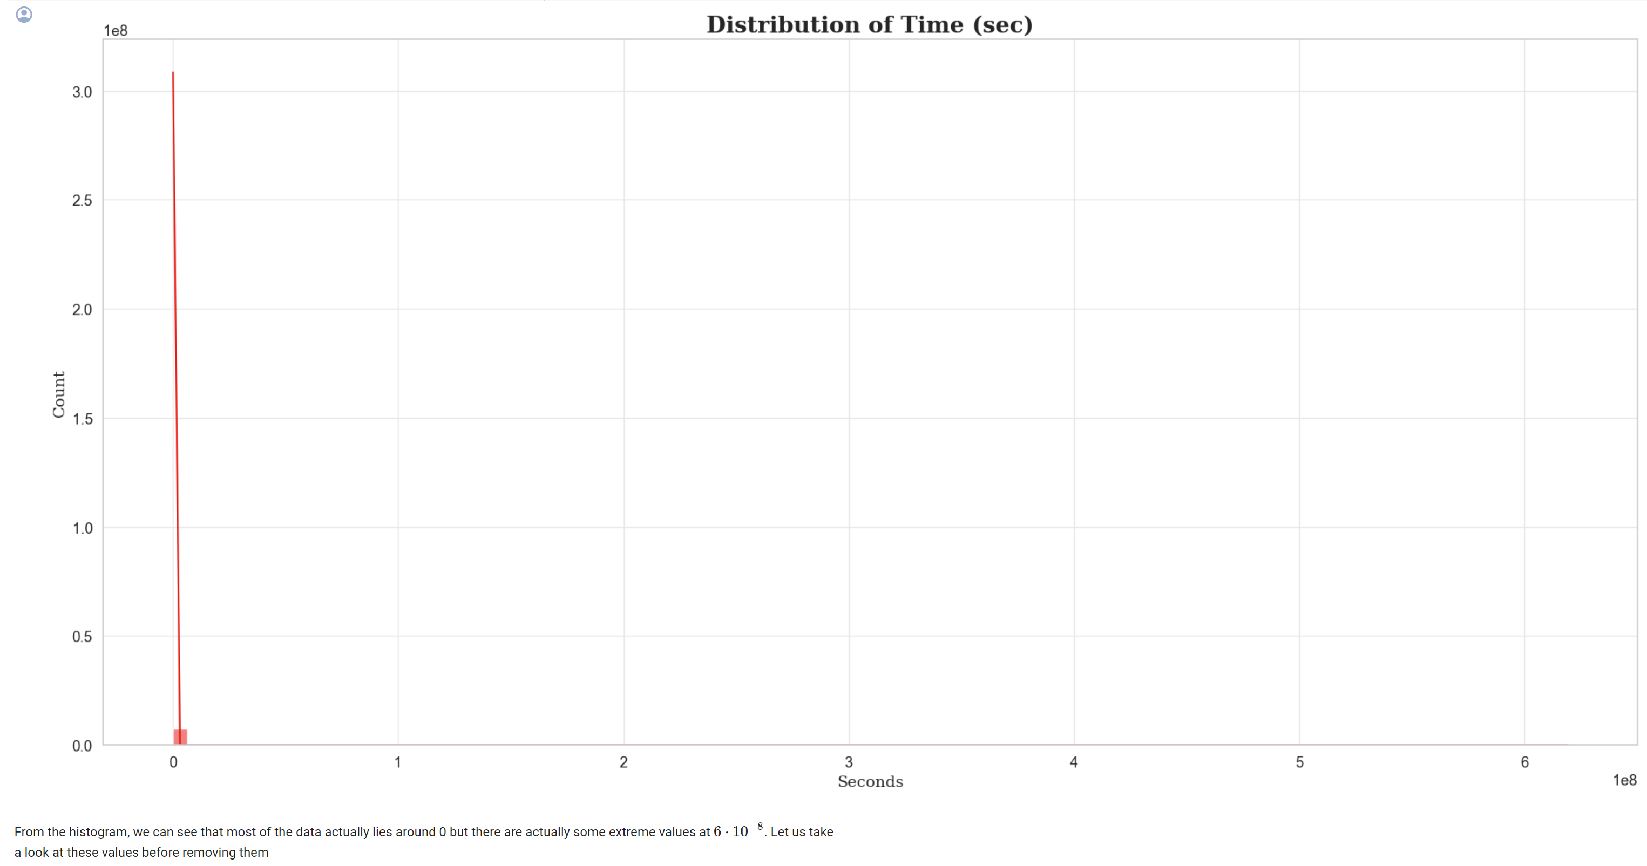

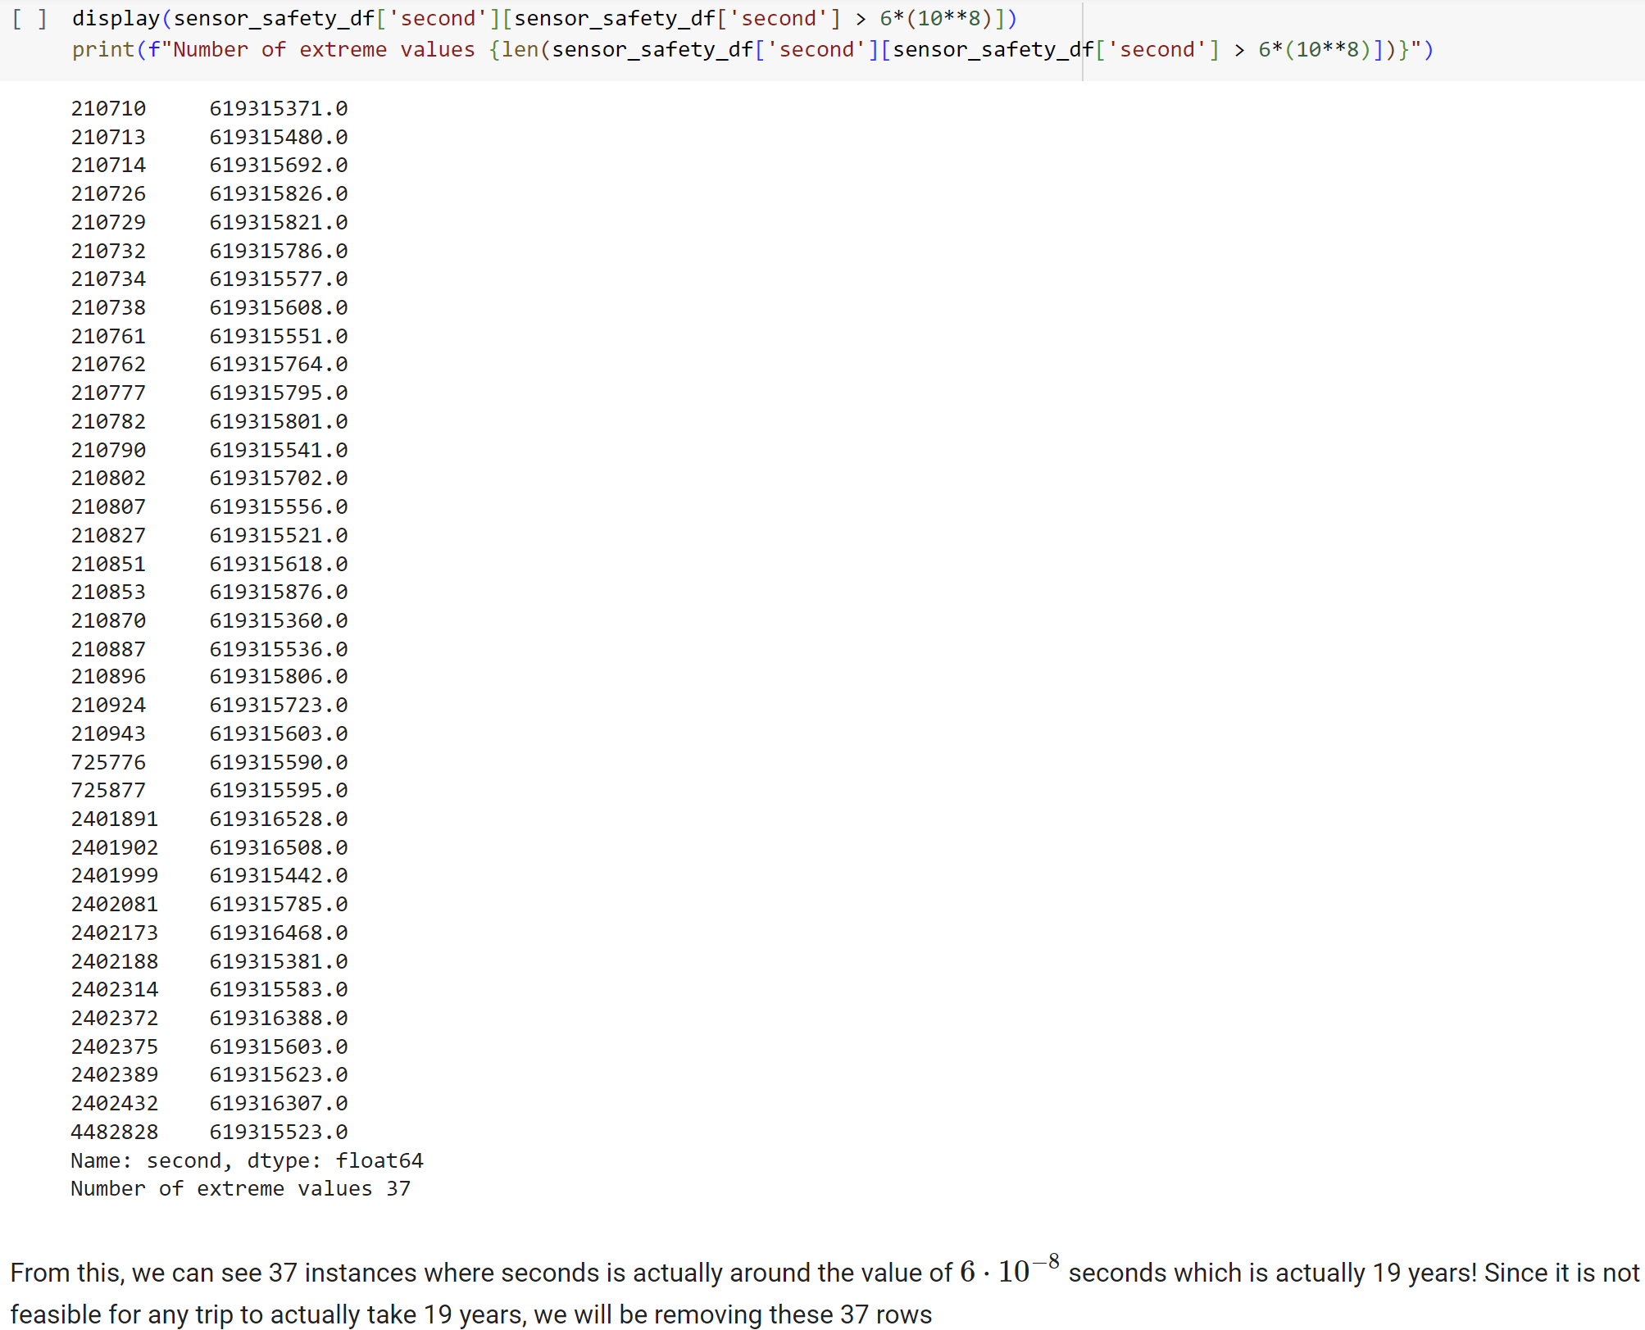



After removal of extreme values for seconds

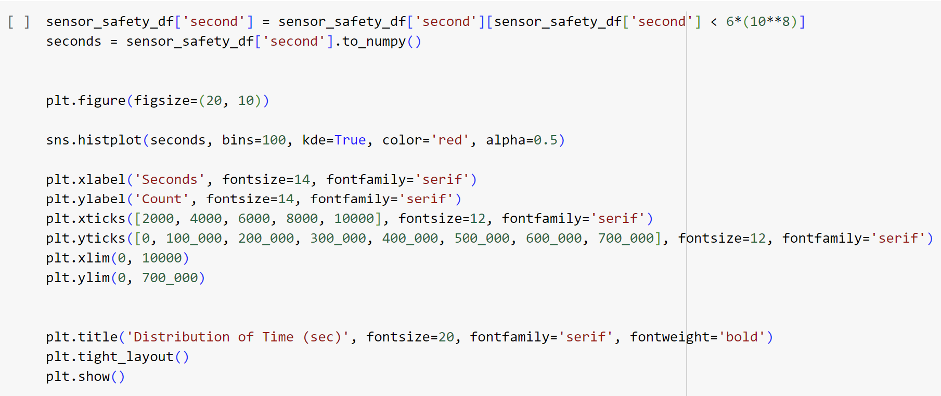

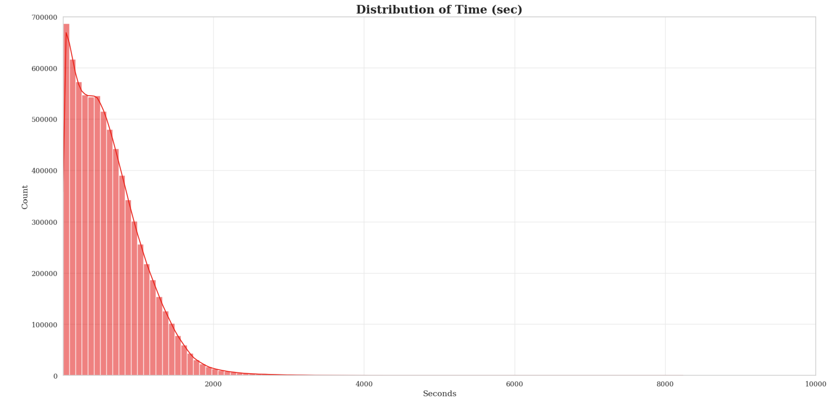

Conversion of m/s to km/h – Singapore main unit used for speed

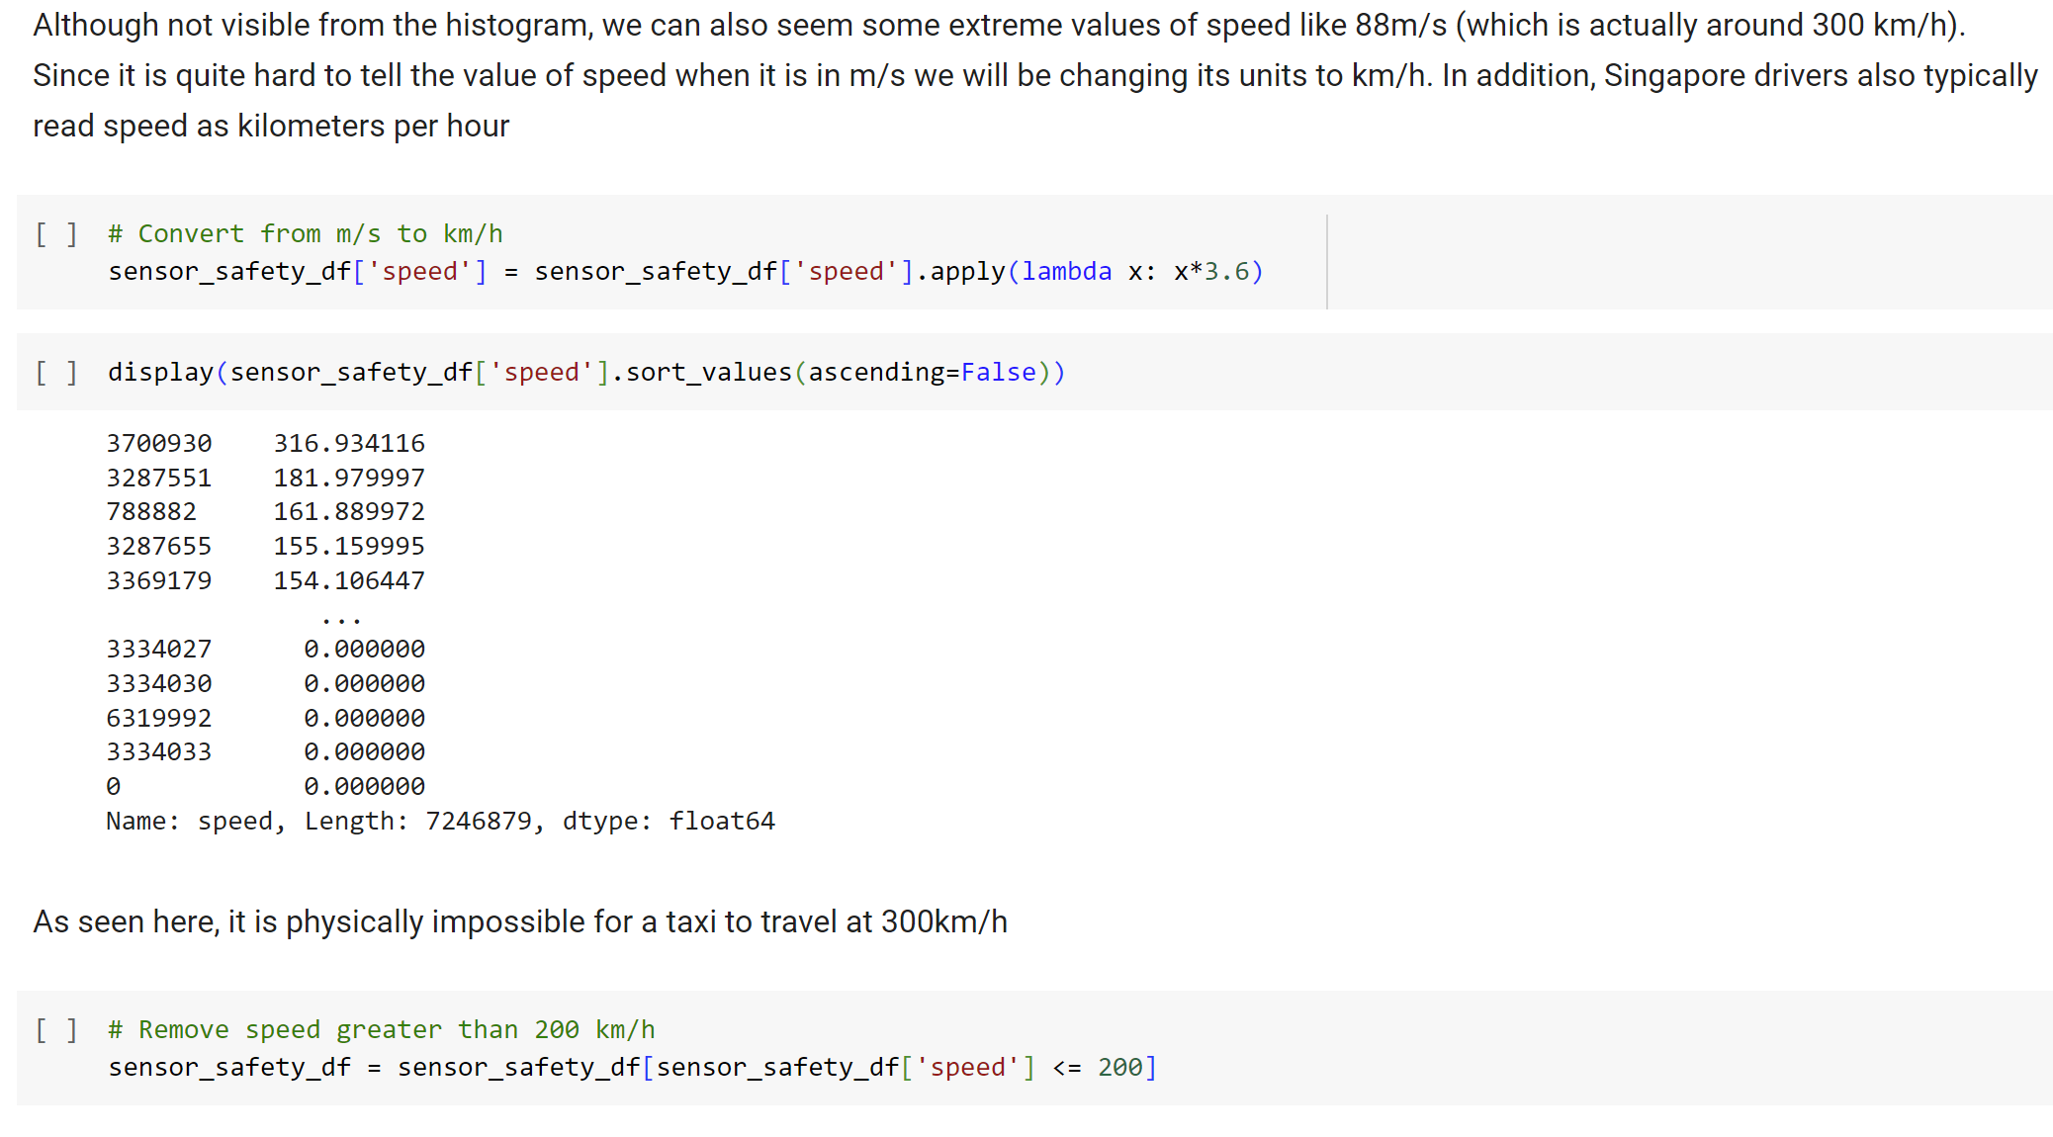

Removal of extreme values for speed – negative values and 300km/h



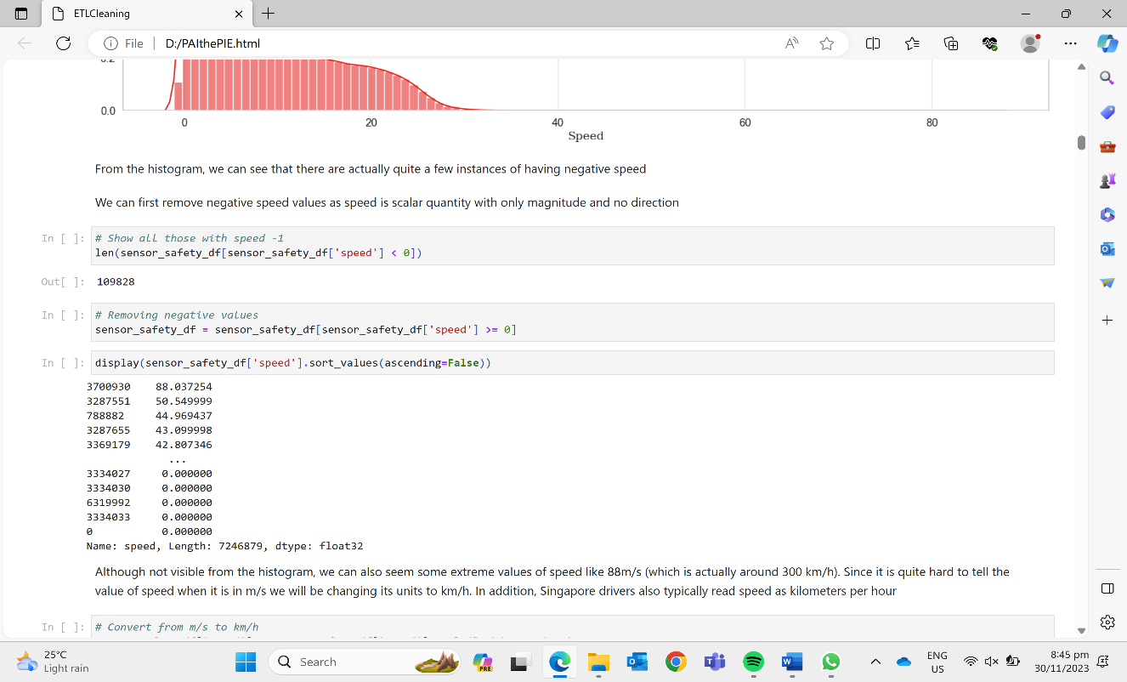

Handling Missing Values - Interpolation of Values by Seconds

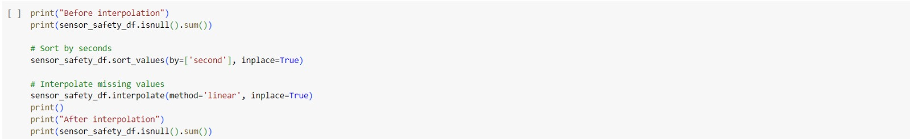

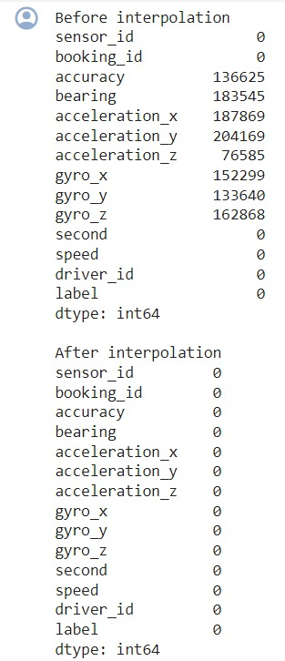 

222,777 from seconds column removed.

120,193 from speed column removed.

Total rows removed: 342,970.

4.2 Feature Engineering

The team has formulated new columns based on existing columns.

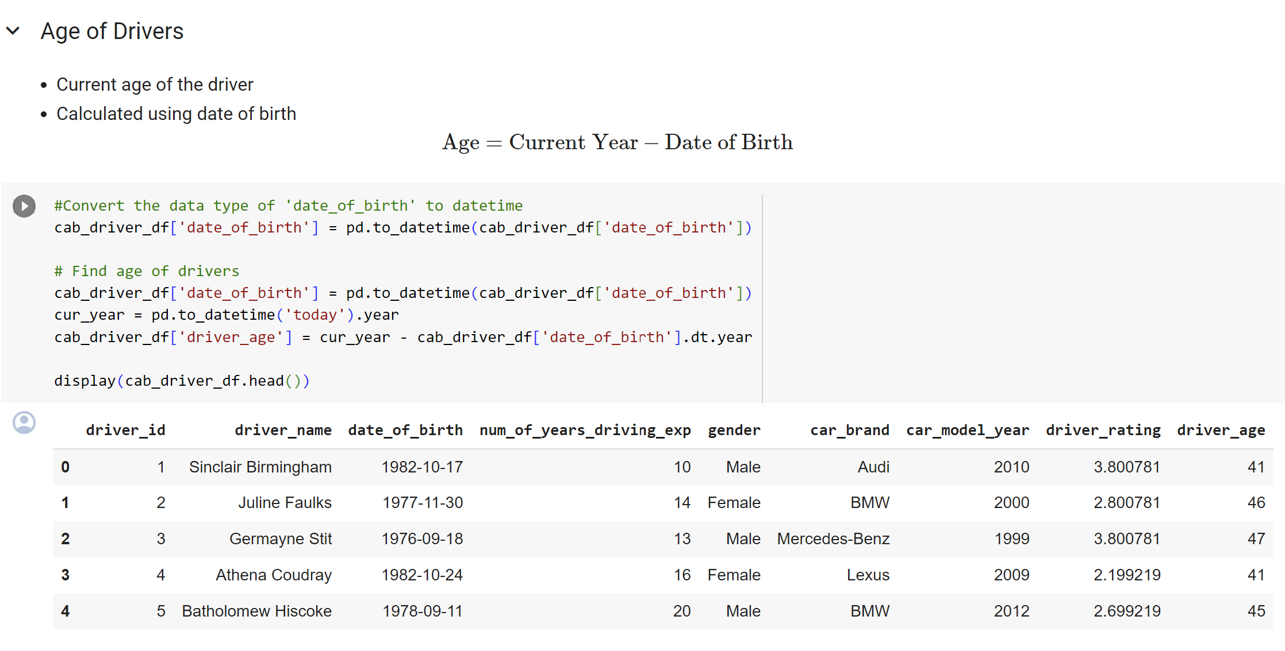 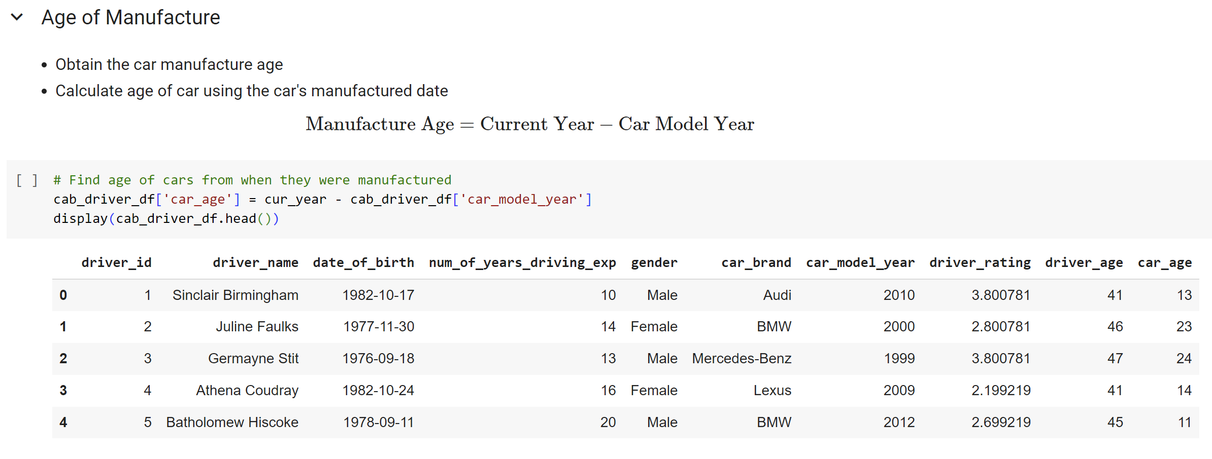

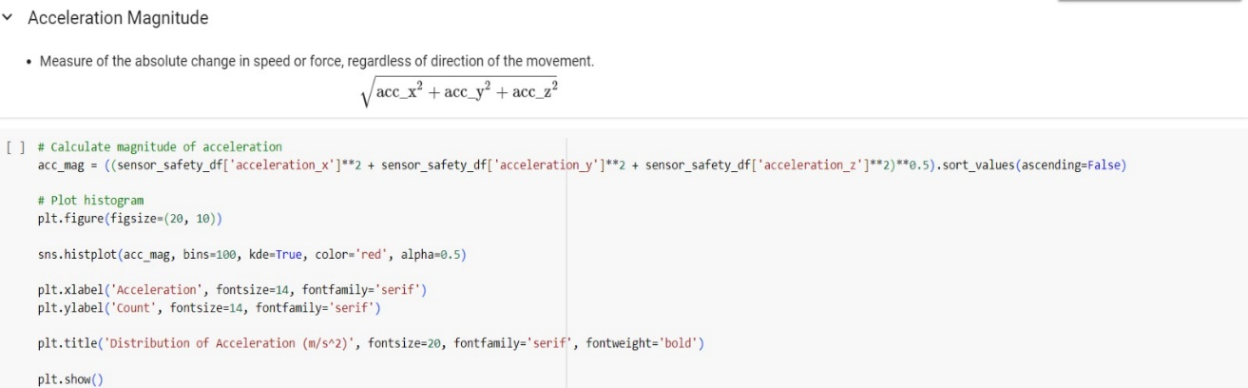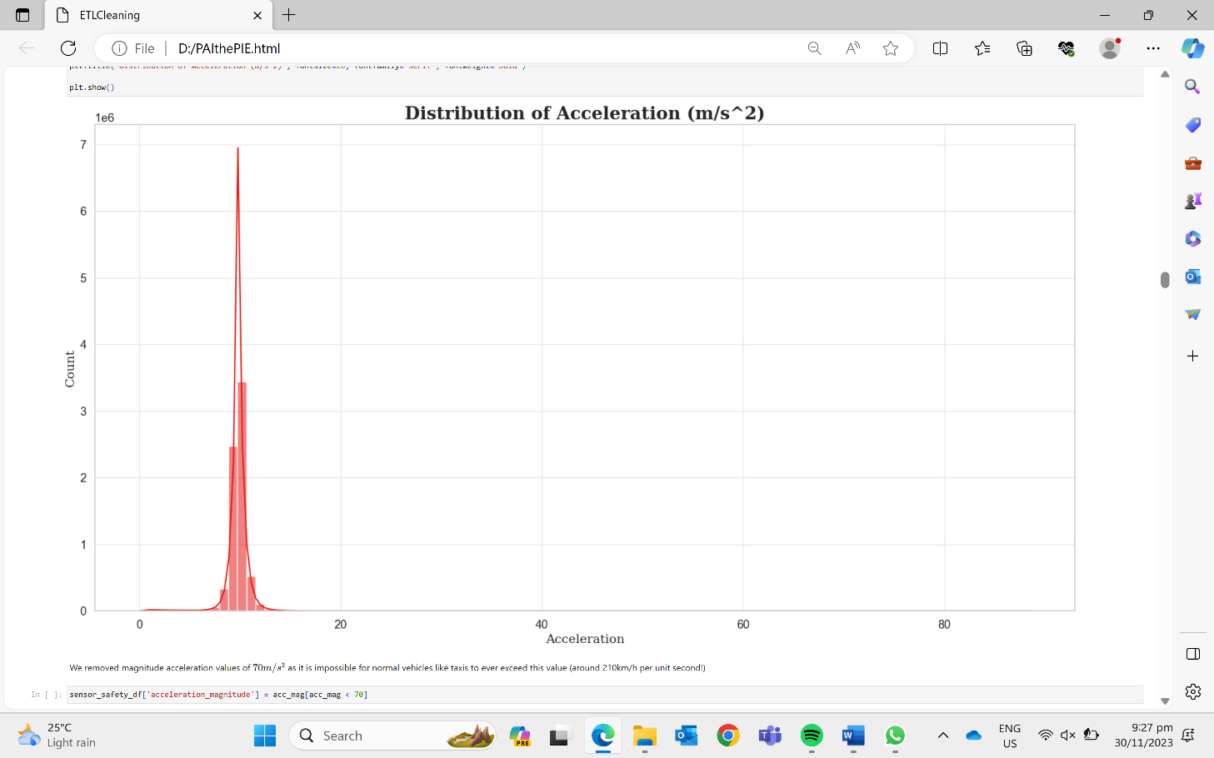

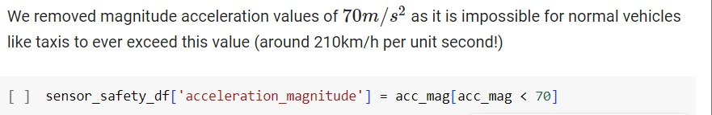

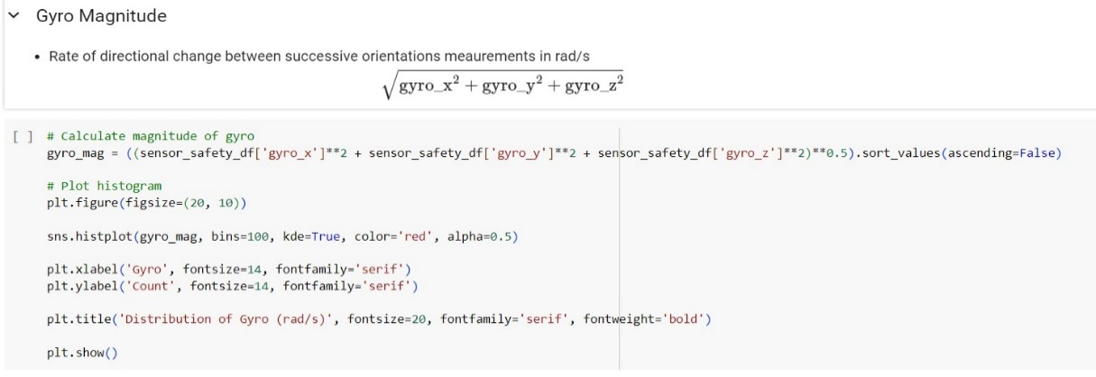

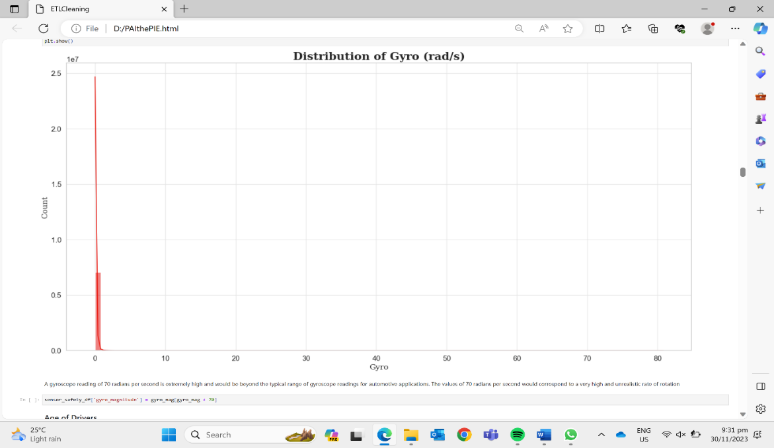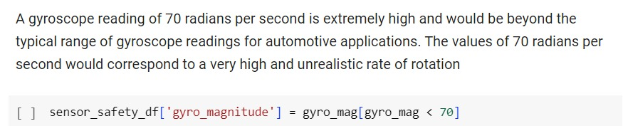

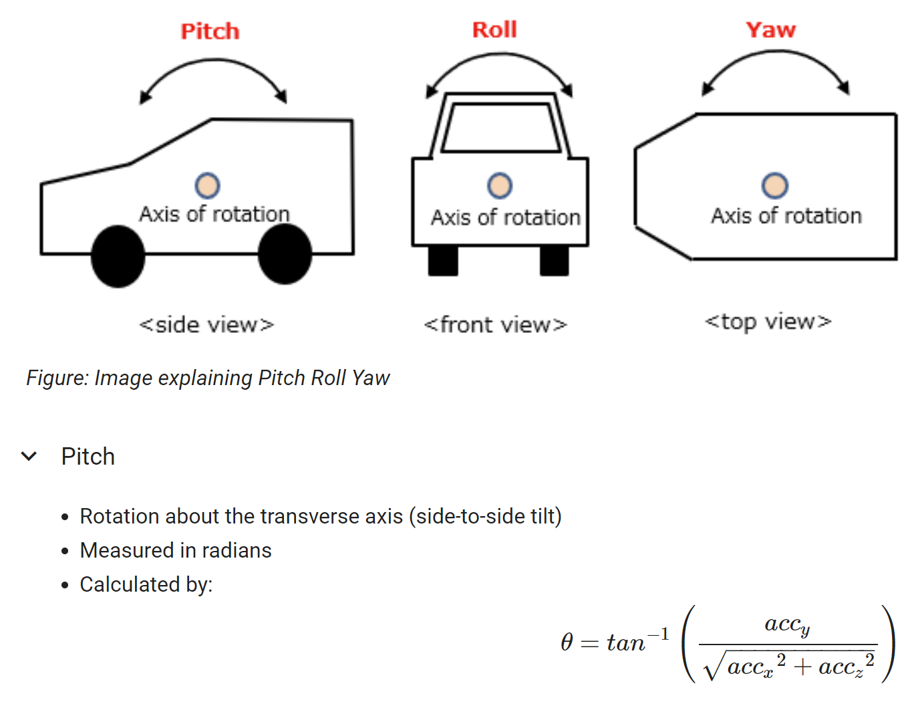

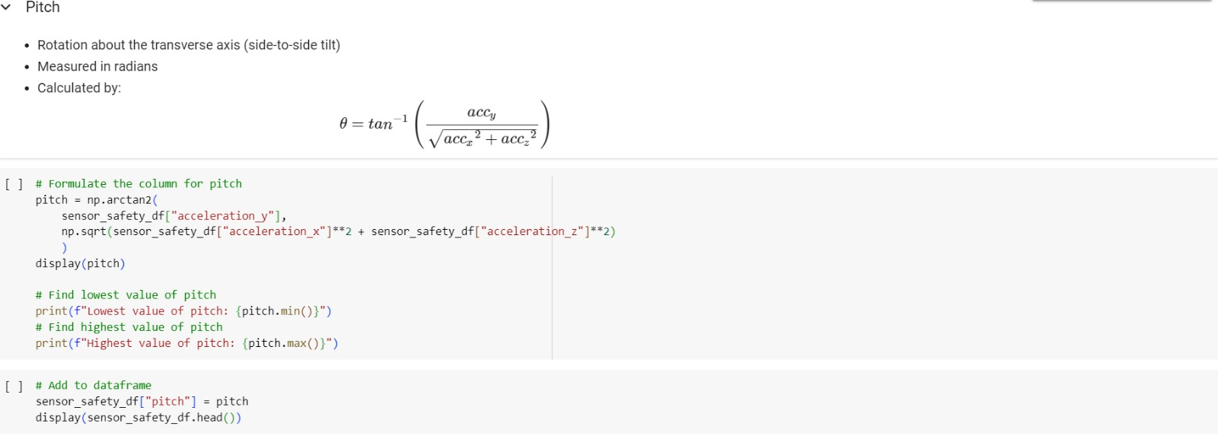 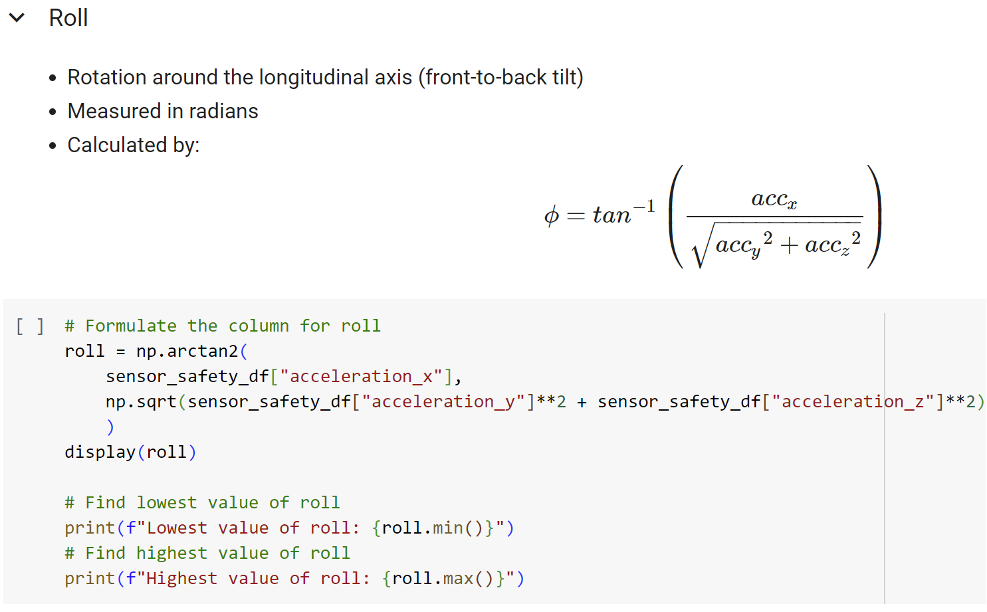

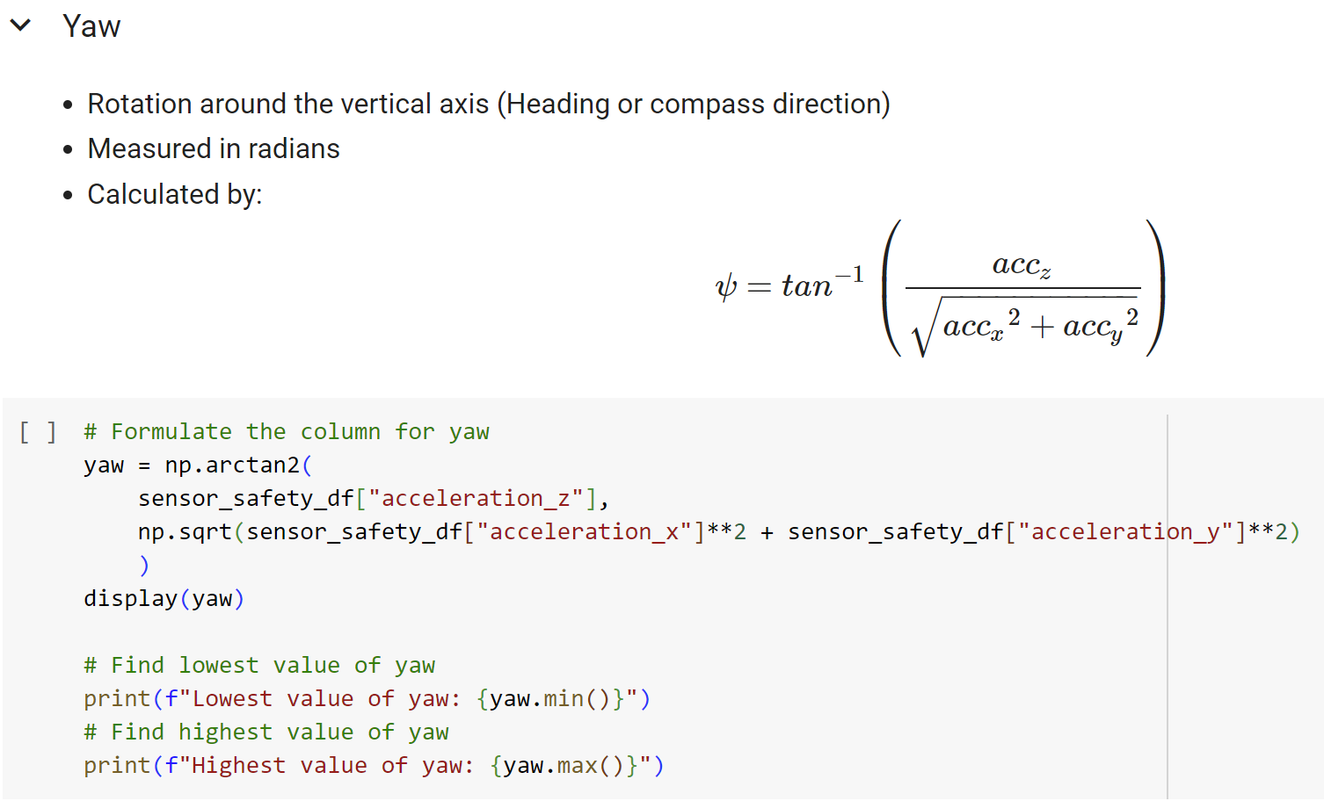 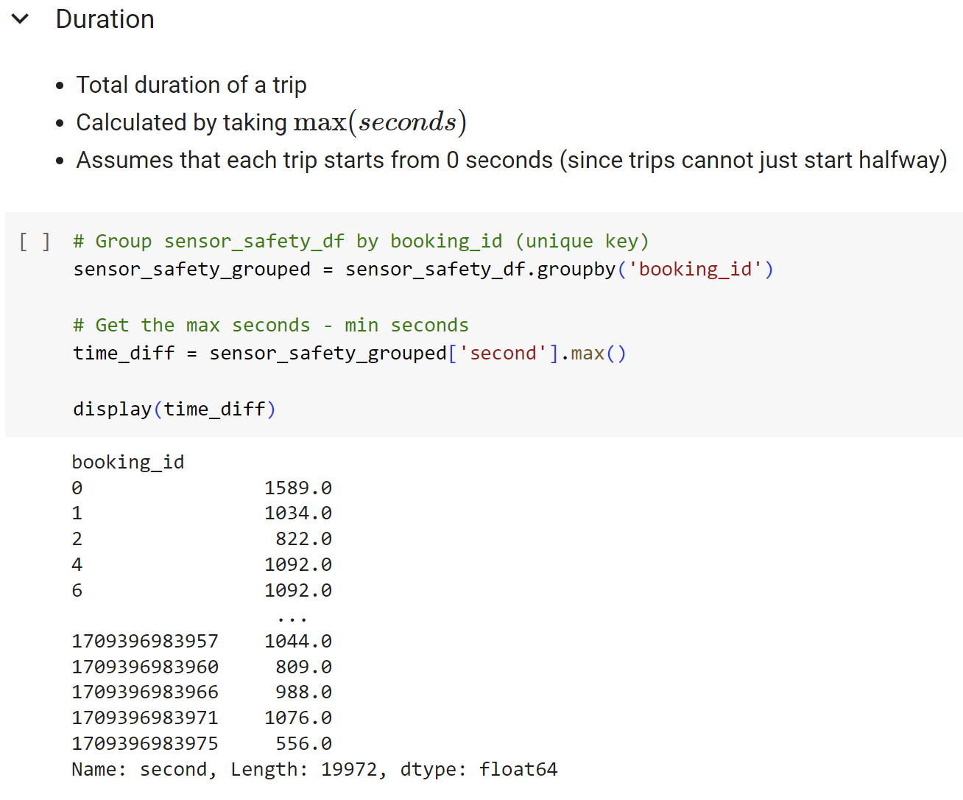

Duration

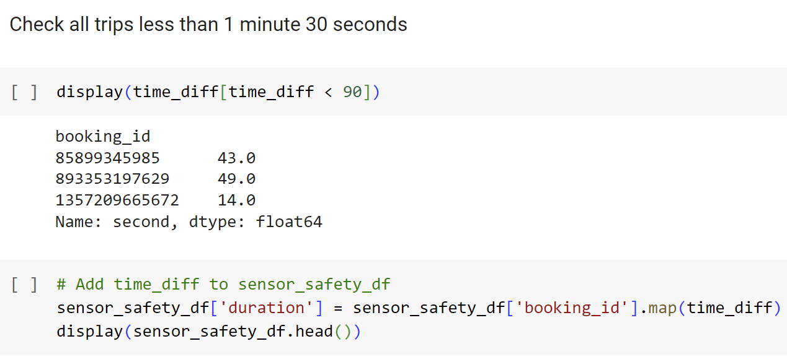

Distribution of Duration

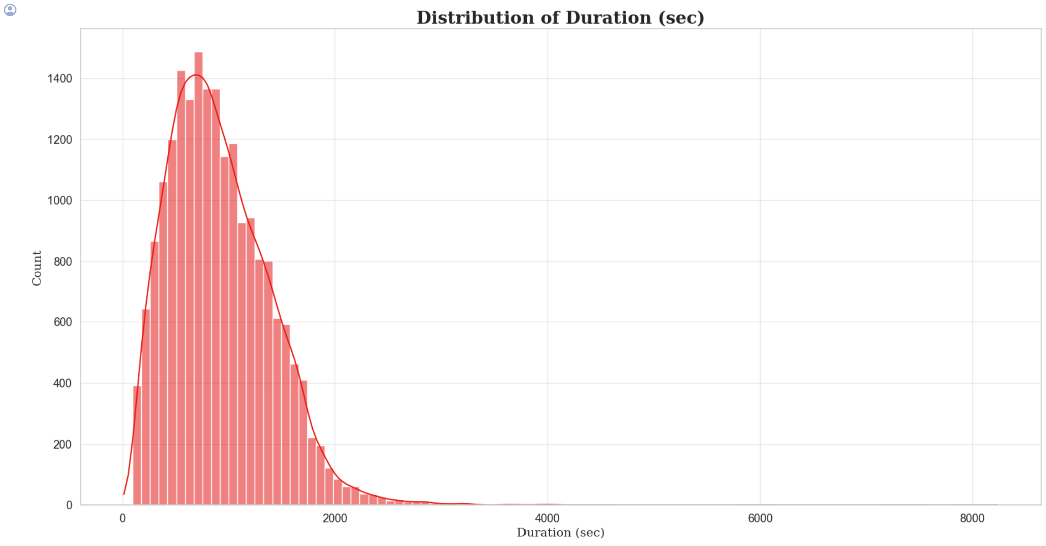

**Insight:** Majority of the trips took around 33.333 minutes long and few trips surpassed the 2000 sec limit, since the distribution of duration is negatively skewed.

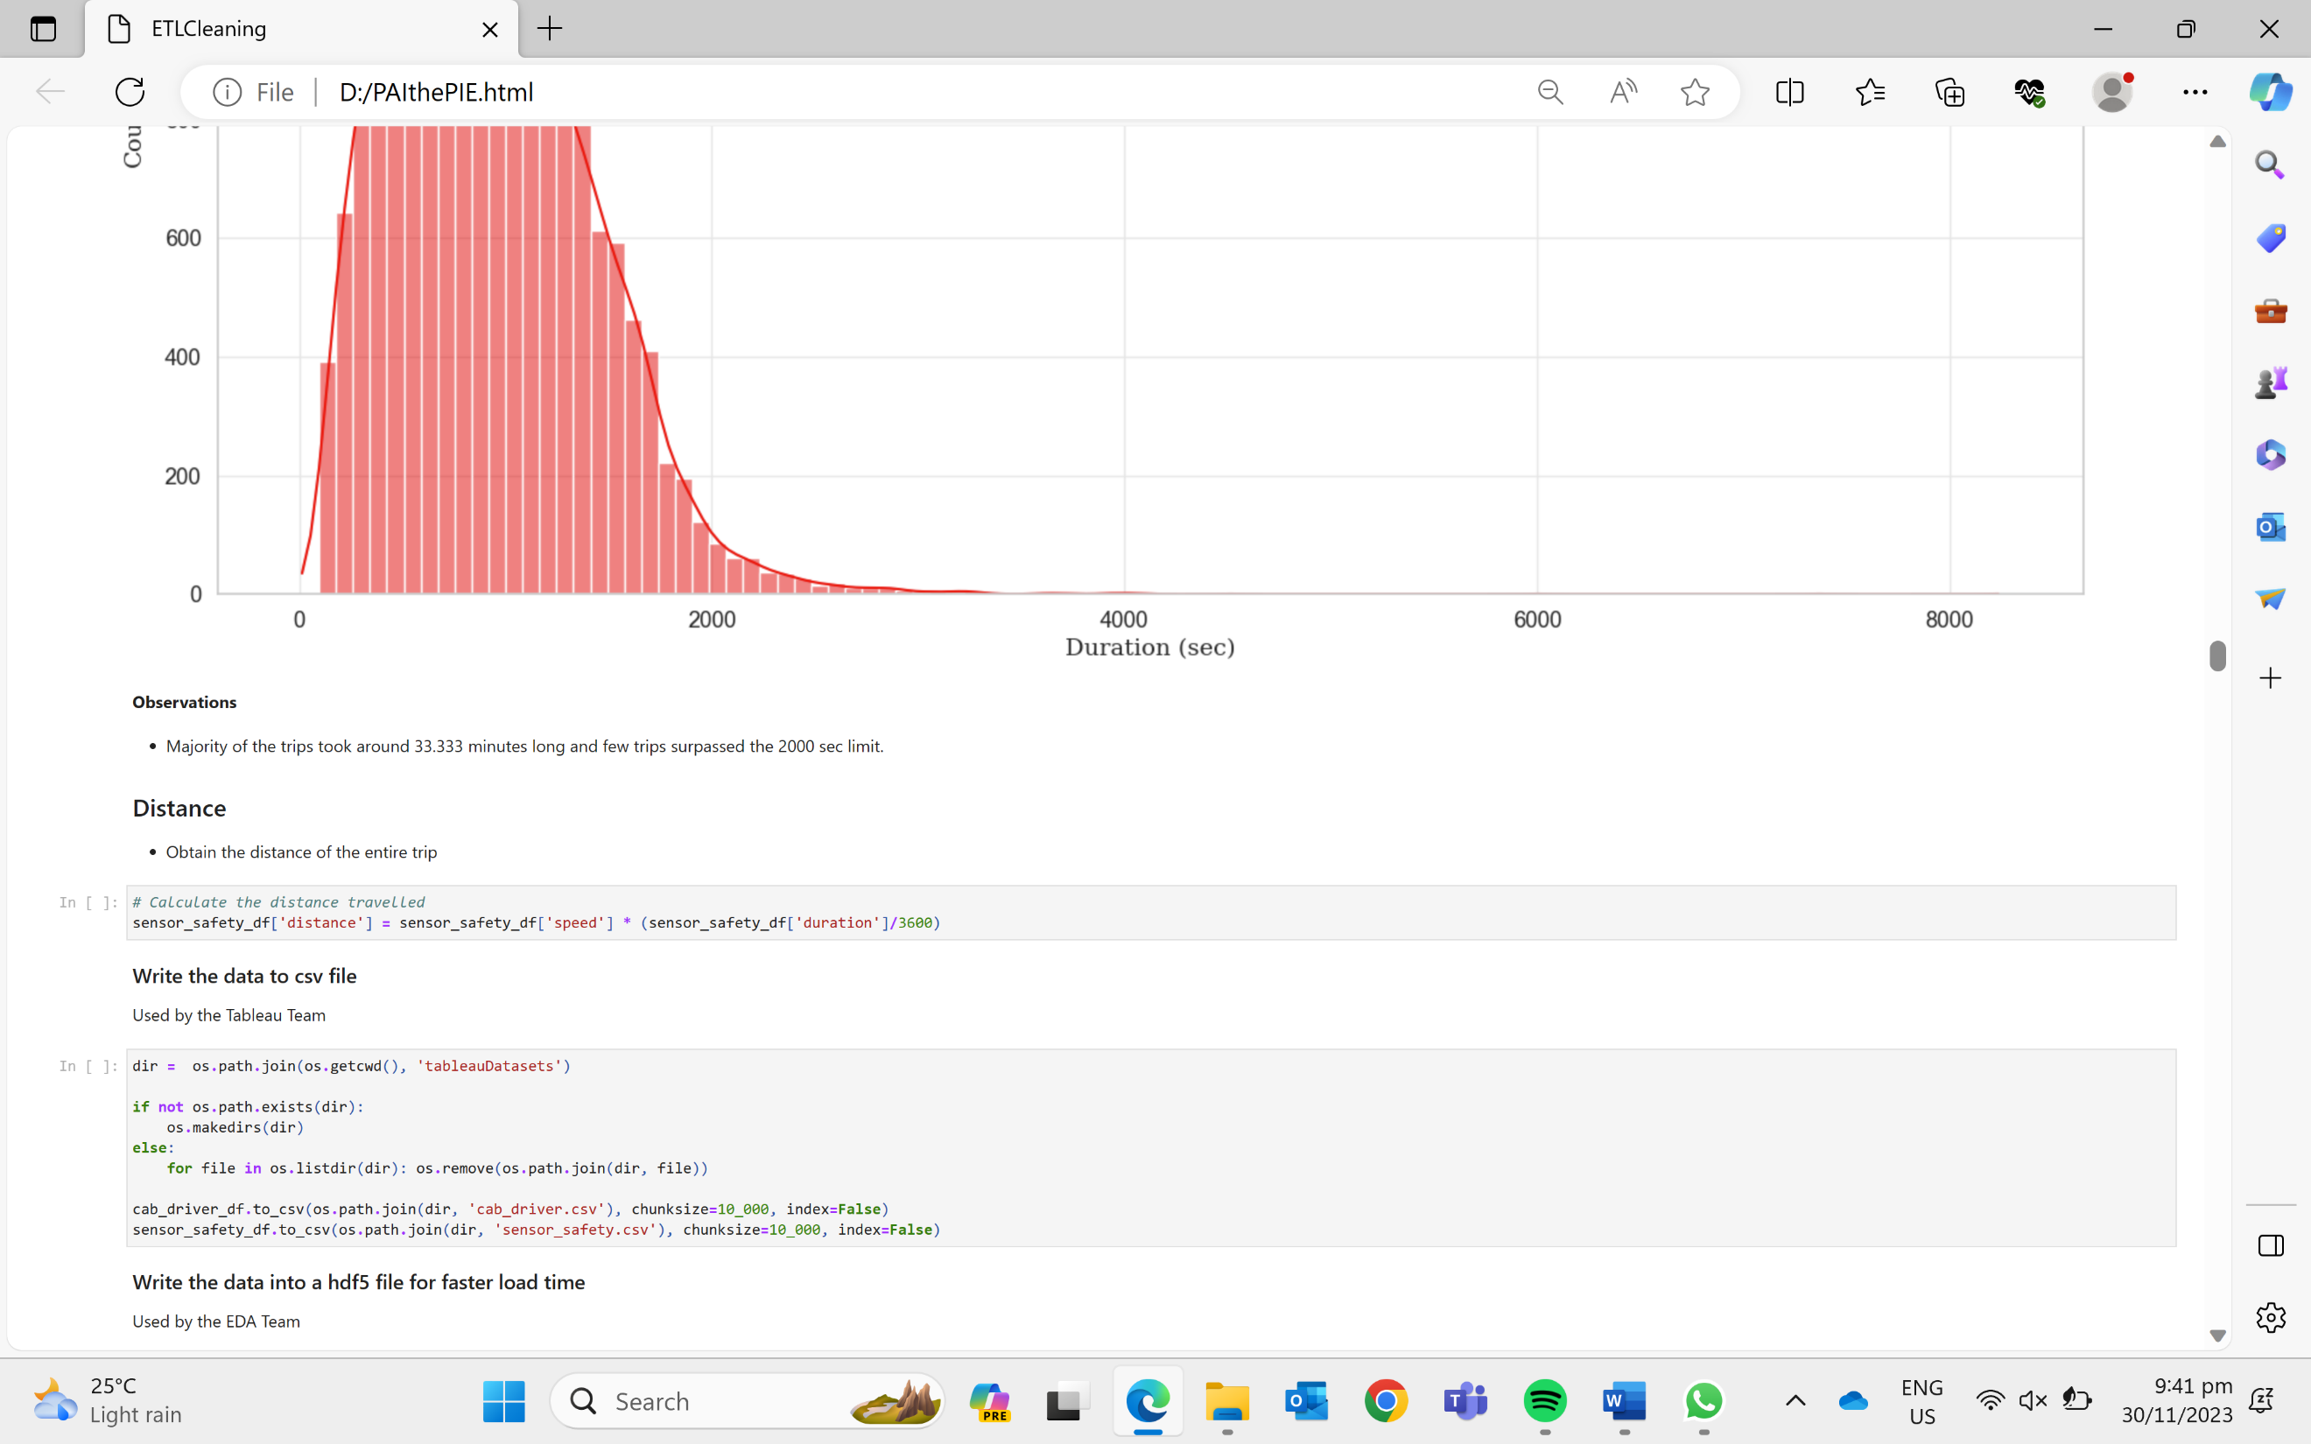

Writing of output to hdf5 file (faster load time) and csv file (Tableau)

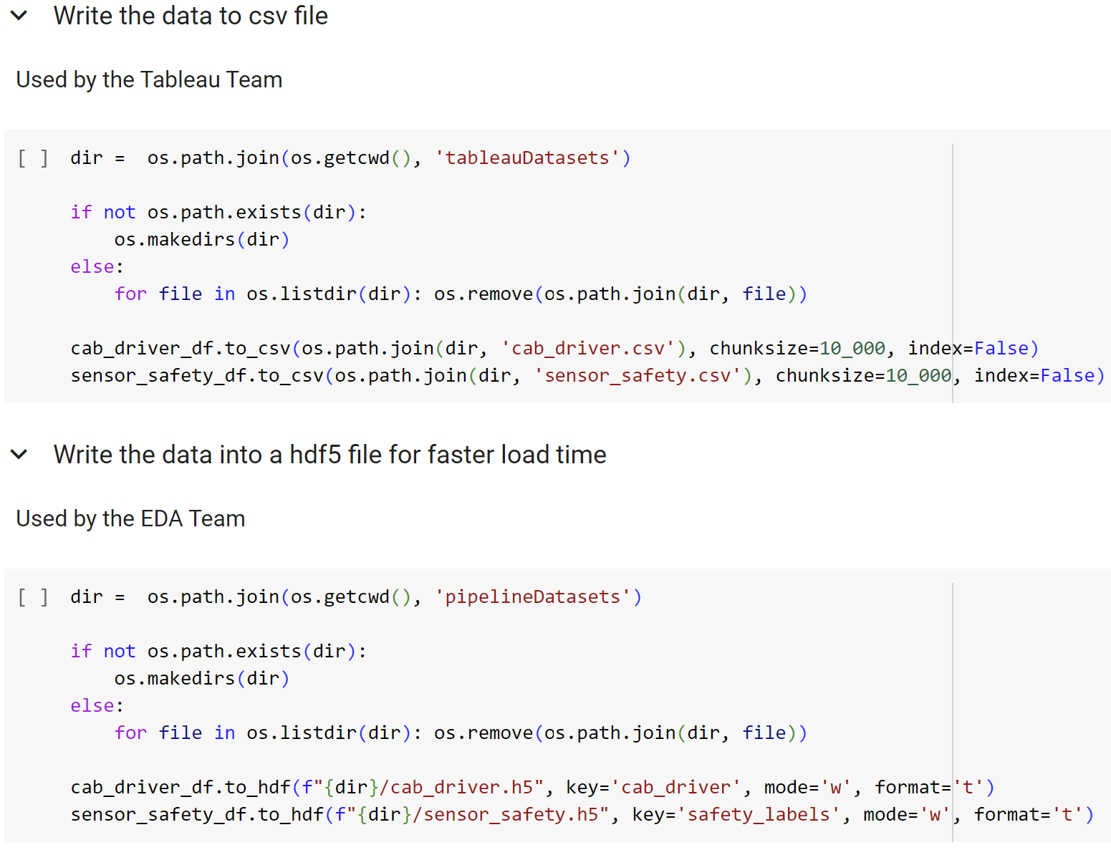



Read hdf5 file as chunk size – Faster load

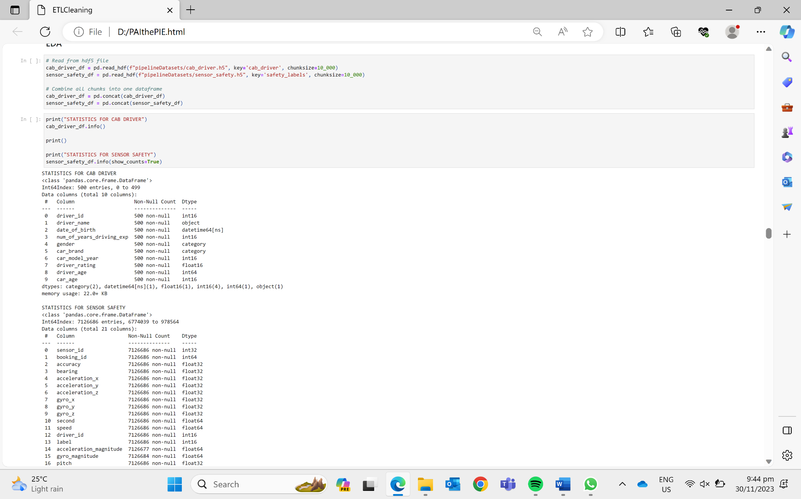

4.3 Exploratory Data Analysis

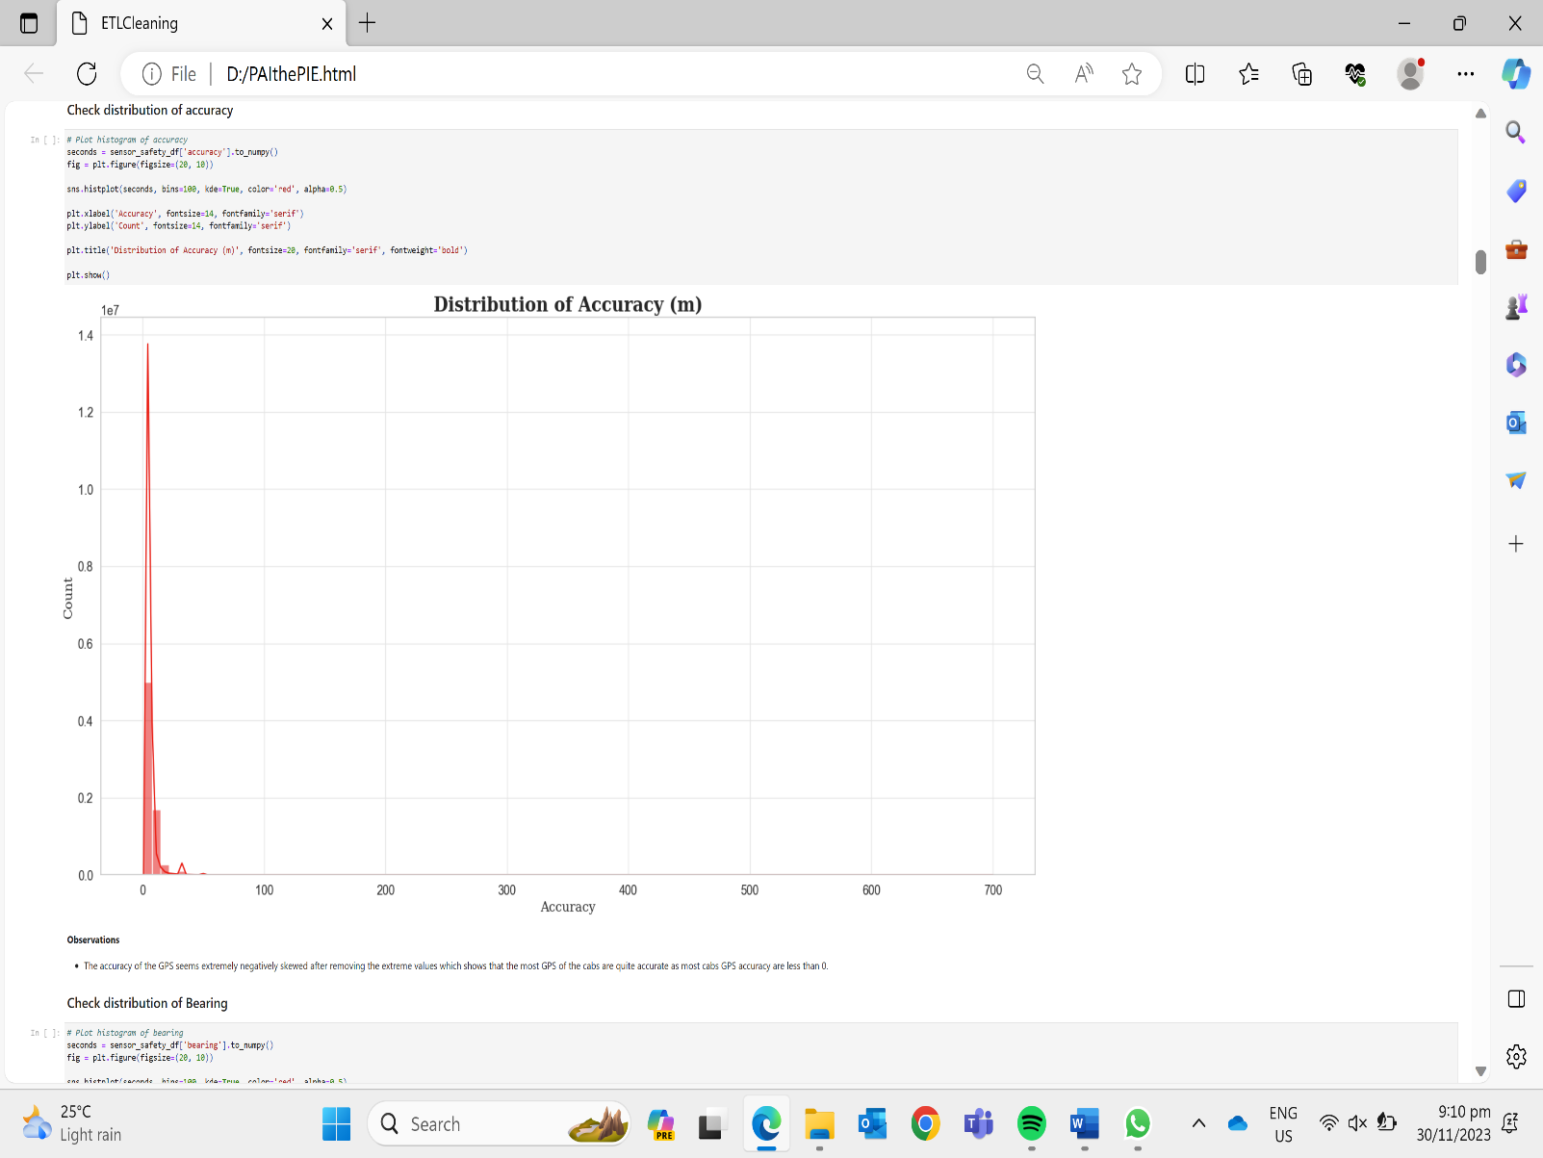

**Insight:** The accuracy of the GPS seems extremely negatively skewed which shows that the most GPS of the cabs are quite accurate as most cabs GPS accuracy are less than 0.

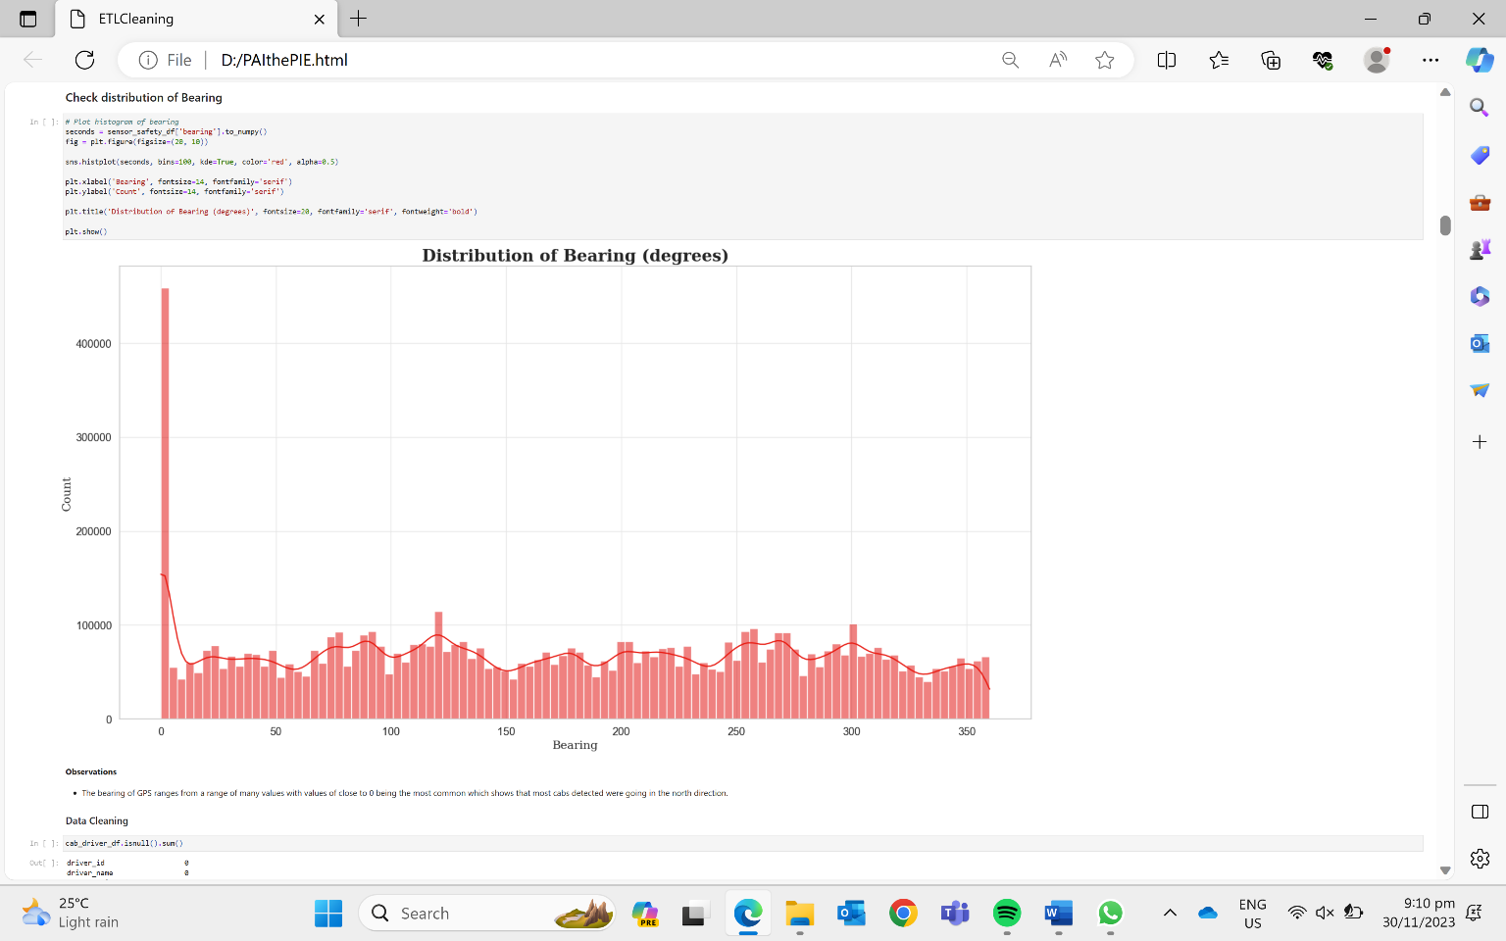

**Insight:** The bearing of GPS ranges from a range of many values with values of close to 0 being the most common which shows that most cabs detected were going in the north direction.

Statistical Description (Cab Driver)

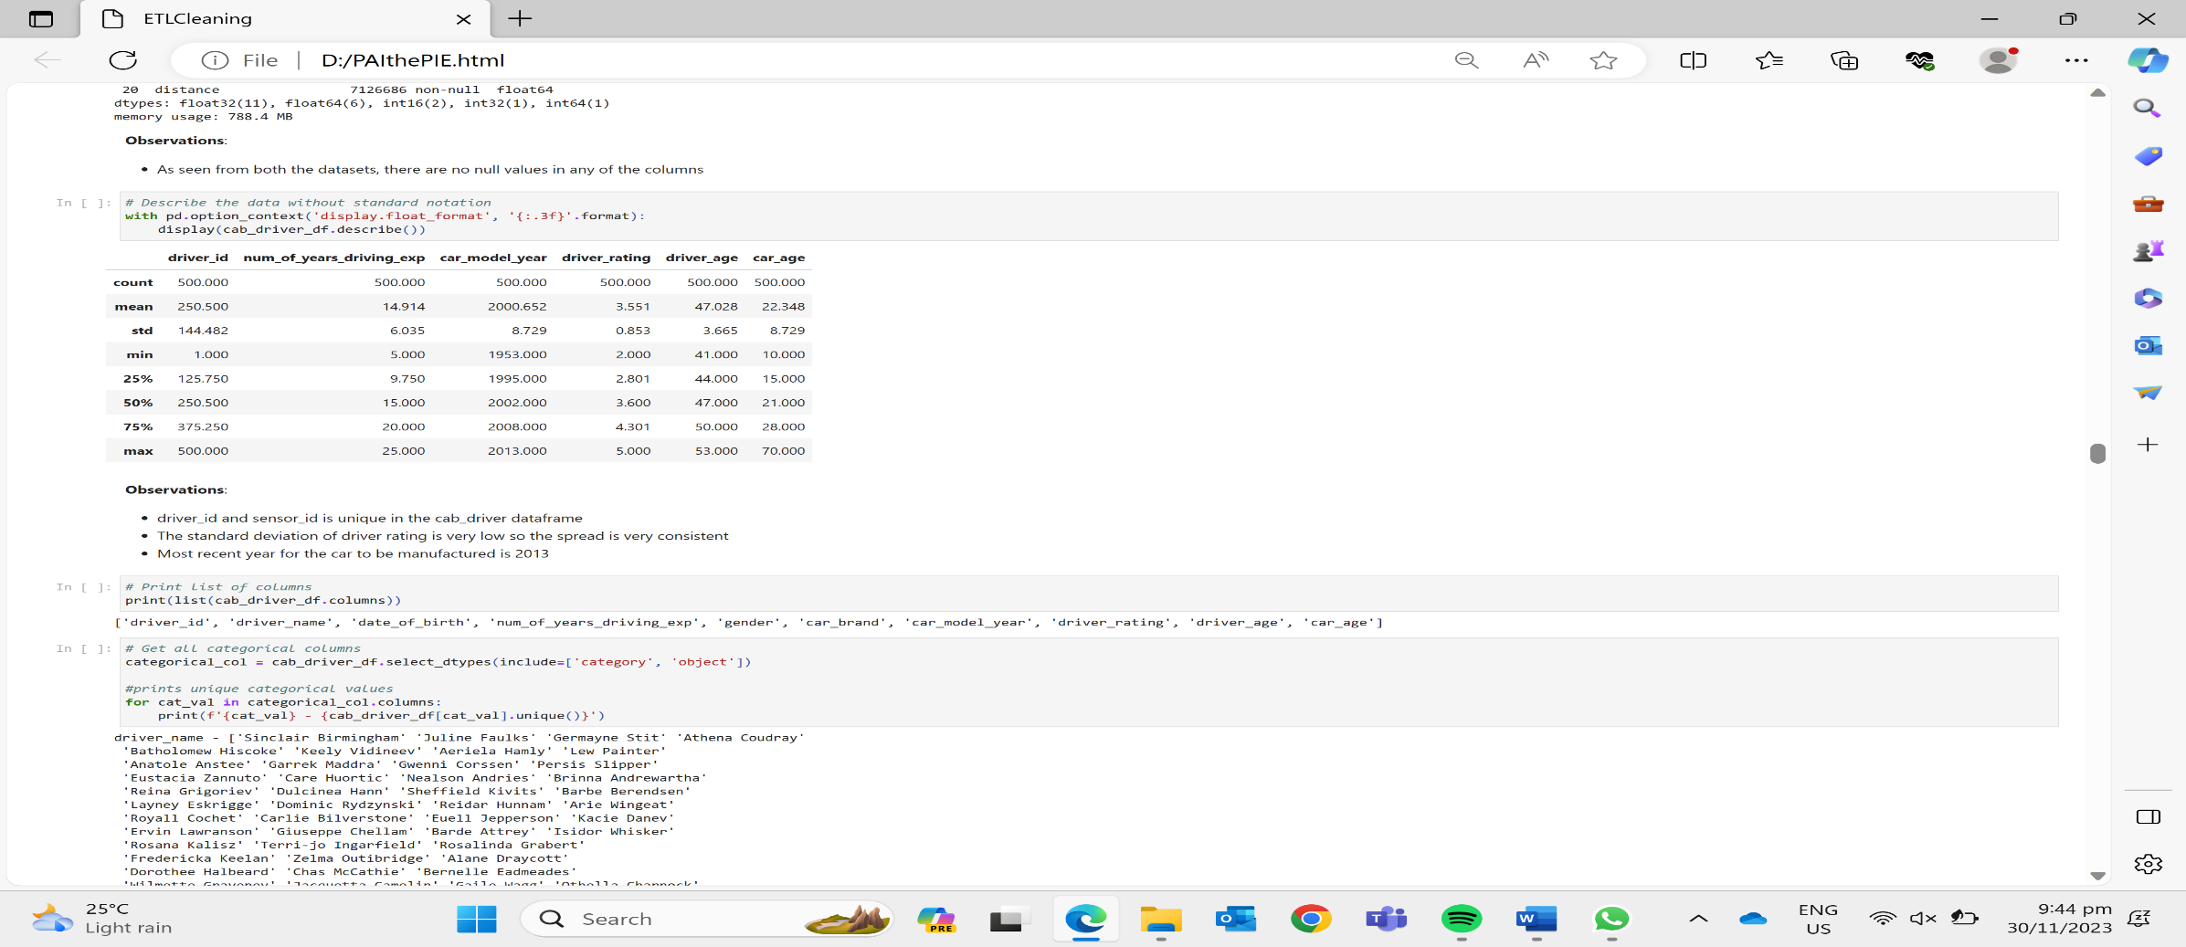

Statistical Description (Sensor Data + Safety Labels)

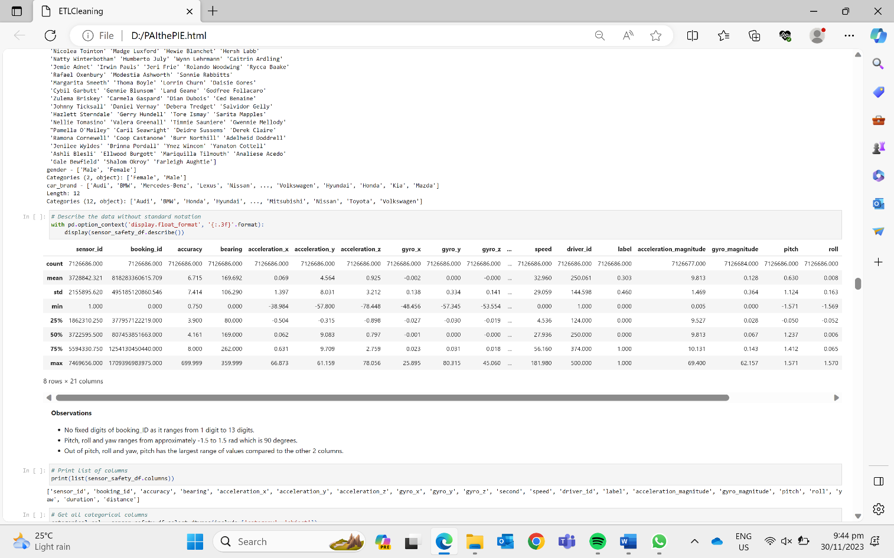

Unique Categorical Variables (Cab Driver)

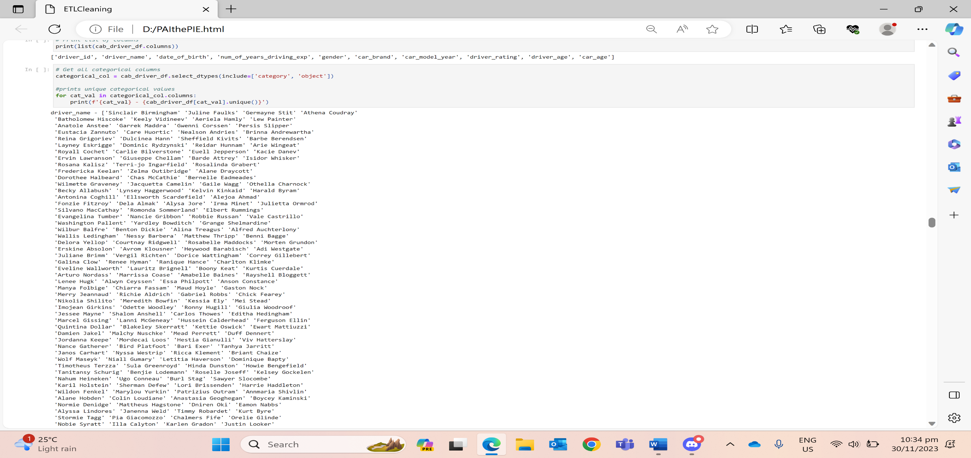

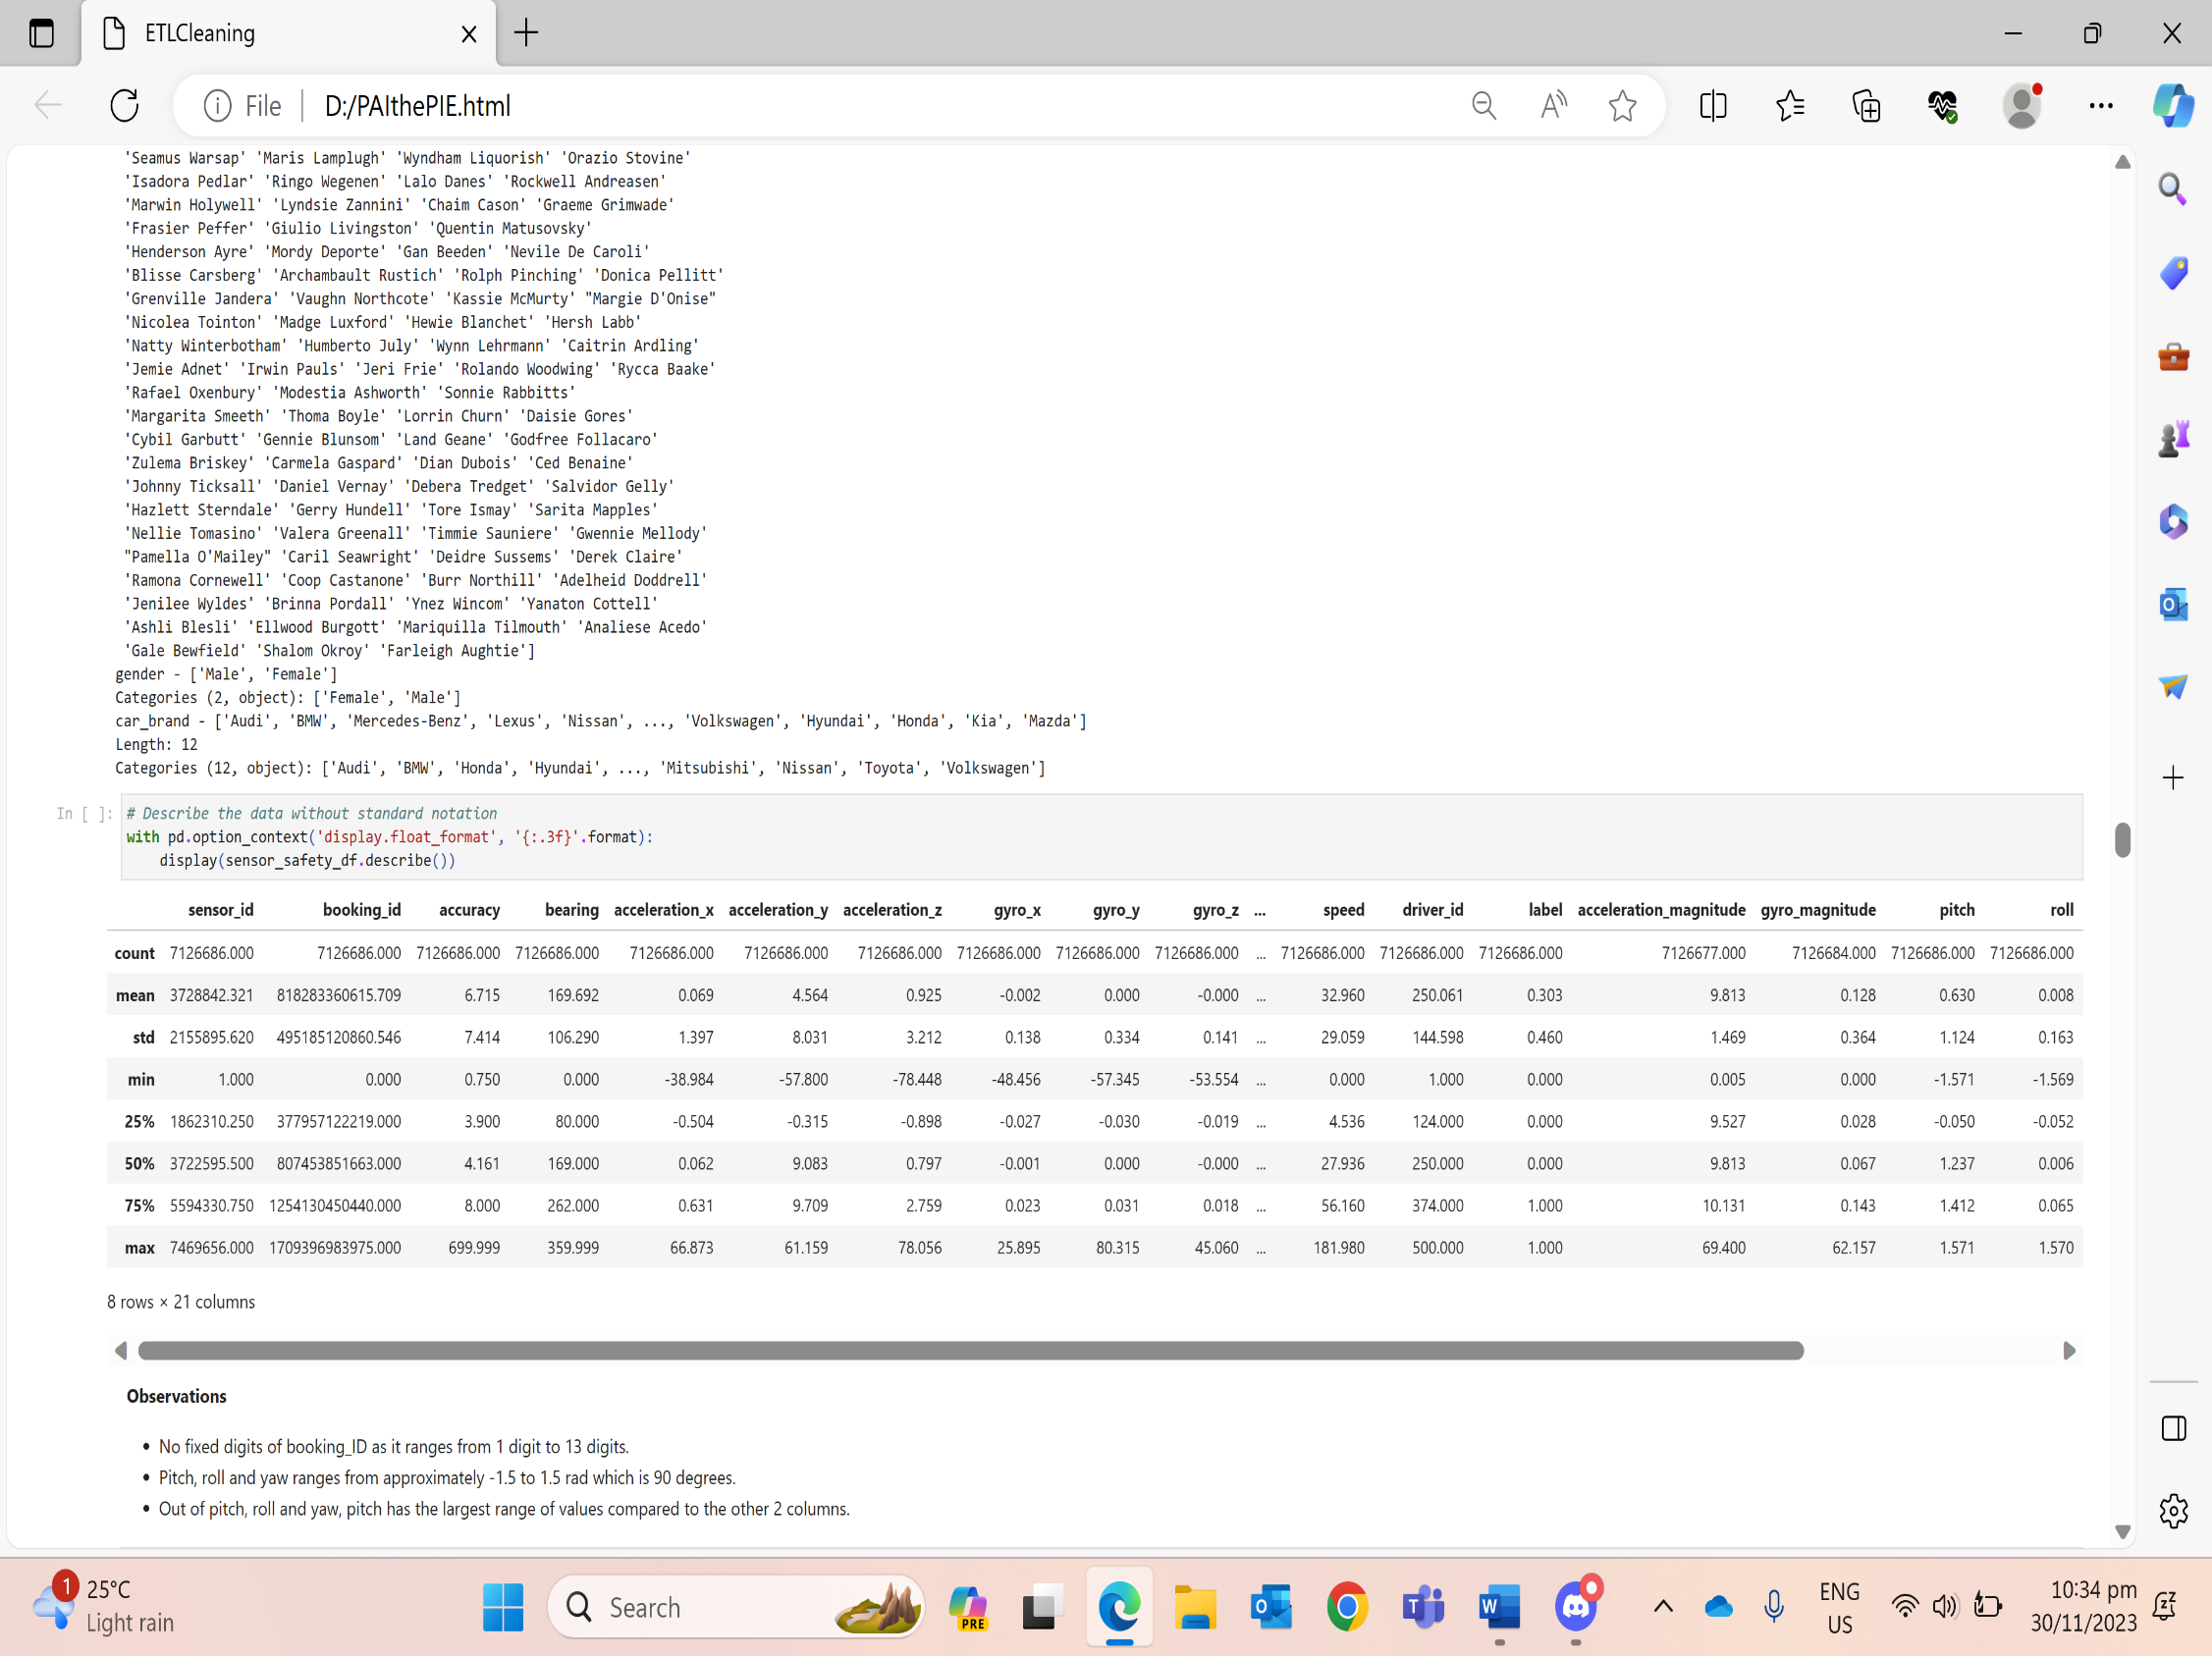

Unique Categorical Variables (Sensor Data + Safety Labels)

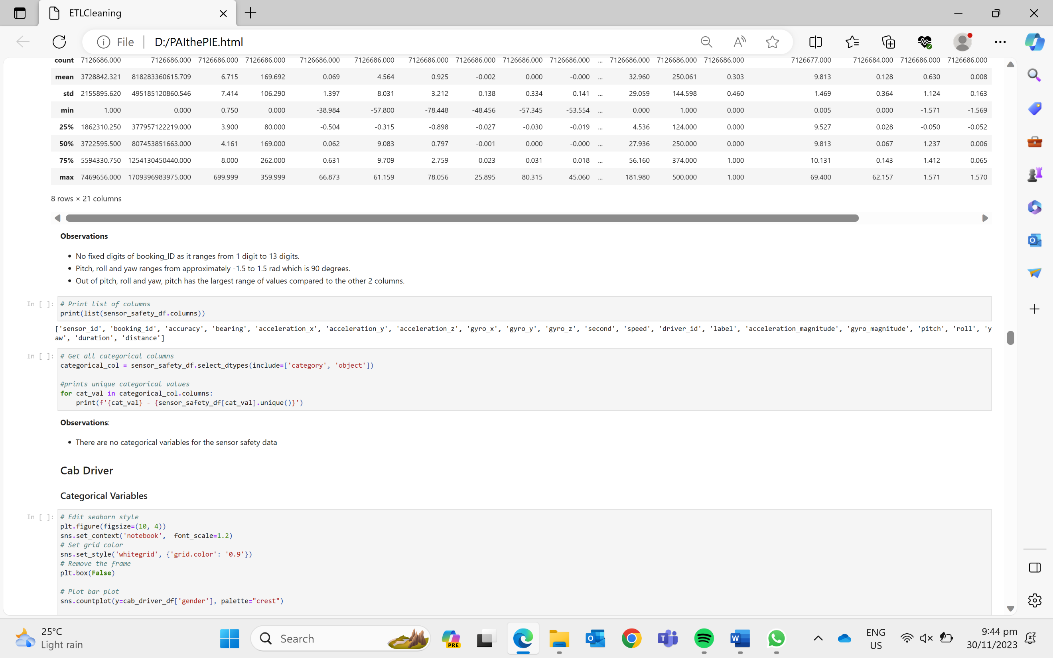

**5 DATA INSIGHTS**

5.1 Seaborn/Matplotlib

**Cab Driver Dataset**

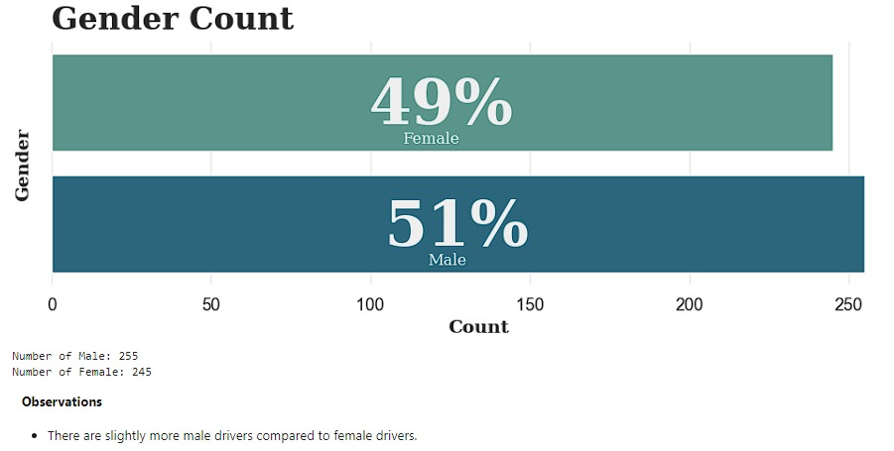

**Insight**: There are slightly more male drivers compared to female drivers.

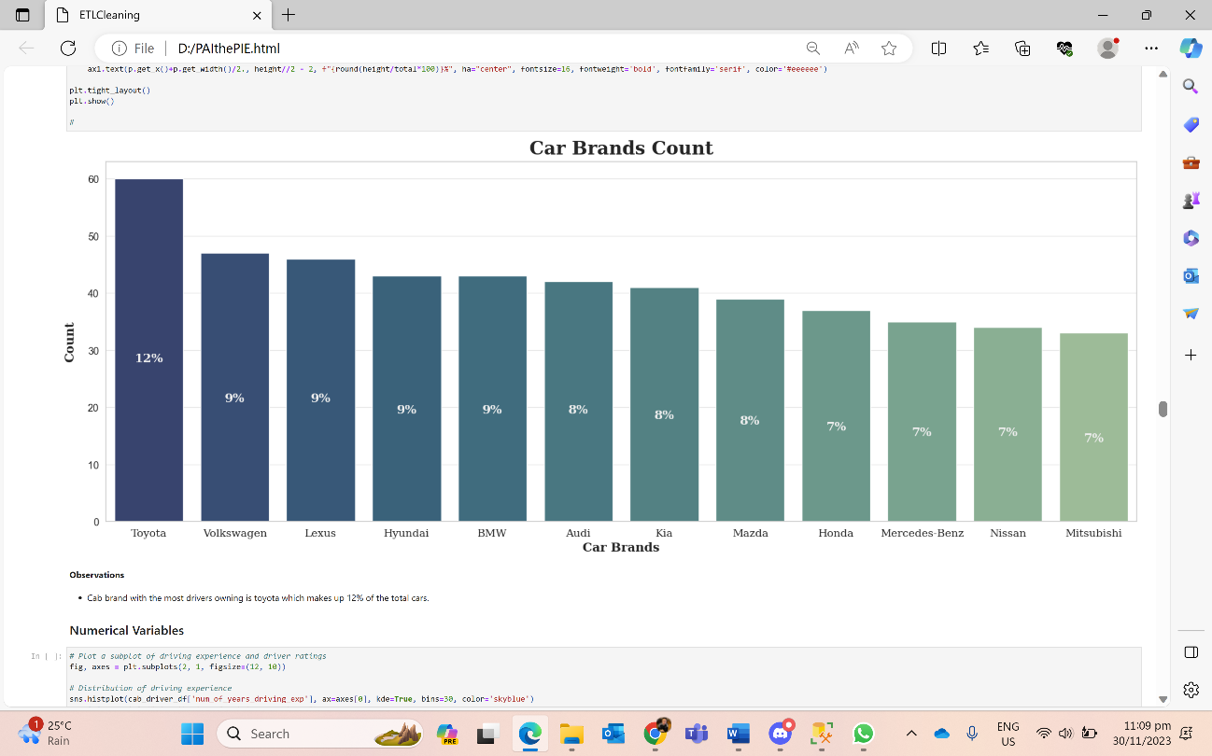

* The car brand with the most drivers driving is Toyota which makes up 12% of the total cars.

Distribution of the drivers’ data metrics are shown as equally distributed across the data.

Histogram

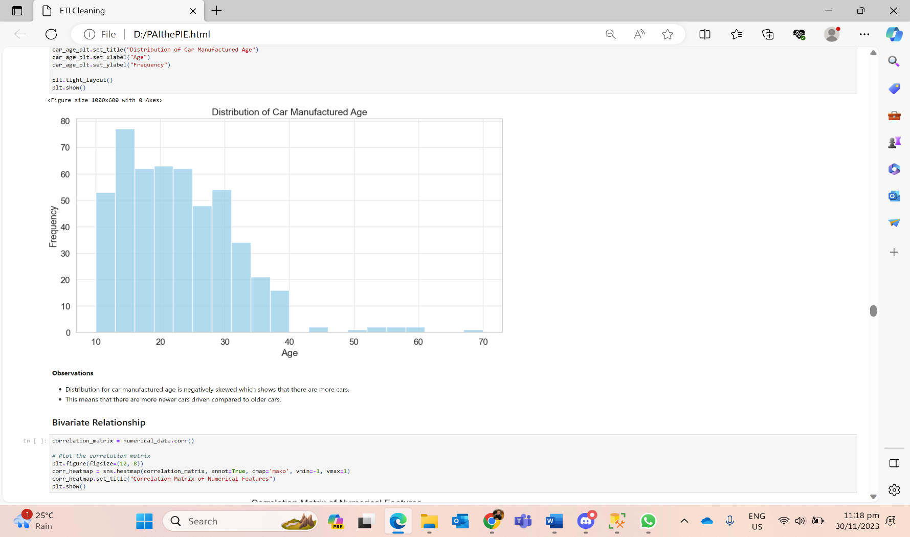

Correlation Matrix Violin Plots  
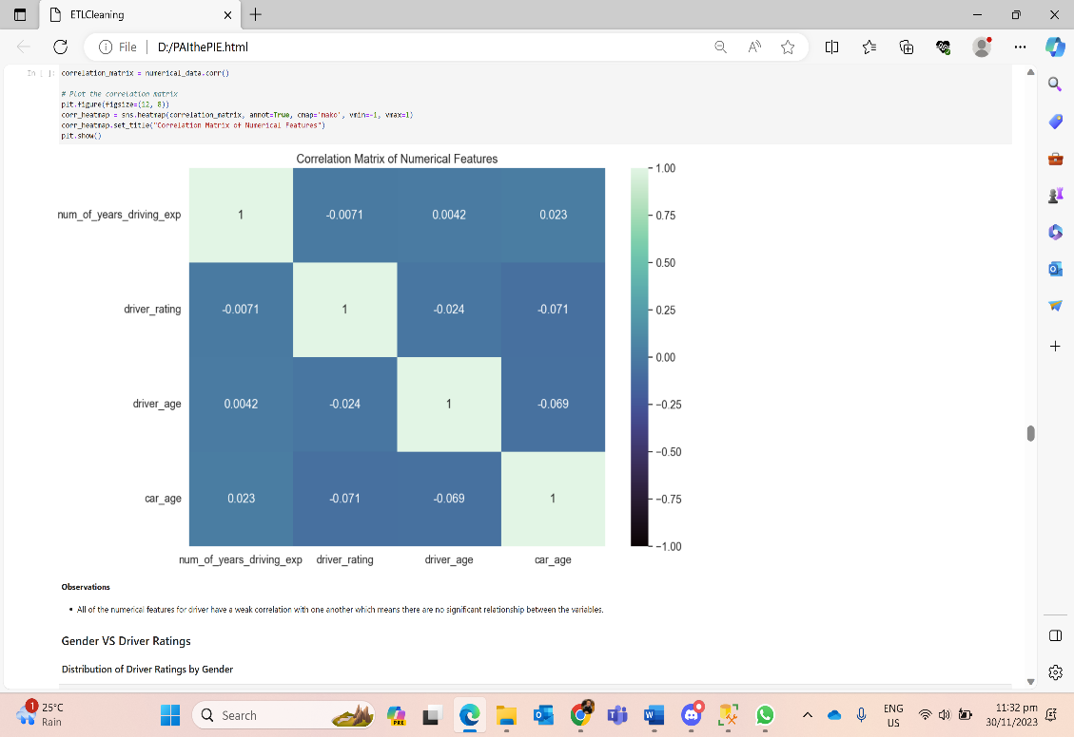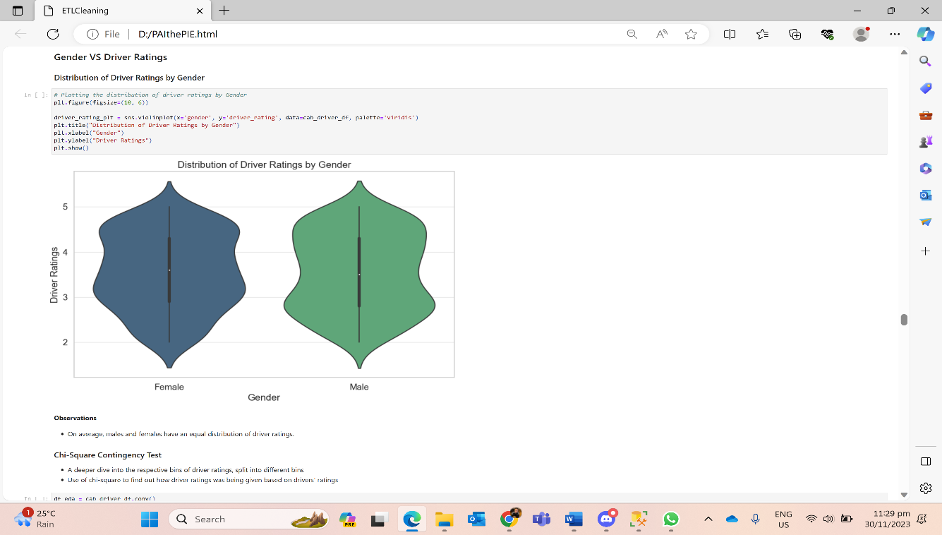

Chi-Square Contingency Test

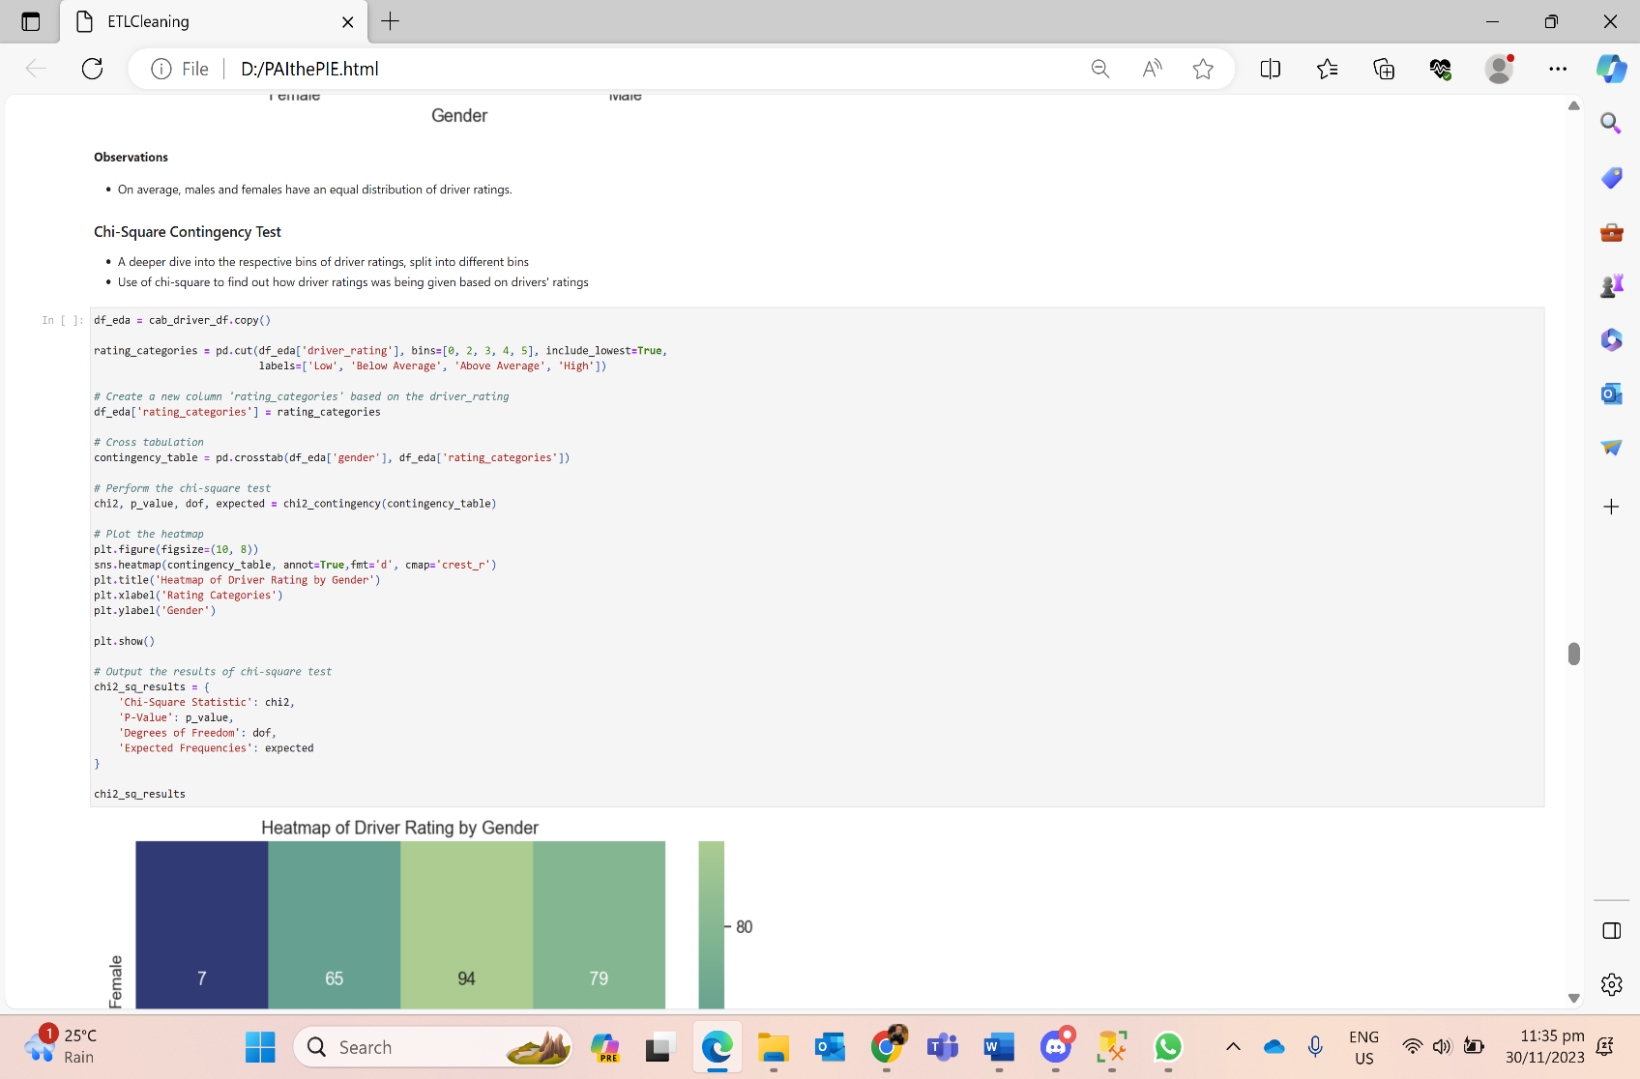 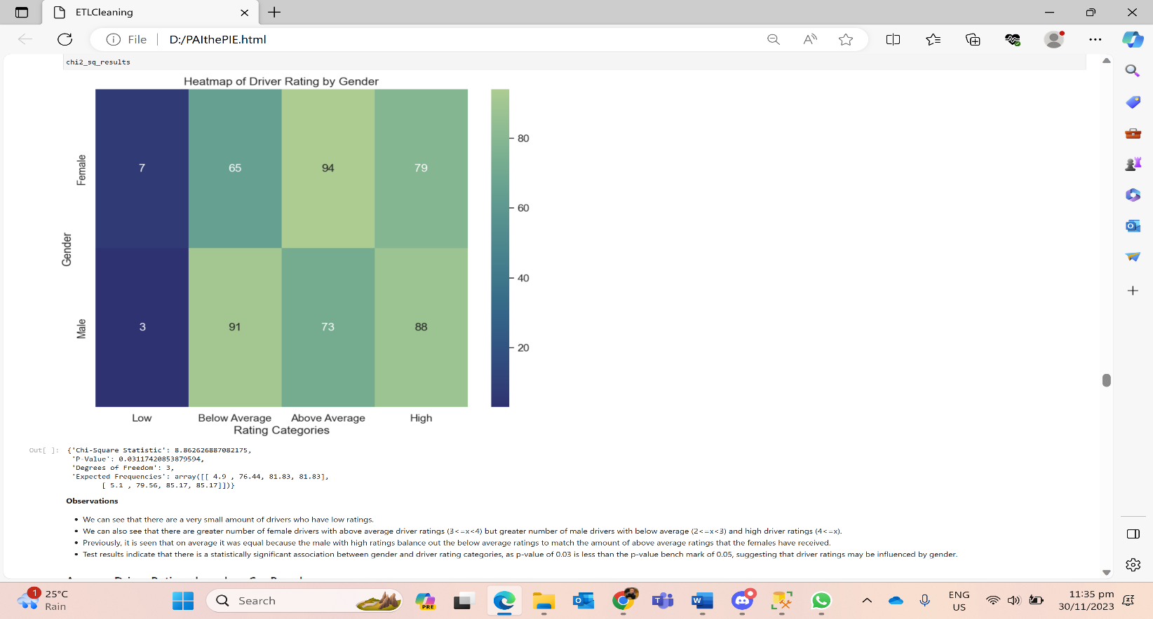

* There are greater number of female drivers with above average driver ratings (3<=x<4) but greater number of male drivers with below average (2<=x<3) and high driver ratings (4<=x) and has a very small number of drivers with low ratings.
* Previously, it is seen that on average it was equal because the male with high ratings balances out the below average ratings to match the amount of above average ratings that the females have received.
* Test results indicate that there is a statistically significant association between gender and driver rating categories, as p-value of 0.03 is less than the p-value benchmark of 0.05, suggesting that driver ratings may be influenced by gender.

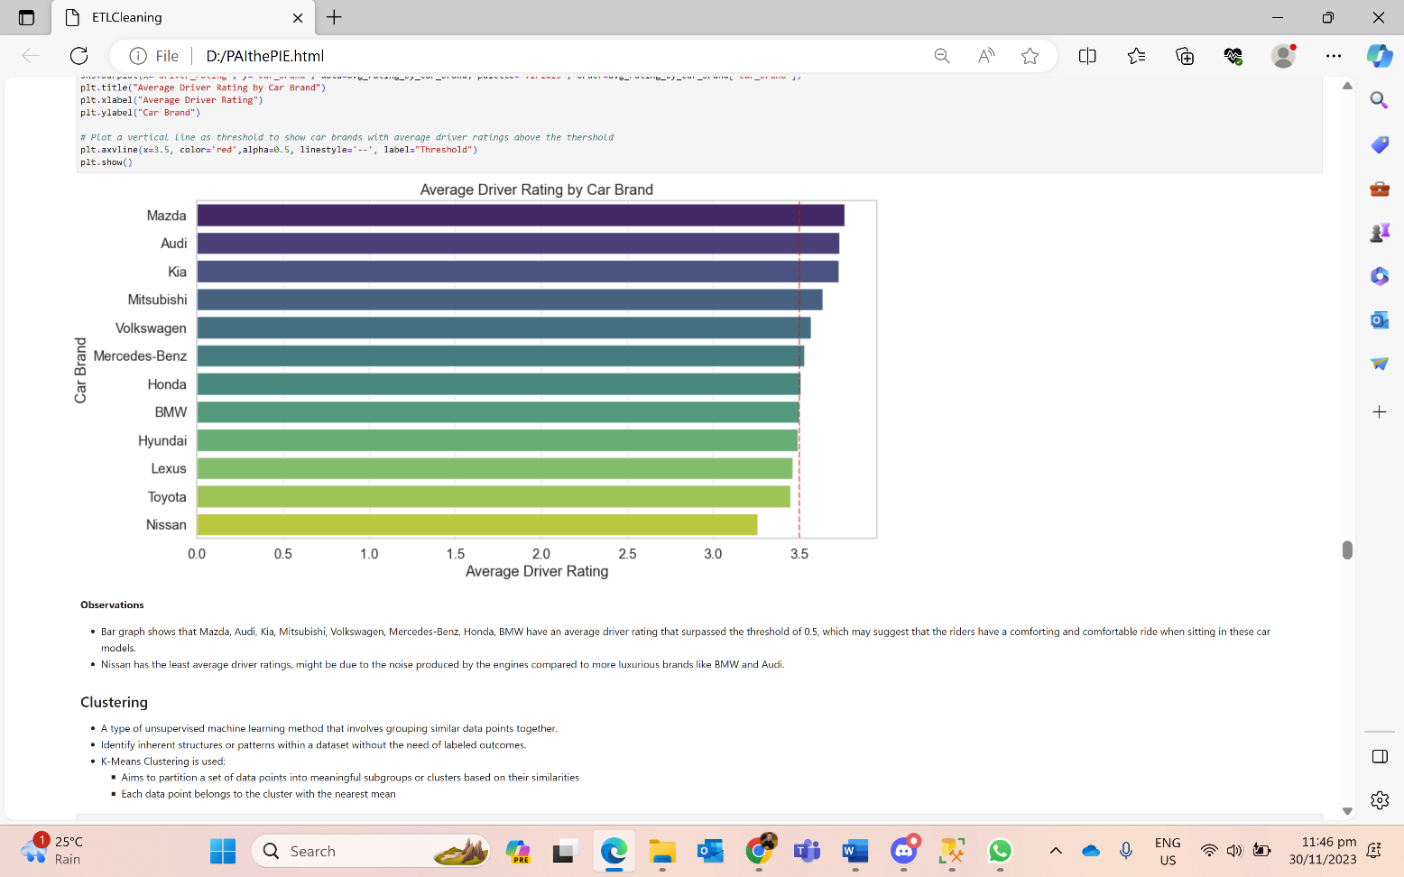

* It shows that Mazda, Audi, Kia, Mitsubishi, Volkswagen, Mercedes-Benz, Honda, BMW have an average driver rating that surpassed the threshold of 3.5, which may suggest that the riders have a comforting and comfortable ride.
* Nissan has the least average driver ratings, might be due to the noise produced by the engines compared to more luxurious brands like BMW and Audi.

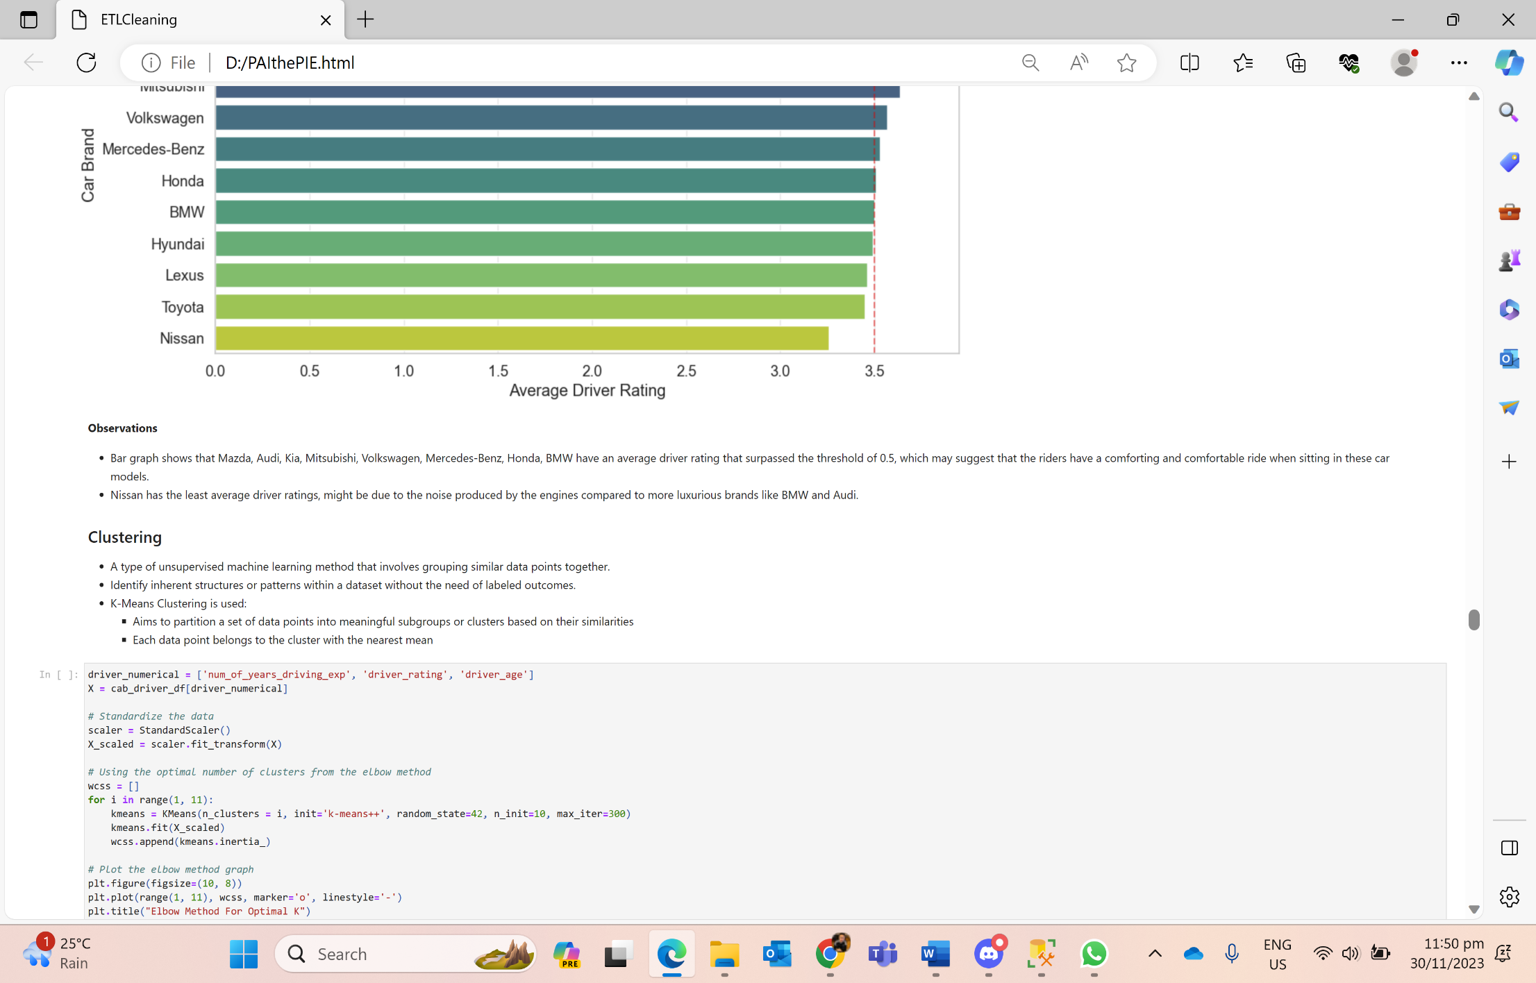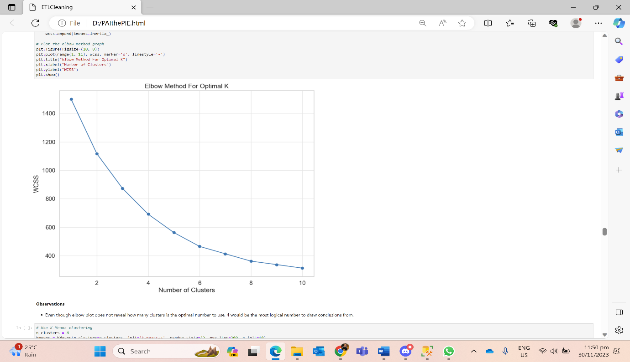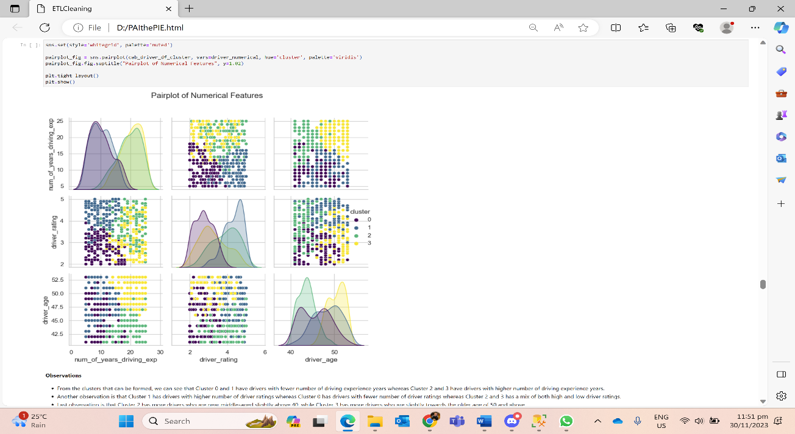

* Number of clusters chosen is 4 but it may not be the most optimal number of clusters.
* Cluster 0 and 1 have drivers with fewer number of driving experience years whereas Cluster 2 and 3 have drivers with a higher number of driving experience years.
* Cluster 1 has drivers with a higher number of driver ratings whereas Cluster 0 has drivers with a lower number of driver ratings whereas Cluster 2 and 3 has a mix of both high and low driver ratings.
* The last observation is that Cluster 2 has more drivers who are near middle-aged slightly above 40, while Cluster 3 has more drivers who are slightly towards the older age of 50 and above.

PCA Visualisation of Clusters Anomaly Detection (Isolation Forest)

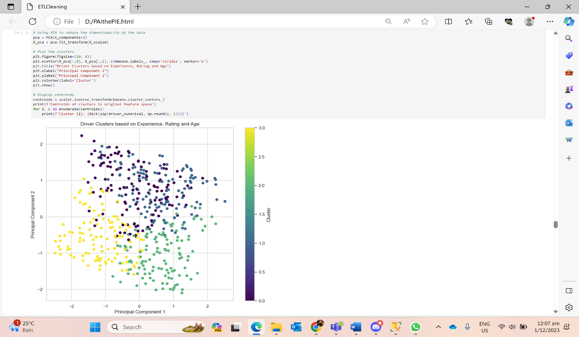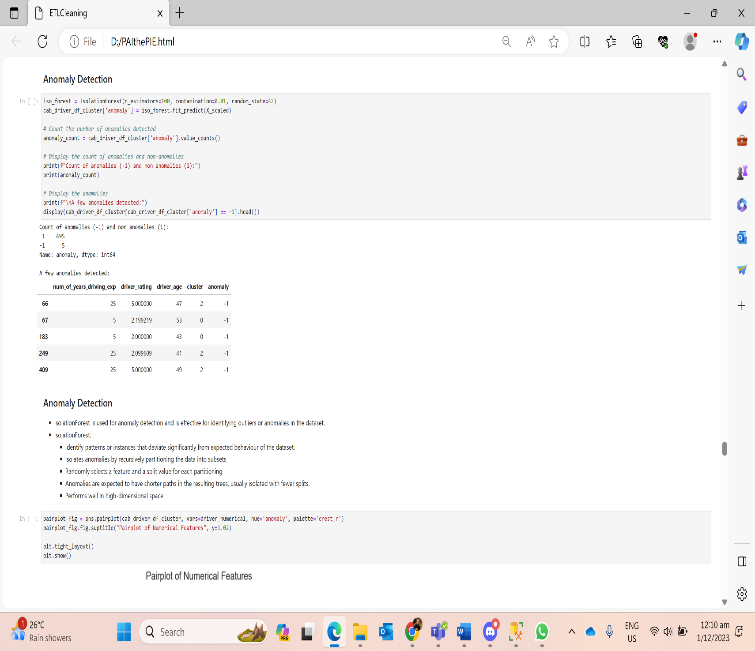

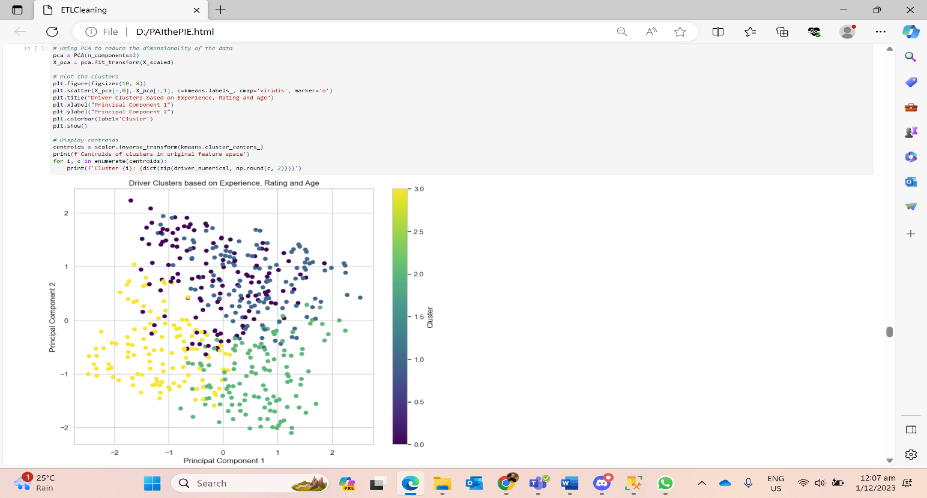 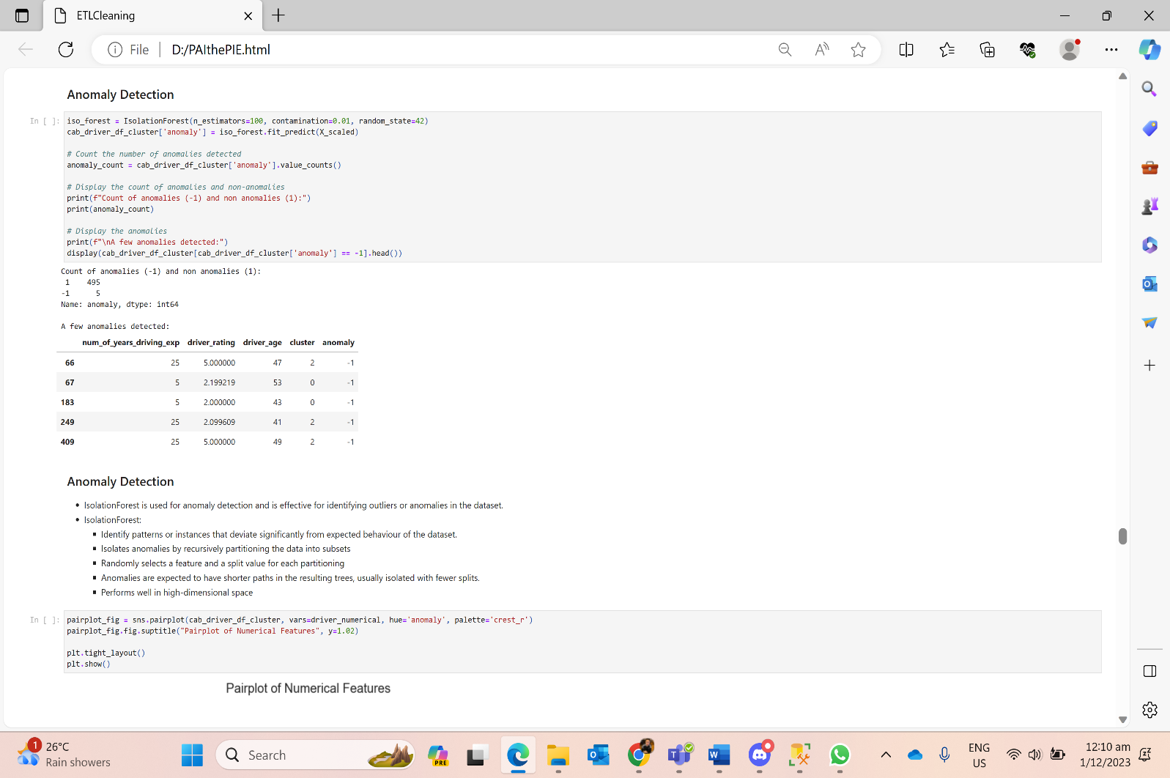

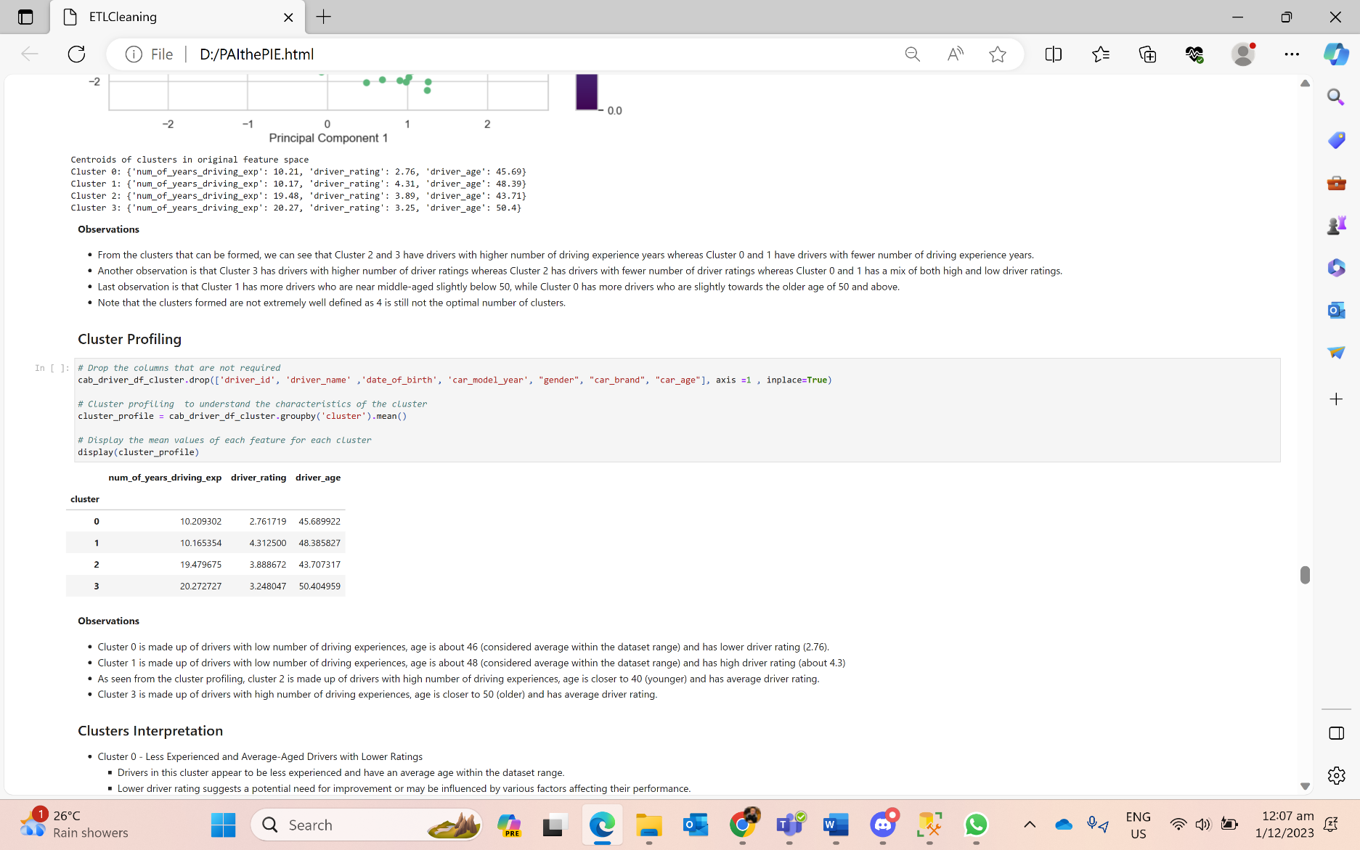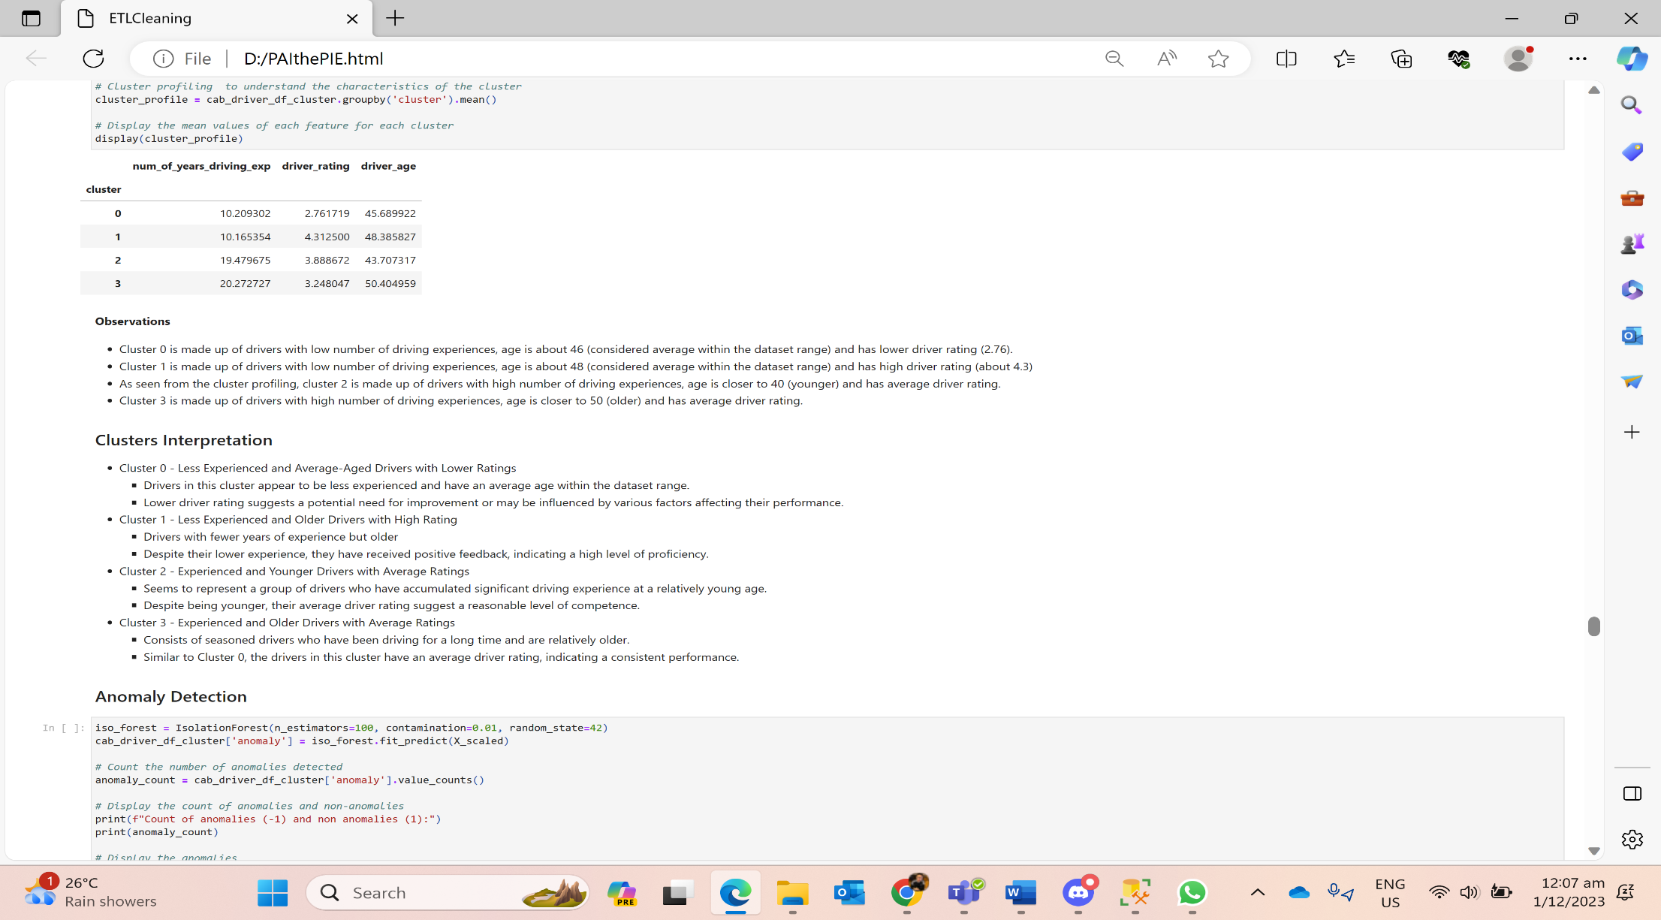

**Sensor Data + Safety Labels Dataset**

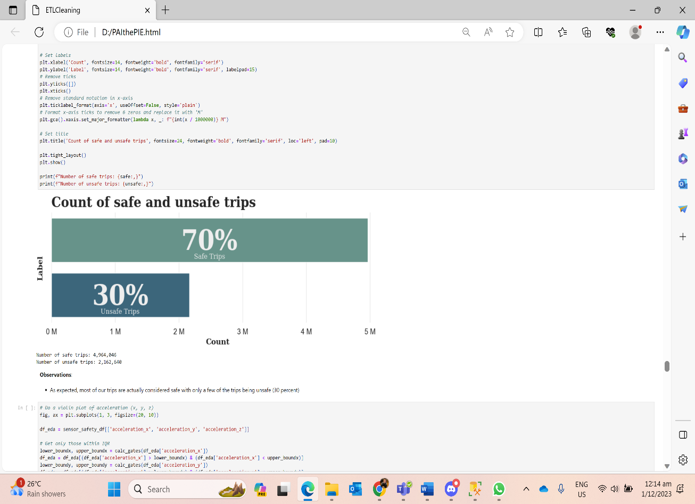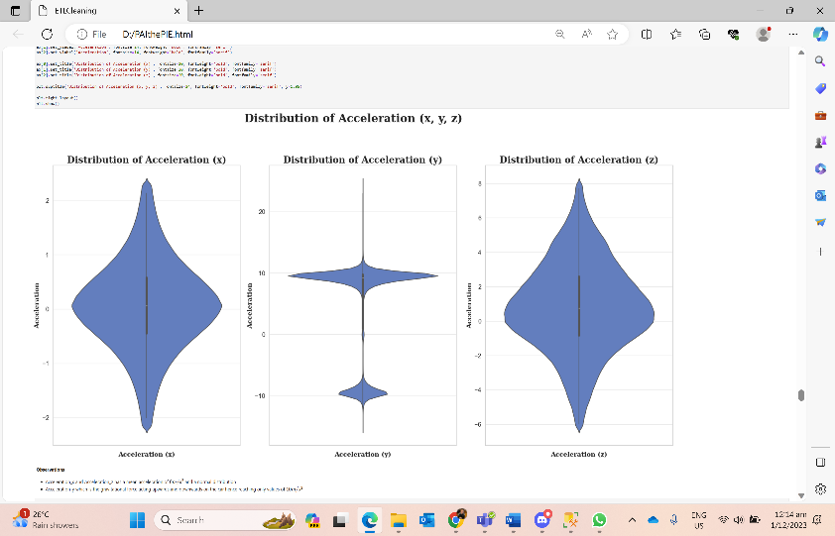

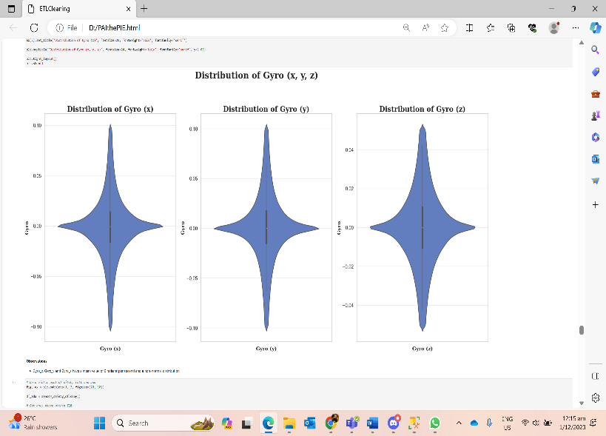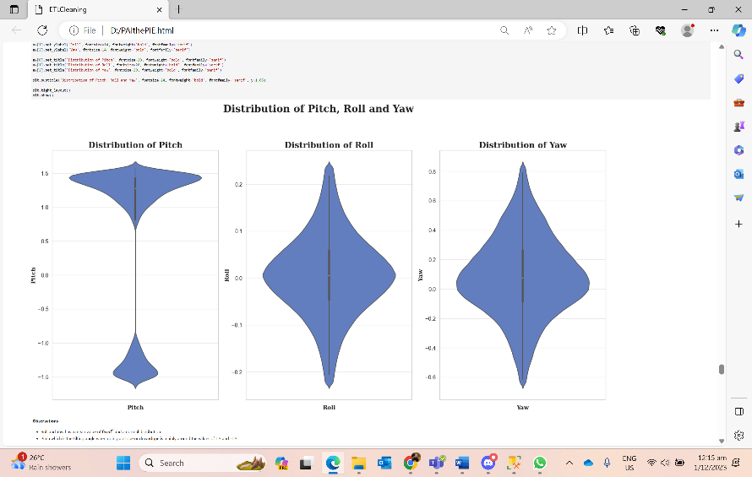

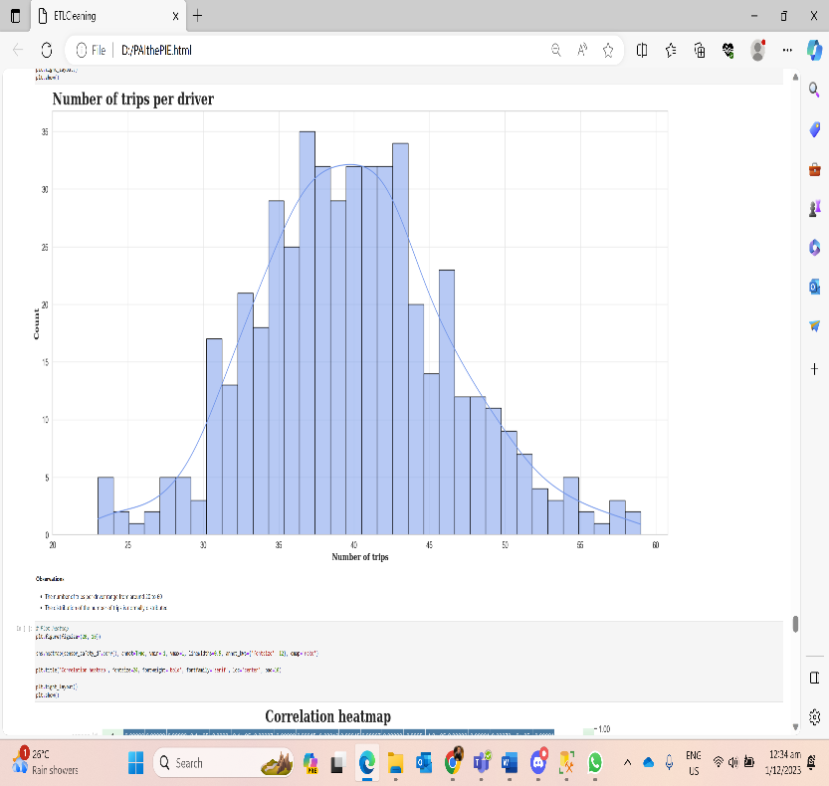 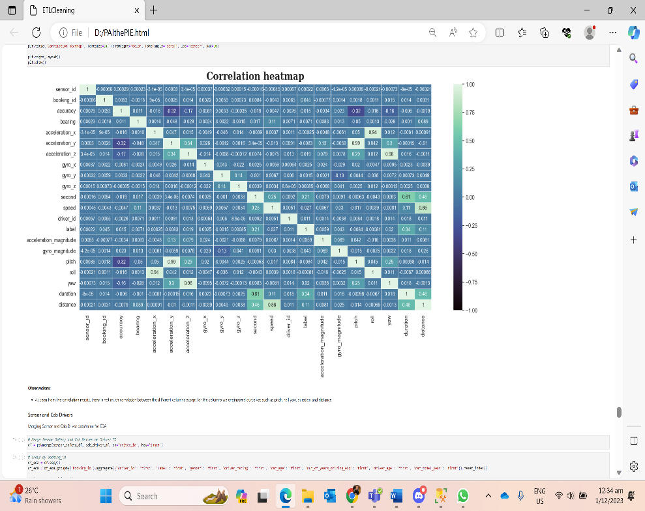

**Cab Driver + Sensor Data + Safety Labels Dataset**

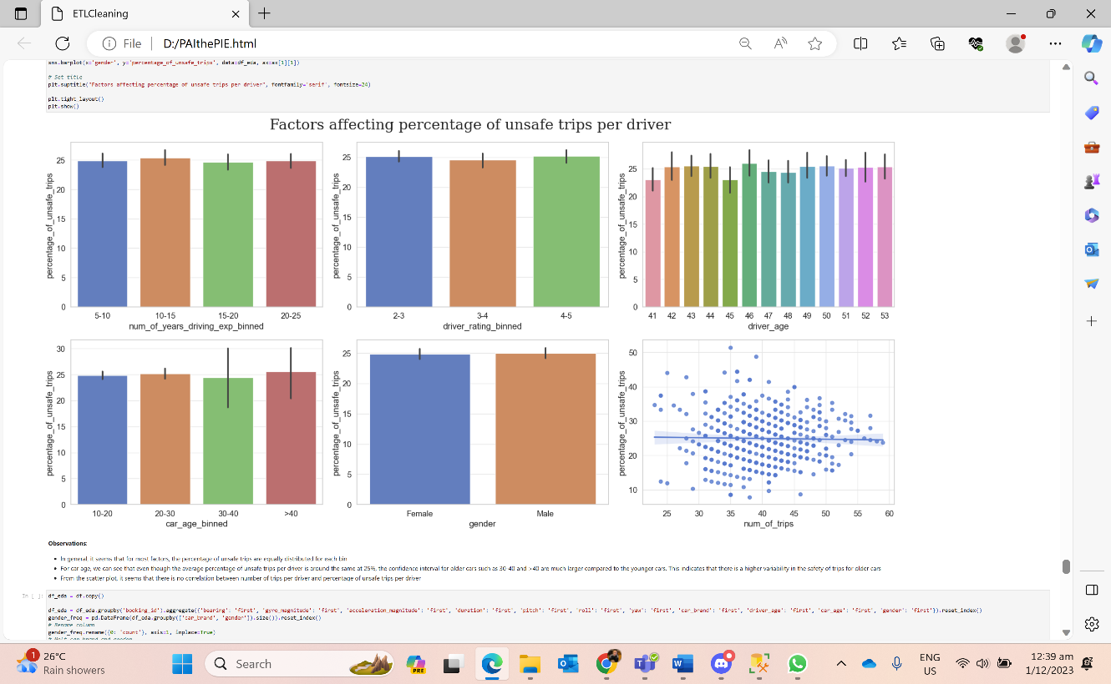

* In general, it seems that for most factors, the percentage of unsafe trips are equally distributed for each bin.
* For car age, we can see that even though the average percentage of unsafe trips per driver is around the same at 25%, the confidence interval for older cars such as 30-40 and >40 is much larger compared to the younger cars. This indicates that there is a higher variability in the safety of trips for older cars.
* From the scatter plot, it seems that there is no correlation between the number of trips per driver and percentage of unsafe trips per driver.

5.2 Bokeh

Driver Rating Count – Binned Ratings

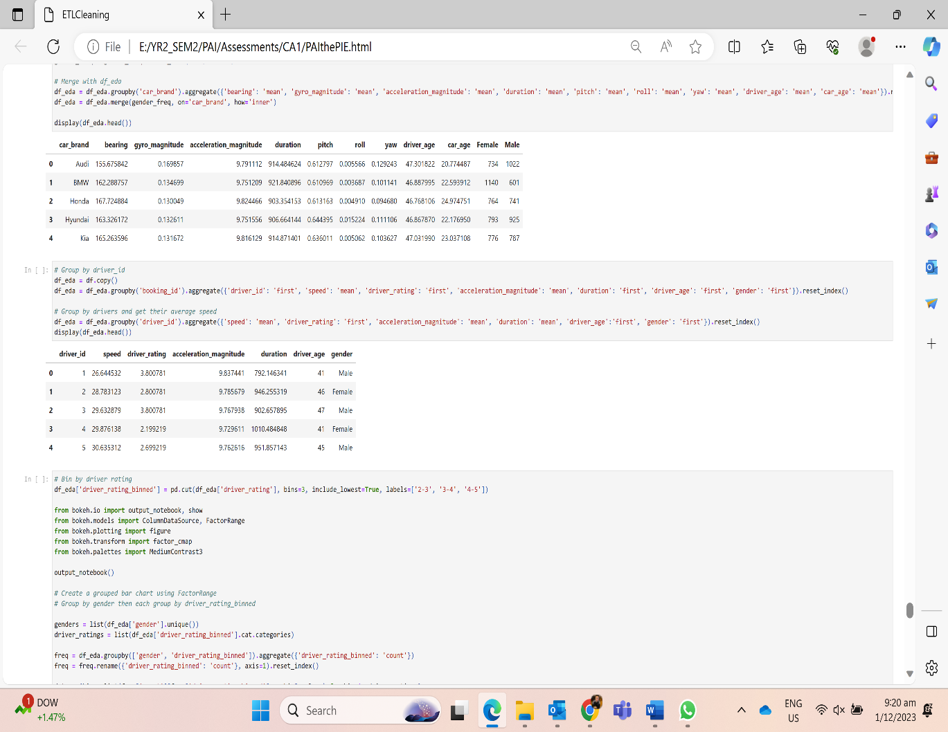

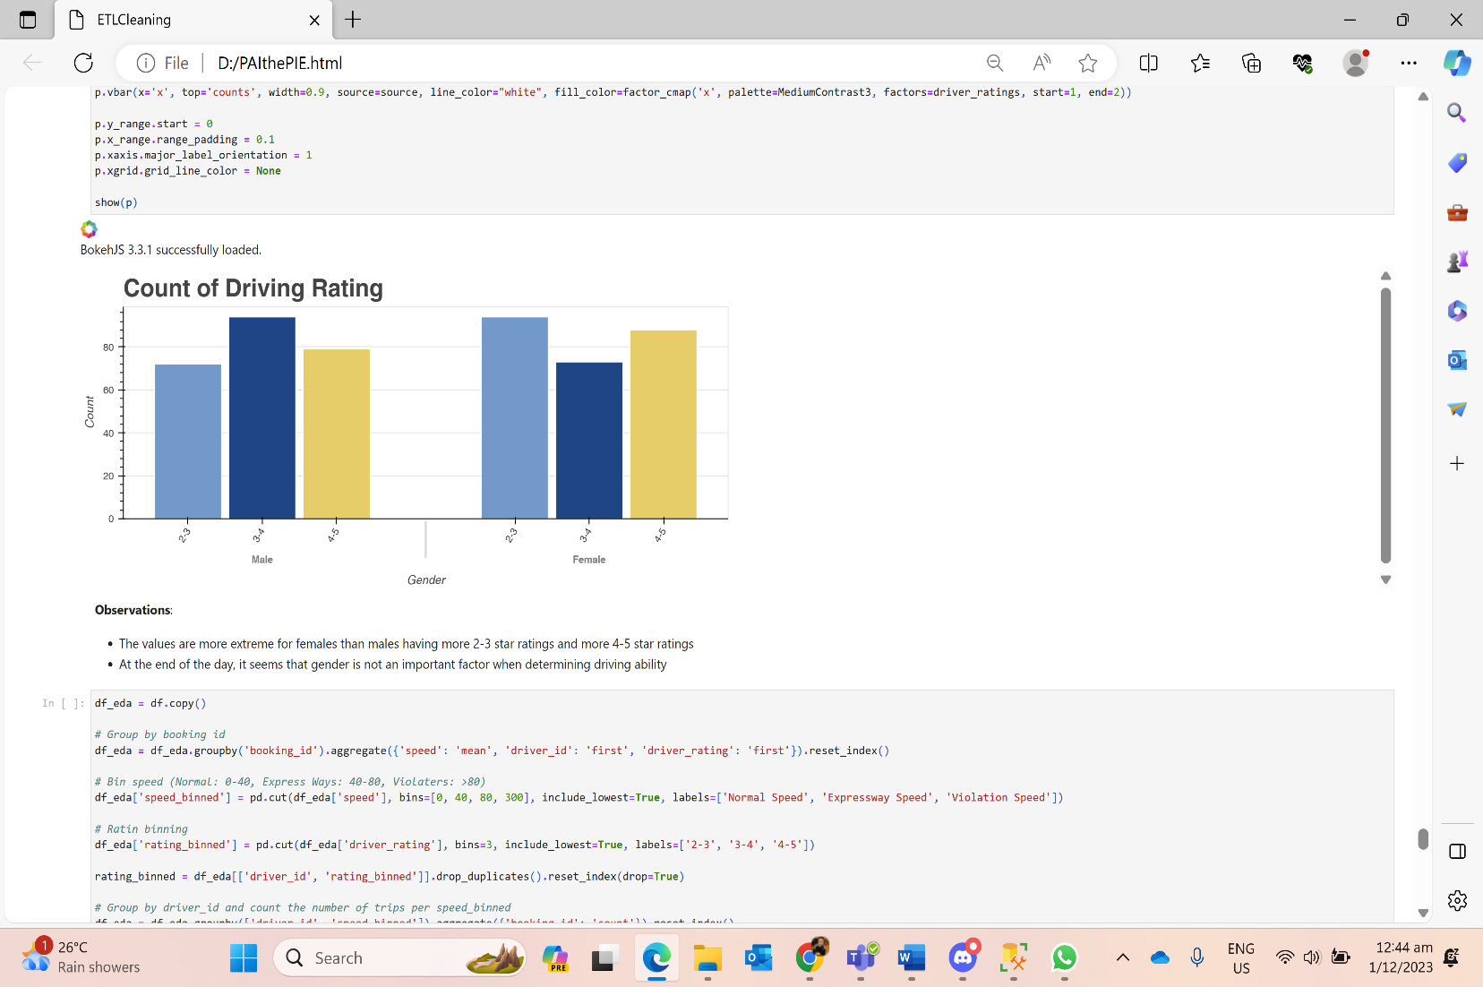

* The values are more extreme for females than males having more 2-3 star ratings and more 4-5 star ratings.

Count of Driver Ratings VS Speed Bins of Different Groups of Ratings

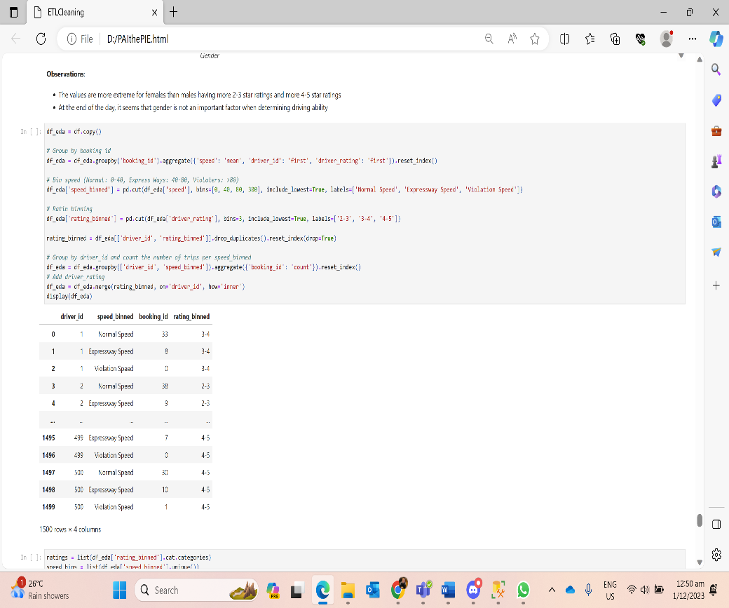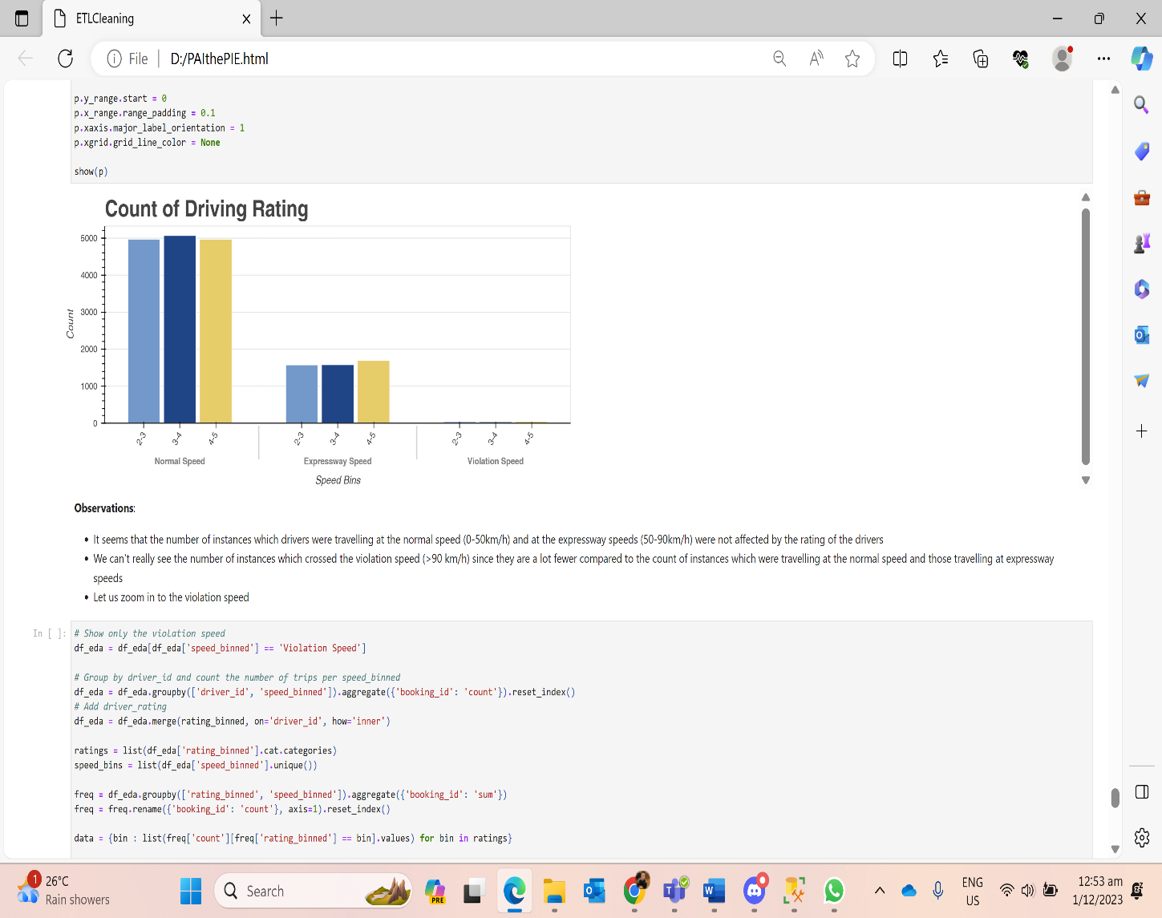

* It seems that the number of instances in which drivers were travelling at the normal speed (0-50km/h) and at the expressway speeds (50-90km/h) were not affected by the rating of the drivers.
* We can't really see the number of instances which crossed the violation speed (>90 km/h) since they are a lot fewer compared to the count of instances which were travelling at the normal speed and those travelling at expressway speeds.

Count of Driver Ratings in Speed Violators (Zoomed in from previous graph)

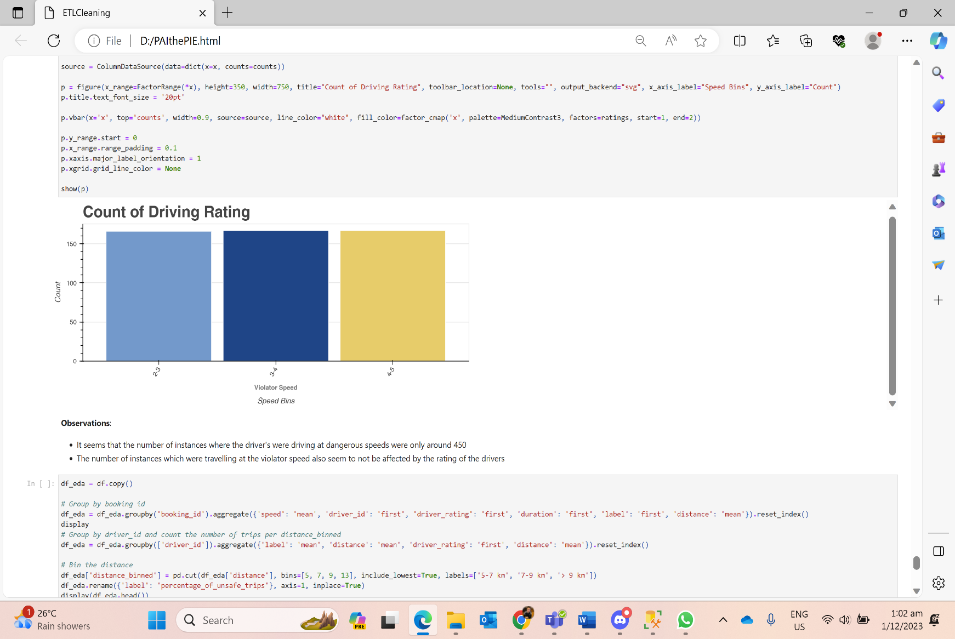

* It seems that the number of instances where the drivers were driving at dangerous speeds were only around 450 km/h.
* The number of instances which were travelling at the violator speed also seem to not be affected by the rating of the drivers.

Binned Distance

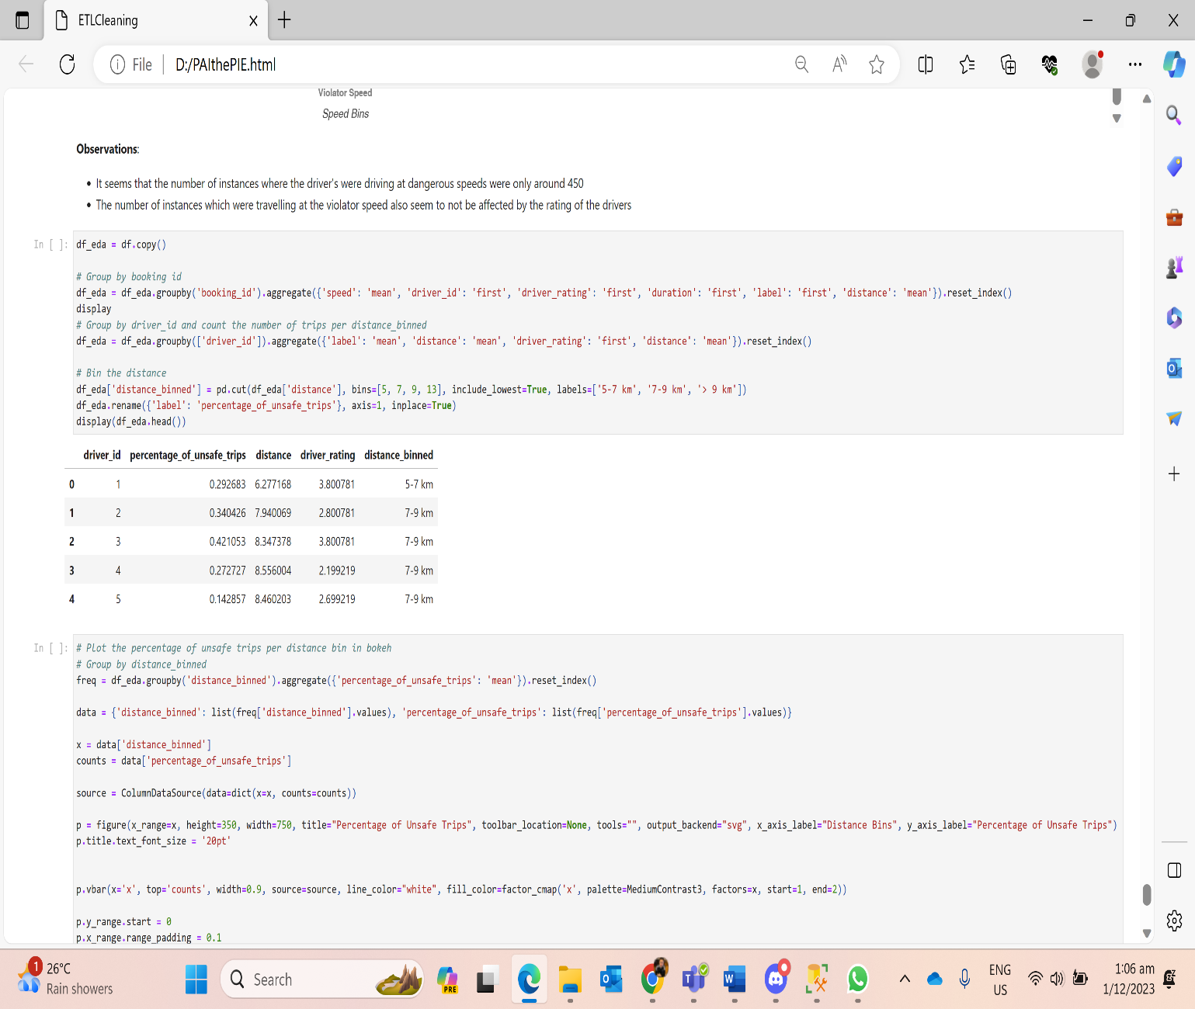

Binned Distance VS Unsafe Trips Binned Distance VS Average Rating

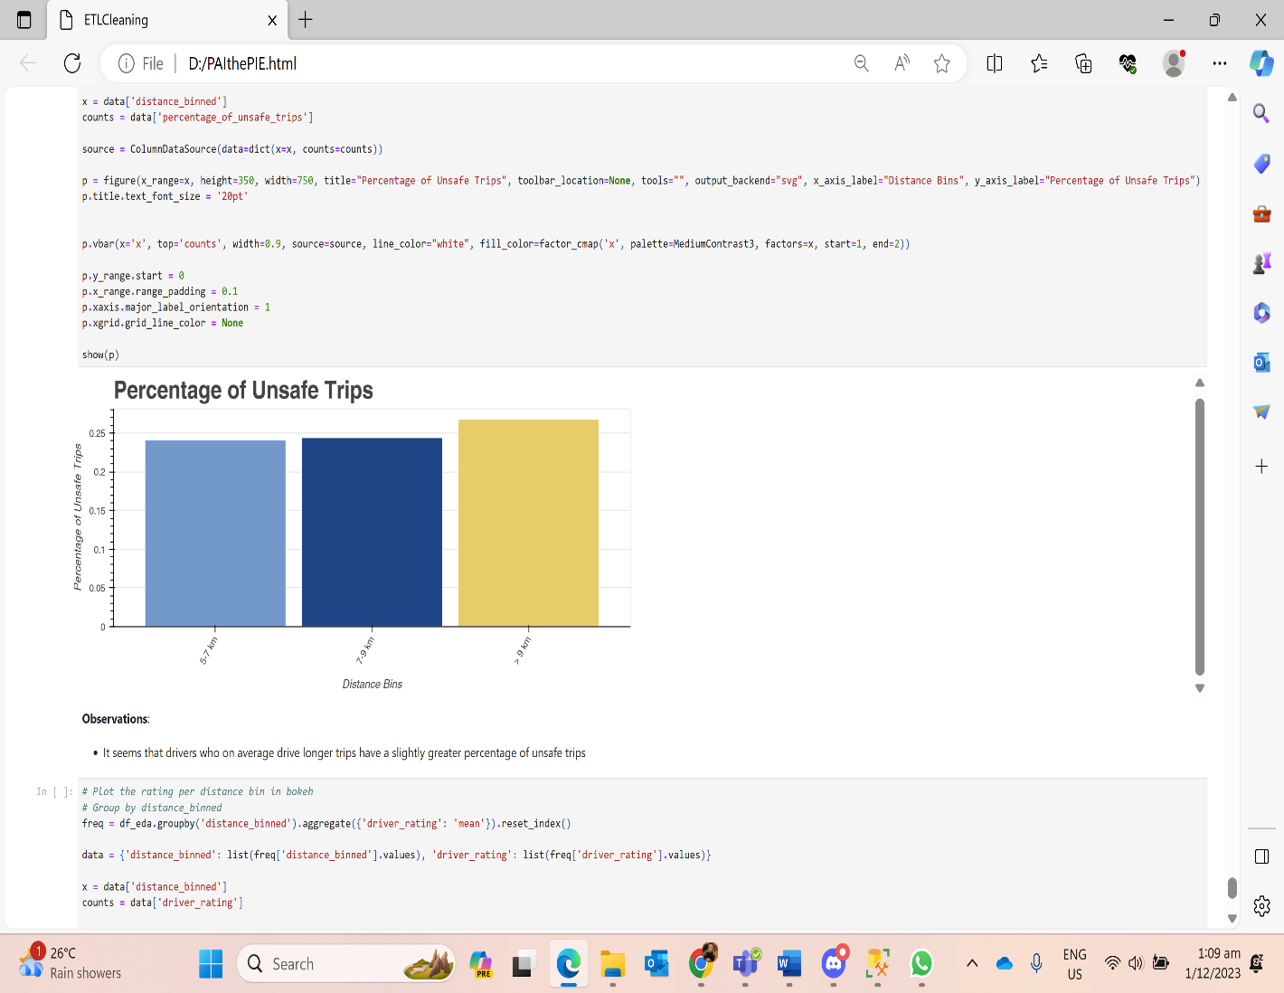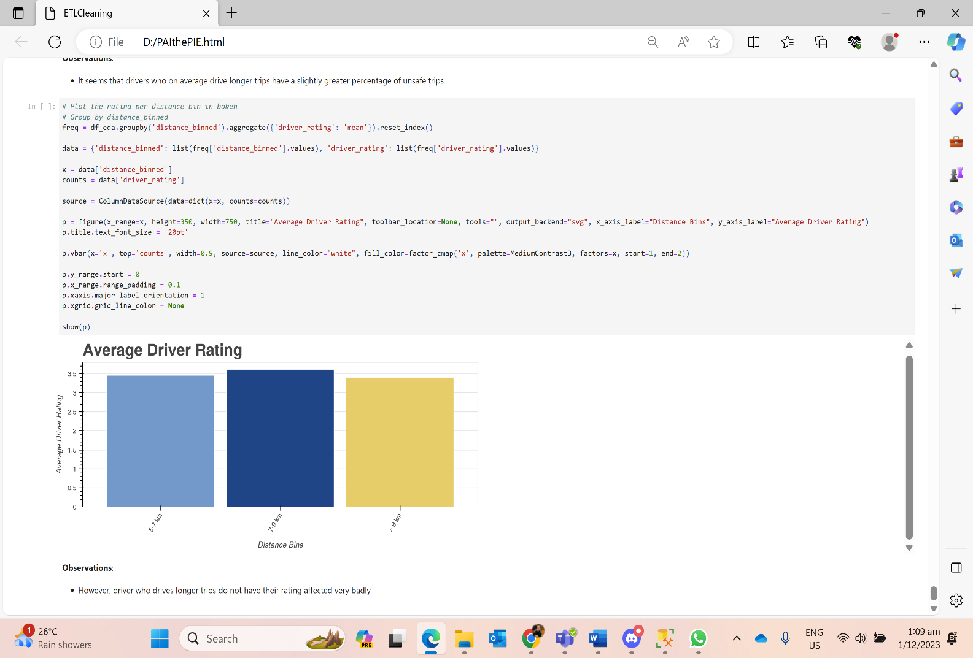

5.3 Tableau Dashboards

Managers Dashboard – Car Model Analysis

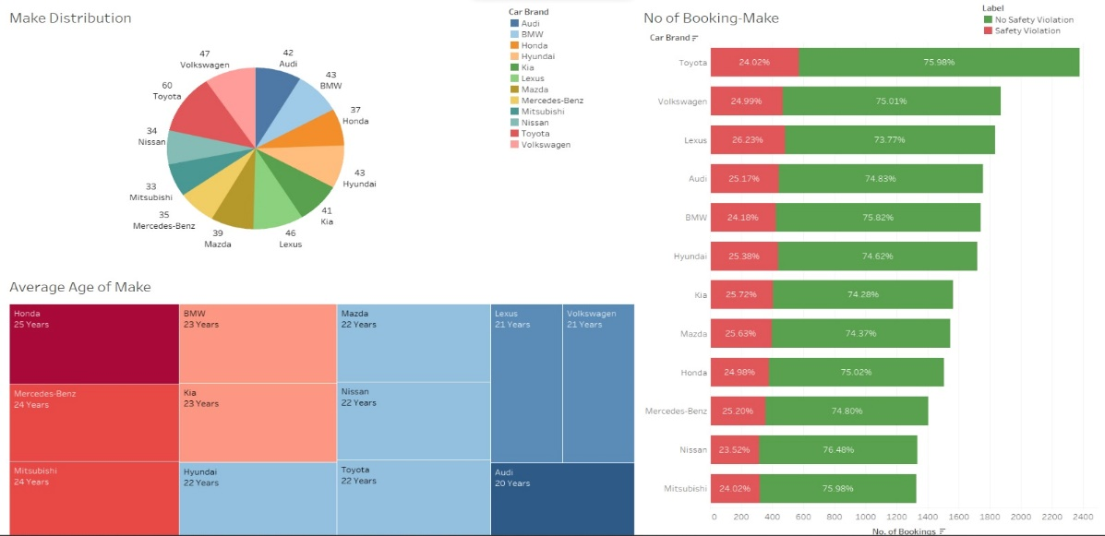

**Insight (Pie Chart):** Toyota has a larger distribution compared to other makes. The fleet sizes for each make range from 33 to 60.

**Insight (Heat Map):** Honda has the highest average age, indicating to the manager the potential need to upgrade Honda cabs for fleet safety.

**Insight (Bar Chart):** Similarly to the Pie Chart, there's a large distribution of Toyota cabs. Across different makes, the percentage of bookings with safety warnings is consistent, ranging from 24.02% to 26.23%.

Managers Dashboard – Safety Label Analysis

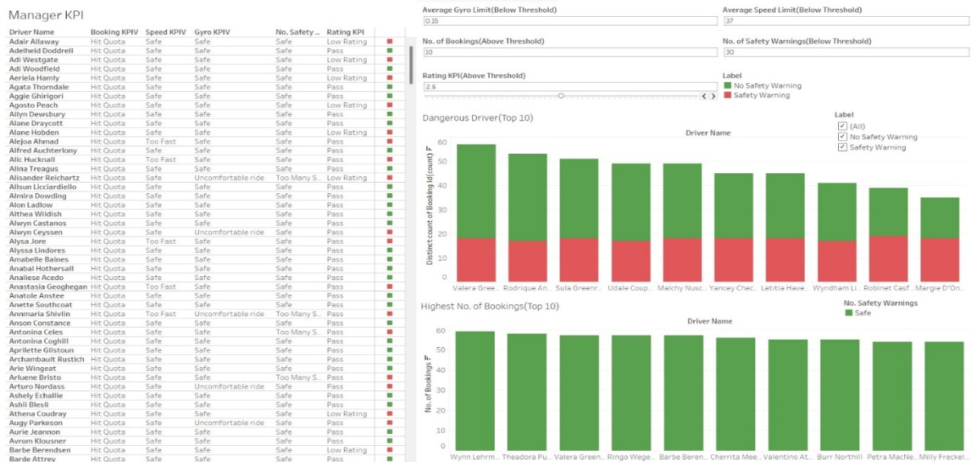

**Insight (KPI):** This KPI shows the drivers who passed based on manager’s KPI input filters showing if they, hit quota; stay under speed limit; stay under gyro limit; stay under total safety warnings; above targeted user rating.

**Insight (Dangerous Driver Bar Chart):** Shows the top 10 driver with highest amount of safety warnings indicating to the manager that they should be closely watched and warned to ensure safety for future booking trips.

**Insight (Highest Booking Bar Chart):** Shows the top 10 driver with highest number of bookings indicating to the manager that these drivers should be commended or even rewarded as they bring in the most revenues.

Cab Driver Dashboard – Drivers & Sensors Analysis

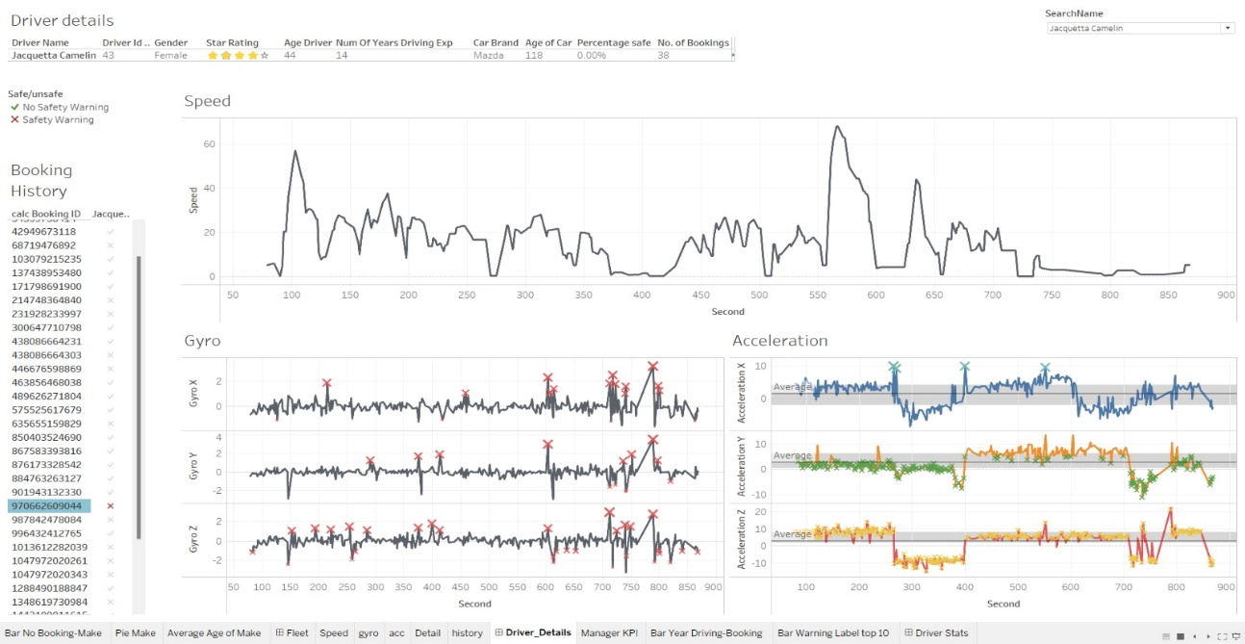

**Details:** Shows the basic details of a driver selected (Name, Rating, Years of driving experience, Age, Car Brand, Age of Car, Percentage of trips that are safe and Number of bookings)

**Booking History**: Shows all the bookings by 1 driver and whether if there is a safety violation.

**Speed, Acceleration and Gyro**: If any sensor metrics exceeds a certain threshold during any booking trips, the threshold will be marked by a cross in the graph.

**For example**: BookingID 970662609044 which was driven by the driver, Jacquetta Camelin, reveals that even though the speed does not exceed the threshold of 90km/h, the gyros exceed their individual thresholds at certain points which means that the car is turning too fast in that X,Y or Z axis, and moreover the acceleration in X,Y and Z axis also exceed our thresholds selected which caused the trip to be unsafe thus could be the cause of the safety violation.

**6 CONCLUSION**

In conclusion, the GoBest Cab Data Science Team has successfully navigated through the **first phase** of the project which is producing out queries, graphs, and dashboards to analyse the cab and sensor data. Some key findings were that having certain sensors’ anomalies or speed violations **do not directly correlate** with the **ratings** customers give the drivers, however **gender** do have a **significant association with how ratings** were given. Single factors like years of driving experience does **not directly correlate** with how safe the trip will be. It can be caused by **many different external factors**, which requires advanced machine learning techniques for a deeper understanding of the external factors that will affect the safety labels of the trip.

**REFERENCES**

* Contributors, B. (n.d.). Bokeh documentation. [online] docs.bokeh.org. Available at: https://docs.bokeh.org/en/latest/index.html. [Accessed 14 Nov]
* Epsondevice.com. (2019). Gyro sensors - How they work and what’s ahead | about Gyro sensor | Technical Information | other Information. [online] Available at: https://www5.epsondevice.com/en/information/technical_info/gyro/. [Accessed 5 Nov. 2023].
* Physics Stack Exchange. (n.d.). What does the magnitude of the acceleration mean? [online] Available at: https://physics.stackexchange.com/questions/98420/what-does-the-magnitude-of-the-acceleration-mean#:~:text=So%20as%20an%20example%20an [Accessed 7 Nov. 2023].
* taketake2.com. (n.d.). Pitch, Roll and Yaw of automobiles- Basics of control engineering, this and that. [online] Available at: https://taketake2.com/S18_en.html [Accessed 7 Nov. 2023].